**CHAPTER 1 INTRODUCTION**

**1.1 INTRODUCTION**

The Pineapple Farm Management System is a comprehensive online platform designed to streamline and enhance the efficiency of pineapple cultivation processes. This system empowers farmers to seamlessly sell their pineapples produce, procure essential tools and fertilizers for cultivation. Additionally, the platform facilitates direct transactions between pineapple agencies and farmers, providing a centralized marketplace. The key features of the system are: Farmers can list and sell their pineapples. Pineapple agencies can directly purchase from farmers, fostering a transparent and efficient marketplace. Shop can list and sell agricultural tools and fertilizers. Farmers can easily purchase necessary supplies for their pineapple cultivation. Intuitive design for easy navigation by farmers, shop, and pineapple agencies. Secure login and transaction mechanisms to ensure data privacy. Shop can manage their inventory of tools and fertilizers effectively. Farmers can keep track of their sales and purchases through the system. Farmers can provide review for purchased tools and fertilizers fostering trust within the community. By integrating these features, the Pineapple Farm Management System aims to create a digital ecosystem that enhances the overall productivity and profitability of pineapple cultivation while fostering collaboration between farmers, agencies, and agricultural suppliers.

## 1.2 PROBLEM STATEMENT

Pineapple farming is a crucial agricultural sector, but many pineapple farmers face challenges in effectively managing their farms, including sales of produce, procurement of tools and fertilizers. Existing systems often lack integration and efficiency, leading to inefficiencies and reduced profitability for farmers. Therefore, there is a pressing need for a comprehensive Pineapple Farm Management System that streamlines these processes and empowers farmers to manage their operations more effectively. The system should provide a platform for farmers to showcase and sell their pineapples directly to pineapple agencies, eliminating intermediaries and maximizing profits for farmers. Farmers should be able to purchase agricultural tools, equipment, and fertilizers directly through the system, with access to a variety of options from trusted shops.

Capability to track inventory levels of pineapples, tools, fertilizers, and other farm supplies in real-time, enabling farmers to make informed purchasing and sales decisions.

## 1.3 SCOPE AND RELEVANCE OF THE PROJECT

A pineapple farm management system with features for selling pineapples to agencies, purchasing tools and fertilizer from shops and significant relevance for pineapple farmers. It could streamline the entire supply chain process, from production to sale, by providing a centralized platform for transactions and communication. This system would enhance efficiency, transparency, and accountability in farm operations while fostering better relationships between farmers, agencies and shop. Additionally, it could facilitate better decision-making by providing data insights on sales and expense. Overall, such a project could greatly benefit pineapple farmers by improving their access to markets and resource.

## 1.4 OBJECTIVES

The objective of the pineapple farm management system project is to create a user-friendly platform where pineapple farmers can efficiently manage their operations. This includes features such as selling pineapples to agencies, purchasing tools and fertilizers. The system aims to streamline processes, improve productivity, and enhance profitability for pineapple farmers.

**CHAPTER 2 SYSTEM ANALYSIS**

**2.1 INTRODUCTION**

Software Engineering is the analysis, design, construction, verification and management of technical or social entities. To engineer software accurately, a software engineering process must be defined. System analysis is a detailed study of the various operations performed by the system and their relationship within and module of the system. It is a structured method for solving the problems related to the development of a new system. The detailed investigation of the present system is the focal point of system analysis. This phase involves the study of the parent system and the identification of system objectives. Information has to be collected from all people who are affected by or who use the system. During analysis, data are collected on the variable files, decision points and transactions handled by the present system. The main aim of the system is to provide efficient and user-friendly automation. So, the system analysis process should be performed with extreme precision so that an accurate picture of the existing system, its disadvantages, and the requirements of the new system can be obtained. System analysis involves gathering the necessary information and using the structured tool for analysis. This includes the studying existing system and its drawback, designing a new system, and conducting a cost-benefit analysis. System analysis is a problem-solving activity that requires intensive communication between the system users and system developers. The system is studied to the minute detail and analysed. The system is viewed as a whole and the inputs to the system are identified. The outputs from the organization are traced through various phases of processing of inputs.

## 2.2 EXISTING SYSTEM

Currently, there isn't a dedicated online shopping platform tailored specifically for pineapple farmers. The conventional approach involves farmers reaching out to pineapple agencies to sell their produce, and vice versa, with agencies contacting known pineapple farmers to purchase pineapples. Farmers typically procure fertilizers and tools from local shops, though there are instances where they face challenges due to the unavailability of required supplies.

## 2.2.1 Limitations of Existing System

Here are some of the limitations of the existing system:

* Limited Market Access: Pineapple farmers are confined to local or regional markets due to the lack of a centralized platform, limiting their reach and potential customer base.
* Dependency on Middlemen: Farmers rely heavily on intermediary agencies to connect with buyers, which can result in reduced profits and lack of control over pricing and market dynamics.
* Inefficient Resource Procurement: Farmers may face difficulties in obtaining necessary fertilizers and tools due to the reliance on physical shops, leading to delays in farming activities and suboptimal yield outcomes.
* Lack of Transparency: Without a centralized platform, there may be a lack of transparency in transactions between farmers and agencies, potentially resulting in unfair practices or disputes.

## 2.3 PROPOSED SYSTEM

## The Proposed System allow farmers, shops, pineapple agencies to create accounts and log in securely. Provide an overview of farm activities, sales, expenses, and available tools/fertilizers. Track available tools, fertilizers, and pineapples for sale. Update quantities as items are bought or sold. Allow farmers to list their pineapples for sale and pineapple agencies to browse and purchase them. Farmers can purchase tools and fertilizers from the shops through the website, with options for delivery or pickup. Enable communication between farmers, shops for inquiries and orders. Facilitate secure transactions for buying and selling pineapples, tools, and fertilizers. Allow users to leave reviews for each other to maintain accountability and build trust within the community. Provide insights into sales performance, inventory turnover, and other key metrics to help farmers make informed decisions. By integrating these features, pineapple farm management system can streamline operations and improve efficiency for all stakeholders involved.

The proposed system consists of four stakeholders. They are:

1. Administrator
2. Farmer
3. Pineapple Agency
4. Shop

**Features Provided to Admin**

• The proposed site should provide the provision for login by the owner with username and password.

• The proposed system Admin should have the provision for add ,update and delete district, place, category, subcategory, type subtype, subscription.

• The site should have a home page for Owner, with the options to view the agency new list, agency accepted list and agency rejected list.

• The site should have a home page for Owner, with the options to view the farmer new list, farmer accepted list and farmer rejected list.

• The site should have a home page for Owner, with the options to view the shop new list, shop accepted list and shop rejected list.

• The site should have a home page for Owner, with the options to view the complaints and give reply to the complaints.

• The site should have a home page for Owner, with the options to view the subscription payments paid by the agency, farmer and shop.

• The site should have a home page for Owner, with the options to view the feedbacks done by the agency, farmer and shop.

• The site should have a home page for Owner, with the options to send email confirmations for accepted agency, farmer and shop.

• The site should have a home page for Owner, with the options to generate various report.

• The site should have a home page for Owner, with the options to logout.

**Features Provided to Agency**

• The site should provide a registration for agency.

• The proposed site should provide the provision for login with username and password.

• The site should provide facility to view and edit the profile.

• The site should provide facility to change the password.

• The site should provide facility to buy pineapples from farmers .

• The site should provide facility to post complaint.

• The site should provide facility to view the complaint.

• The site should provide facility to view the reply of the complaint.

• The site should provide facility for subscription.

• The site should provide facility to create new password .

• The site should provide facility to add and view feedbacks .

• The site should provide facility to make payments .

• The site should provide facility to delete the account .

• The site should provide facility to logout .

**Features Provided to Farmer**

• The site should provide a registration for farmer.

• The proposed site should provide the provision for login with username and password.

• The site should provide facility to view and edit the profile.

• The site should provide facility to change the password.

• The site should provide facility to sale their pineapples to different agency.

• The site should provide facility to buy tools & fertilizers from different shop.

• The site should provide facility to review the products that they buy.

• The site should provide facility to view the review of the products.

• The site should provide facility to add and view feedbacks.

• The site should provide facility to add comments about products.

• The site should provide facility to post complaint.

• The site should provide facility to view the complaint.

• The site should provide facility to view the reply complaint.

• The site should provide facility to create new password.

• The site should provide facility to add products to cart.

• The site should provide facility to add products to wishlist.

• The site should provide facility to add, update and delete pineapples .

• The site should provide facility to add, update and delete stock .

• The site should provide facility to make payments.

• The site should provide facility to delete account .

• The site should provide facility for subscription.

• The site should provide facility to logout.

**Features Provided to Shop**

• The site should provide a registration for Shop.

• The proposed site should provide the provision for login with username and password.

• The site should provide facility to view and edit the profile.

• The site should provide facility to change the password.

• The site should provide facility to sale tools & fertilizers.

• The site should provide facility to add and view feedbacks.

• The site should provide facility to post complaint.

• The site should provide facility to view the complaint.

• The site should provide facility to view the reply of the complaint.

• The site should provide facility to add, update and delete products.

• The site should provide facility to add, update and delete stock.

• The site should provide facility to view the reply of the complaint.

• The site should provide facility to make payments.

• The site should provide facility to create new password.

• The site should provide facility for subscription.

• The site should provide facility to delete the account.

• The site should provide facility to logout.

### **2.3.1 Advantages of the Proposed System**

The proposed pineapple farm management system offers several advantages:

1. Convenience: Farmers can manage various aspects of their farm operations, including selling pineapples, purchasing tools and fertilizers all from one platform, saving time and effort.

2. Efficiency: Streamlining transactions and communication between farmers, agencies and shops, improves efficiency in the supply chain, leading to smoother operations and increased productivity.

3. Transparency: The system provides transparency in pricing, availability of tools and fertilizers, fostering trust among stakeholders and reducing potential conflicts.

4. Access to Markets: Farmers gain access to a broader market through the platform, connecting them with pineapple agencies and enabling them to sell their produce more effectively.

5. Resource Management: By allowing farmers to purchase tools and fertilizers online, the system promotes better resource management, ensuring timely access to essential inputs for crop cultivation.

6. Data-driven Insights: The system can collect and analyse data on transactions, market trends, and farm performance, providing valuable insights for decision-making and improving overall farm management strategies.

## 2.4 FEASIBILITY STUDY

Pineapple Farm Management Systemis efficiently handled all the requirements for service providers and service seekers in one system. It allows freeing up wasted time, information is easy to find anytime, anywhere. Use of one system is more secure than using lot of applications. Using this system tasks are difficult to handle the existing system are easily performed. And for the System to be act as worth-while it should pass through some test that examine that it should proceed further or not. This series of test is commonly known as feasibility study on the system and it plays a very vital role for every system projects.

Feasibility studies undergo three major analyses to predict the system to be success and they are as follows: -

* Technical Feasibility
* Operational Feasibility
* Economic Feasibility

### **2.4.1 Technical Feasibility**

A pineapple farm management system with features like selling pineapples to agencies and purchasing tools and fertilizers is technically feasible. It would require a web application with user authentication, a database to store farmer, agency and shop information, and modules for transactions and inventory management. Integration with payment gateways for transactions and GPS for location-based services could enhance functionality. This web application is technically feasible because it satisfying all the basic requirements. The basic requirement to use the application is a computer with internet connection. The application is technically feasible because all the basic requirements are available.

### **Recommending the Hardware Part:**

|  |  |  |
| --- | --- | --- |
| 1. | Monitor | LCD !5” screen (Lenovo) |
| 2. | Keyboard | Standard PS/2 Keyboard |
| 3. | Mouse | HID-Compliant Mouse |
| 4. | Hard drive | 475GB (gigabyte) hard drive |
| 5. | Ram | 8GB(gigabyte) |
| 6. | Processor | 11th Gen Intel(R) Core(TM) i3-1115G4 @3.00GHz |
| 7. | Graphics: | On board graphics card,8MB |
| 8. | System type | 1GHZ (gigahertz)32-bit(x86) |

tbl2.1 Hardware Part Specifications

#### **2.4.2 Operational Feasibility**

By providing the basic knowledge about the system, the users (Admin, Agency,Farmer,Shop) in the project can efficiently operate the system. Every user can login to their home page by just providing the credentials. And they are provided with a user-friendly interface in order to view the details according to their roles. Operational feasibility determines whether the system is operating effectively once it is developed. It ensures that the management should support the proposed system and its working feasible in the current organizational environment. The stakeholders or users have a basic knowledge to operate the system. The application is operationally feasible because all the users are able to work with the application without any training.

#### **2.4.3 Economic Feasibility**

Economic analysis is the most frequently used technique for evaluating the effectiveness of a proposed system. More commonly known as Cost / Benefit analysis, the procedure is to determine the benefits and savings that are expected from a proposed system and compare them with costs. Economic feasibility determines whether the required software is capable of generating financial gains for an organization. It involves the cost incurred on the software development team, estimated cost of hardware and software, cost of performing feasibility study, and so on. For this, it is essential to consider expenses made on purchases (such as hardware purchase) and activities required to carry out software development. In addition, it is necessary to consider the benefits that can be achieved by developing the software. Software is said to be economically feasible if it focuses on the issues listed below.

* Cost incurred on software development to produce long-term gains for an organization.
* Cost required to conduct full software investigation (such as requirements elicitation and requirements analysis).
* Cost of hardware, software, development team, and training.

It is estimated that my project is economically feasible because it is student project and also included only a less number of data bases, which result in reduced maintenance and hosting charges for the software. The overall maintenance charge is comparatively low while comparing to the expenditure of the existing system so I can proudly say that my system is economically feasible.

The project is developed as an academic project so there is no need to pay extra amount to the developers. The colleges have enough basic requirements to install the system. The additional charge is only for hosting so the application is economically feasible.

## 2.5 SOFTWARE ENGINEERING PARADIGM APPLIED

One of the basic notions of the software development process is SDLC models which stand for Software Development Life Cycle models. SDLC – is a continuous process, which starts from the moment, when it’s made a decision to launch the project, and it ends at the moment of its full removal from the exploitation. Software development lifecycle (SDLC) is a framework that defines the steps involved in the development of software. It covers the detailed plan for building, deploying, and maintaining the software. SDLC defines the complete cycle of development i.e., all the tasks involved in gathering a requirement for the maintenance of a Product. Some of the common SDLC models are Waterfall Model, V Shaped Model, Prototype Model, Spiral Model, Iterative Incremental Model, Big Bang Model, and Agile Model. We used **Agile Model** for our Project. Agile Model is a combination of the Iterative and incremental model. This model focuses more on flexibility while developing a product rather than on the requirement. In the agile methodology after every development iteration, the client is able to see the result and understand if he is satisfied with it or he is not. Extreme programming is one of the practical uses of the agile model. The basis of this model consists of short meetings where we can review our project.

In Agile, a product is broken into small incremental builds. It is not developed as a complete product in one go. At the end of each sprint, the project guide verifies the product and after his approval, it is finalized. Client feedback is taken for improvement and his suggestions and enhancement are worked on in the next sprint. Testing is done in each sprint to minimize the risk of any failures.

**Phases of Agile Model** are the phases in the Agile model are as follows:

1. Requirements gathering
2. Design the requirements
3. Construction/ iteration
4. Testing/ Quality assurance
5. Deployment
6. Feedback

**1.Requirements gathering:** In this phase, you must define the requirements. You should explain business opportunities and plan the time and effort needed to build the project. Based on this information, you can evaluate technical and economic feasibility.

**2.Design the requirements:** When you have identified the project, work with stakeholders to define requirements. You can use the user flow diagram or the high-level UML diagram to show the work of new features and show how it will apply to your existing system.

**3. Construction/ iteration:** When the team defines the requirements, the work begins. Designers and developers start working on their project, which aims to deploy a working product. The product will undergo various stages of improvement, so it includes simple, minimal functionality.

**4. Deployment:** In this phase, the team issues a product for the user's work environment.

**5. Feedback:** After releasing the product, the last step is feedback. In this, the team receives feedback about the product and works through the feedback.

**Advantages of Agile Model:**

* It allows more flexibility to adapt to the changes.
* The new feature can be added easily.
* Customer satisfaction as the feedback and suggestions are taken at every stage.
* Risks are minimized thanks to the flexible change process.

**Disadvantages:**

* Lack of documentation.
* If a customer is not clear about how exactly they want the product to be, then the project would fail.
* With all the corrections and changes there is possibility that the project will exceed expected time.

# **CHAPTER 3 SYSTEM DESIGN**

## 3.1 INTRODUCTION

A system architecture or systems architecture is the conceptual model that defines the structure, behaviour, and more views of a system. An architecture description is a formal description and representation of a system, organized in a way that supports reasoning about the structures of the system, System architecture can comprise system components, the externally visible properties of those components, the relationships (e.g. the behavior) between them. It can provide a plan from which products can be procured, and systems developed, that will work together to implement the overall system. There have been efforts to formalize languages to describe system architecture; collectively these are called architecture description languages (ADLs). The system architecture can best be thought of as a set of representations of an existing (or to be created) system. It is used to convey the informational content of the elements comprising a system, the relationships among those elements, and the rules governing those relationships. The architectural components and set of relationships between these components that architecture describes may consist of hardware, software, documentation, facilities, manual procedures, or roles played by organizations or people. The system architecture is primarily concerned with the internal interfaces among the system's components or subsystems, and the interface between the system and its external environment, especially the user. The structural design reduces complexity, facilitates change, and result in easier implementation by encouraging parallel development of different parts of the system. The procedural design transforms structural elements of program architecture into a procedural description of software components. The architectural design considers architecture as the most important functional requirement. The system is based on the three-tier architecture. The first level is the user interface (presentation logic), which displays controls, receives, and validates user input. The second level is the business layer (business logic) where the application-specific logic takes place. The third level is the data layer where the application information is stored in files or databases. It contains logic about retrieving and updating data. The important feature about the three tier design is that information only travels from one level to an adjacent level.

**3.2 DATABASE DESIGN**

A database is a collection of interrelated data stored with minimum redundancy to serve many users quickly and efficiently. The general objective is to make information access easy, quick, inexpensive and flexible for the users. The general theme behind a database is to integrate all information. Database design is recognized as a standard of management information system and is available virtually for every computer system.

In database design several specific objectives are considered:

* Ease of learning and use
* Controlled redundancy
* Data independence
* More information at low cost
* Accuracy and integrity

A database is an integrated collection of data and provides centralized access to the data. Usually, the centralized data managing the software is called RDBMS. The main significant difference between RDBMS and other DBMS is the separation of data as seen by the program and data has in direct access to stores device. This is the difference between logical and physical data.

### **3.2.1 Entity Relationship Model**

ER model stands for an Entity-Relationship model. It is a high-level data model. This model is used to define the data elements and relationship for a specified system. It develops a conceptual design for the database. It also develops a very simple and easy to design view of data. In ER modelling, the database structure is portrayed as a diagram called an entity relationship diagram. An entity–relationship model (or ER model) describes interrelated things of interest in a specific domain of knowledge. A basic ER model is composed of entity types and specifies relationships that can exist between entities. In software engineering, an ER model is commonly formed to represent things a business needs to remember in order to perform business processes. Consequently, the ER model becomes an abstract data model, that defines a data or information structure which can be implemented in a database, typically a relational database.

**ADMIN**

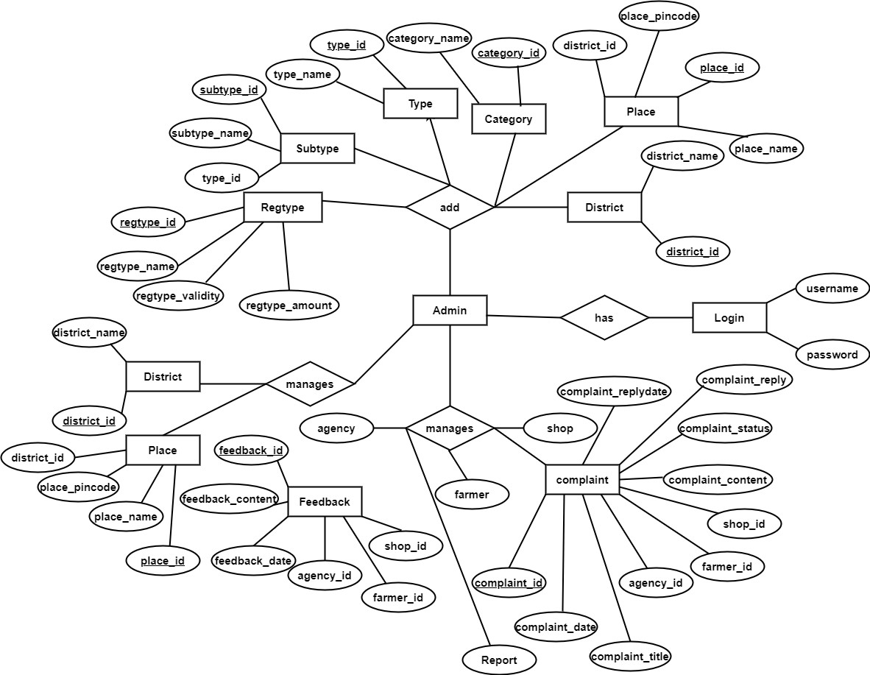

Fig 3.1 ER diagram for Admin

**AGENCY**

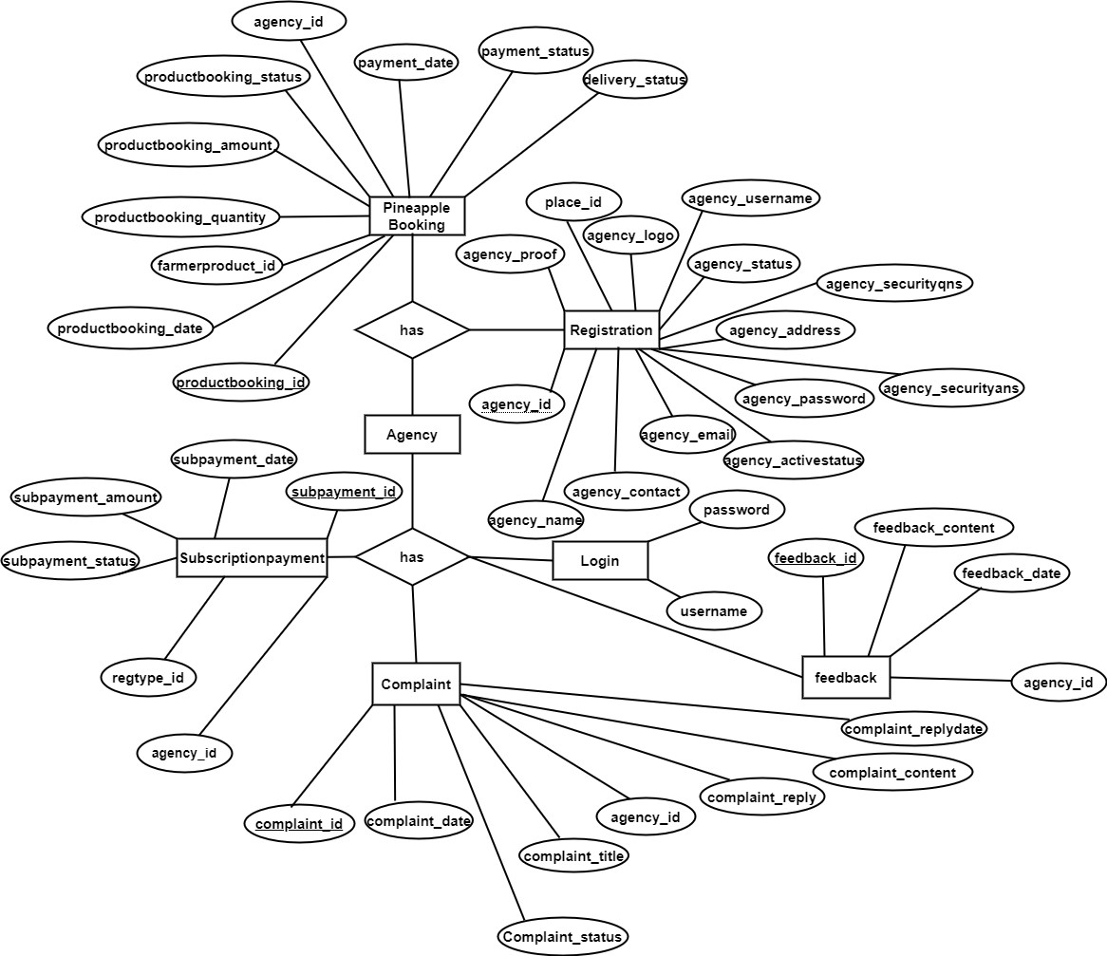

Fig 3.2 ER diagram for Agency

**FARMER**

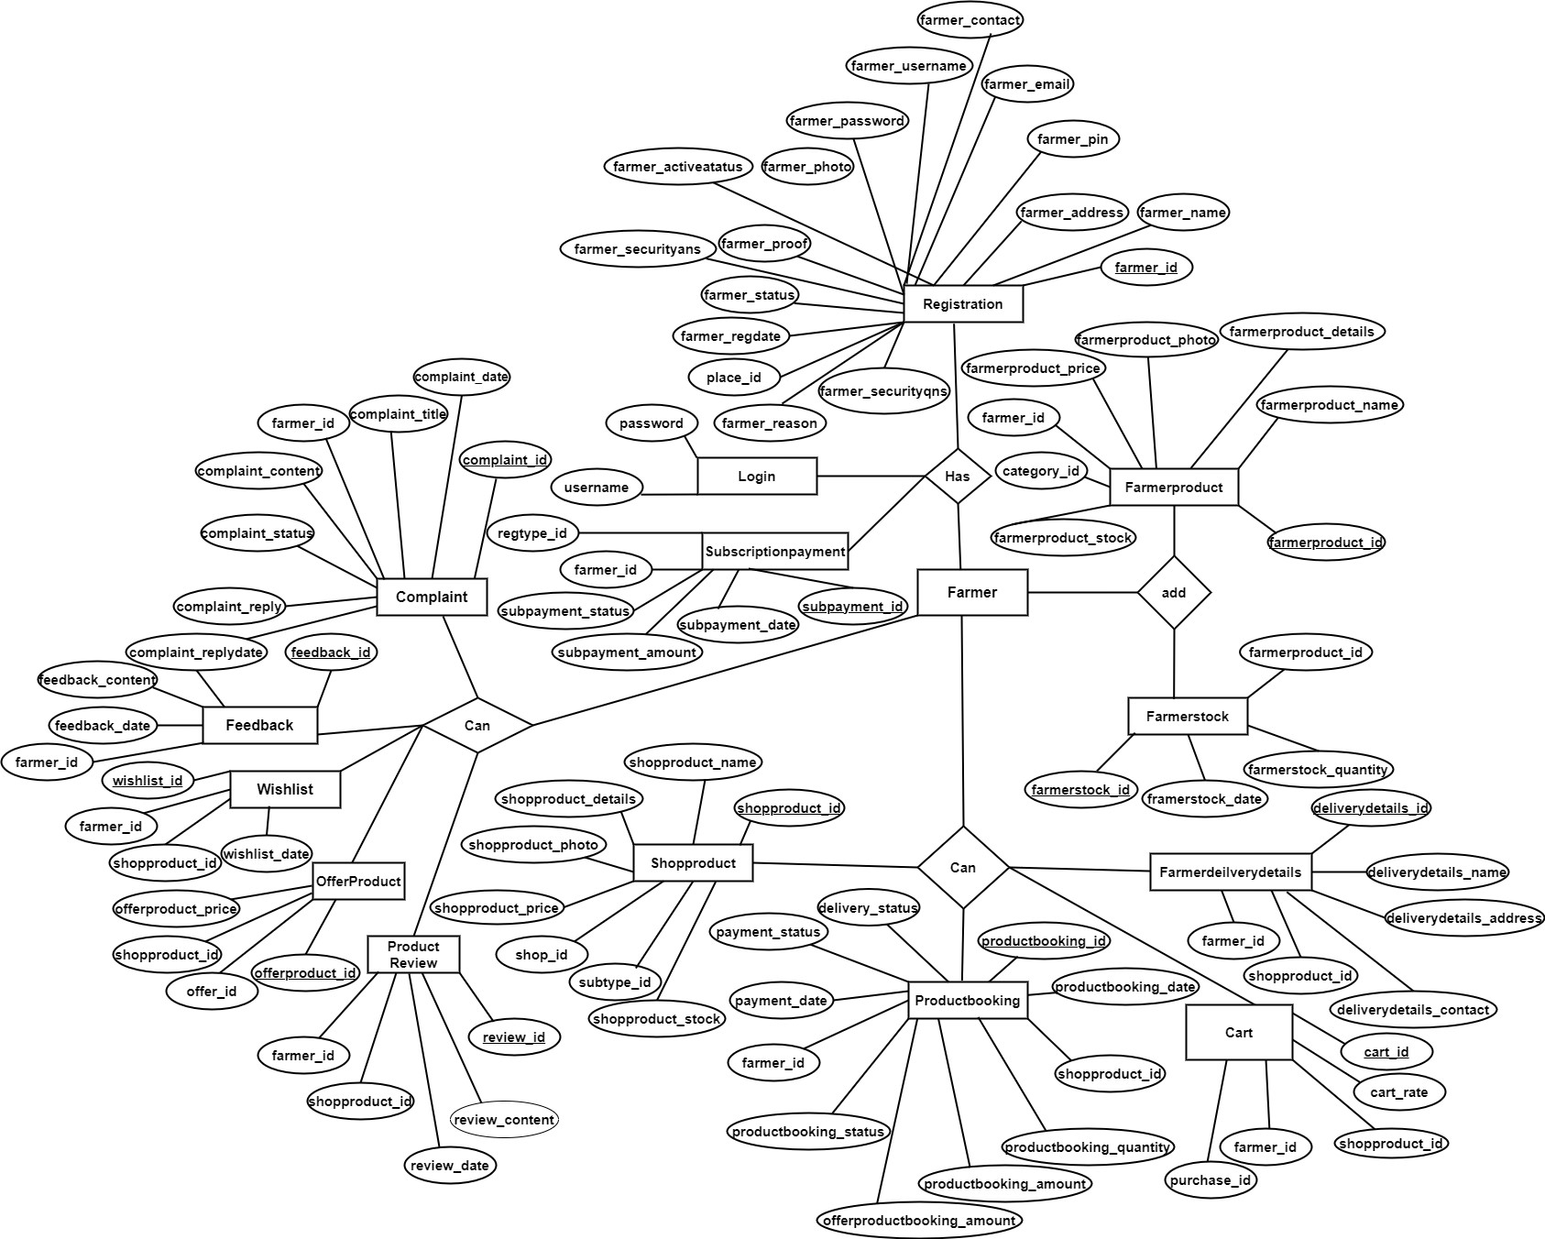

Fig 3.3 ER diagram for Farmer

**SHOP**

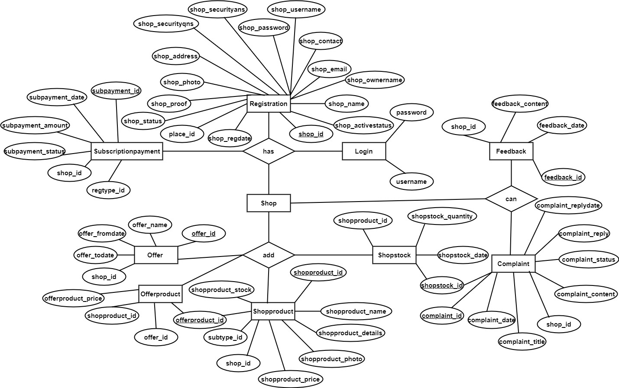

Fig 3.4 ER diagram for Shop

### **3.2.2 Table Structure**

Table is a collection of complete details about a particular subject. These data are saved in rows and Columns. Hence, rows are called RECORDS and Columns of each row are called FIELDS. Data is stored in tables, which is available in the backend.

The items and data, which are entered in the input, form id directly stored in this table using linking of database. We can link more than one table to input forms. We can collect the details from the different tables to display on the output.

There are 28 tables in project. They are,

* tbl_admin
* tbl_district
* tbl_place
* tbl_registrationtype
* tbl_agency
* tbl_shop
* tbl_farmer
* tbl_complaint
* tbl_shopproduct
* tbl_shopstock
* tbl_farmerproduct
* tbl_farmerstock
* tbl_category
* tbl_type
* tbl_subtype
* tbl_productreview
* tbl_agencydeliverydetails
* tbl_cart
* tbl_comment
* tbl_farmerdeliverydetails
* tbl_farmerproductbooking
* tbl_feedback
* tbl_offer
* tbl_offerproduct
* tbl_productbooking
* tbl_purchase
* tbl_subscriptionpayment
* tbl_wishlist

**Table No: 1**

**Table Name:** tbl_admin

**Description:** This table is used to store admin details.

**Primary Key:** admin_id

### **Foreign key:** Nil

Table 3.1 tbl_admin

|  |  |  |  |
| --- | --- | --- | --- |
| **SI.**  **No** | **FIELD NAME** | **DATA TYPE** | **DESCRIPTION** |
| 1. | admin_id | Int | Used as a primary key to uniquely identify column and it is an auto increment column |
| 2. | admin_name | Varchar(50) | This field for storing the adminname. |
| 3. | admin_email | varchar(50) | This field for storing the email. |
| 4. | admin_password | Varchar(50) | This field for storing the password. |

**Table No: 2**

**Table Name:** tbl_district

**Description:** This table is used to store district details.

**Primary Key:** district_id

**Foreign key:** Nil

Table 3.2 tbl_district

|  |  |  |  |
| --- | --- | --- | --- |
| **SI.**  **No** | **FIELD NAME** | **DATA TYPE** | **DESCRIPTION** |
| 1. | district_id | Int | Used as a primary key to uniquely identify column and it is an auto increment column |
| 2. | district_name | Varchar(50) | This field for storing the district name as string. |

**Table No: 3**

**Table Name:** tbl_place

**Description:** This table is used to store place details.

**Primary Key:** place_id

### **Foreign key:** district_id

Table 3.3 tbl_place

|  |  |  |  |
| --- | --- | --- | --- |
| **SI.**  **No** | **FIELD NAME** | **DATA TYPE** | **DESCRIPTION** |
| 1. | place_id | Int | Used as a primary key to uniquely identify column and it is an auto increment column |
| 2. | place_name | Varchar(50) | it is used to store the place name as string. |
| 3. | district_id | Int | This field is generating relation between place table and district table |

**Table No: 4**

**Table Name:** tbl_agency

**Description:** This table is used to store agency details.

**Primary Key:** agency_id

**Foreign key:**place_id

Table 3.4 tbl_agency

|  |  |  |  |
| --- | --- | --- | --- |
| **SI.**  **No** | **FIELD NAME** | **DATA TYPE** | **DESCRIPTION** |
| 1. | agency_id | Int | Used as a primary key to uniquely identify column and it is an auto increment column |
| 2. | agency_name | Varchar(50) | it is used to store the name of the agency. |
| 3. | agency_contact | Varchar(50) | it is used to store the contact number of agency . |
| 4. | agency_email | Varchar(50) | it is used to store the email of the agency. |
| 5. | agency_username | Varchar(50) | it is used to store the username of the agency. |
| 6. | agency_password | Varchar(50) | it is used to store the password of the agency. |
| 7. | agency_address | Varchar(50) | it is used to store the address of the agency. |
| 8. | agency_status | Int | it is used to store the status of the agency. |
| 9. | agency_photo | Varchar(50) | it is used to store the photo of the agency |
| 10. | agency_proof | Varchar(50) | it is used to store the proof of the agency |
| 11. | agency_pincode | Int | it is used to store the pincode of the place. |
| 12. | agency_regdate | Date | it is used to store the date of the agency registartion. |
| 13. | agency_activestatus | Int | it is used to store the active status of the account. |
| 14. | agency_reason | Varchar(50) | it is used to store the reason for deactivating the account. |
| 15. | agency_securityqns | Varchar(50) | it is used to store the security questions. |
| 16. | agency_securityans | Varchar(50) | it is used to store the security questions answers. |
| 17. | Place_id | Int | This field is generating relation between place table and agency table |

**Table No: 5**

**Table Name:** tbl_shop

**Description:** This table is used to store shop details.

**Primary Key:** shop_id

**Foreign key:**place_id Table 3.5 tbl_shop

|  |  |  |  |
| --- | --- | --- | --- |
| **SI.**  **No** | **FIELD NAME** | **DATA TYPE** | **DESCRIPTION** |
| 1. | shop_id | Int | Used as a primary key to uniquely identify column and it is an auto increment column |
| 2. | shop_name | Varchar(50) | it is used to store the name of the shop. |
| 3. | shop_ownername | Varchar(50) | it is used to store the name of the shopowner. |
| 4. | shop_contact | Varchar(50) | it is used to store the contact number of shop. |
| 5. | shop_email | Varchar(50) | it is used to store the email of the shop. |
| 6. | shop_username | Varchar(50) | it is used to store the username of the shop. |
| 7. | shop_password | Varchar(50) | it is used to store the password of the shop. |
| 8. | shop_address | Varchar(50) | it is used to store the address of the shop. |
| 9. | shop_status | Int | it is used to store the status of the shop. |
| 10. | shop_proof | Varchar(50) | it is used to store the proof of the shop. |
| 11. | shop_photo | Varchar(50) | it is used to store the photo of the shop. |
| 12. | shop_pincode | Varchar(50) | it is used to store the pincode of the place. |
| 13. | shop_regdate | Varchar(50) | it is used to store the date of the registartion. |
| 14. | shop_activestatus | Int | it is used to store the active status. |
| 15. | shop_reason | Varchar(50) | it is used to store the reason for deactivating the account. |
| 16. | shop_securityqns | Varchar(50) | it is used to store the security questions. |
| 17. | shop_securityans | Varchar(50) | it is used to store the security answers. |
| 18. | Place_id | Varchar(50) | This field is generating relation between place table and shop table |

**Table No: 6**

**Table Name:** tbl_farmer

**Description:** This table is used to store farmer details.

**Primary Key:** farmer_id

**Foreign key:**place_id

Table 3.6 tbl_farmer

|  |  |  |  |
| --- | --- | --- | --- |
| **SI.**  **No** | **FIELD NAME** | **DATA TYPE** | **DESCRIPTION** |
| 1. | farmer_id | Int | Used as a primary key to uniquely identify column and it is an auto increment column |
| 2. | farmer_name | Varchar(50) | it is used to store the name of the farmer. |
| 3. | farmer_contact | Varchar(50) | it is used to store the contact number of the farmer . |
| 4. | farmer_email | Varchar(50) | it is used to store the email of the farmer. |
| 5. | farmer_username | Varchar(50) | it is used to store the username of the farmer. |
| 6. | farmer_password | Varchar(50) | it is used to store the password of the farmer. |
| 7. | farmer_address | Varchar(50) | it is used to store the address of the farmer. |
| 8. | farmer_status | Int | it is used to store the status of the farmer. |
| 9. | farmer_photo | Varchar(50) | it is used to store the photo of the farmer. |
| 10. | farmer_proof | Varchar(50) | it is used to store the proof of the farmer. |
| 11. | farmer_pin | Int | it is used to store the pincode of the place. |
| 12. | farmer_regdate | Date | it is used to store the date of the registration. |
| 13. | farmer_activestatus | Int | it is used to store the active status of the account. |
| 14. | farmer_reason | Int | it is used to store the reason for deactivating the account. |
| 15. | farmer_securityqns | Varchar(50) | it is used to store the security questions. |
| 16. | farmer_securityans | Varchar(50) | it is used to store the security questions answers. |
| 17. | place_id | Int | This field is generating relation between place table and farmer table |

**Table No: 7**

**Table Name:** tbl_regtype

**Description:** This table is used to store registration type details.

**Primary Key:** regtype_id

**Foreign key:**Nil

Table 3.7 tbl_registrationtype

|  |  |  |  |
| --- | --- | --- | --- |
| **SI.**  **No** | **FIELD NAME** | **DATA TYPE** | **DESCRIPTION** |
| 1. | regtype_id | Int | Used as a primary key to uniquely identify column and it is an auto increment column |
| 2. | regtype_name | Varchar(50) | it is used to store the name of the registration type. |
| 3. | regtype_validity | Int | it is used to store the registration type validity . |
| 4. | regtype_amount | Int | it is used to store amount of the registration type. |

**Table No: 8**

**Table Name:** tbl_complaint

**Description:** This table is used to store complaint details.

**Primary Key:** complaint_id

**Foreign key:** shop_id, farmer_id ,agency_id

Table 3.8 tbl_complaint

|  |  |  |  |
| --- | --- | --- | --- |
| **SI.**  **No** | **FIELD NAME** | **DATA TYPE** | **DESCRIPTION** |
| 1. | complaint_id | Int | Used as a primary key to uniquely identify column and it is an auto increment column |
| 2. | complaint_title | Varchar(50) | it is used to store the title. |
| 3. | complaint_details | Varchar(50) | it is used to store the details. |
| 4. | complaint_status | Int | it is used to store the status of the complaint. |
| 5. | complaint_reply | Varchar(50) | it is used to store the reply of the complaint. |
| 6. | shop_id | Int | This field is generating relation between shop table and complaint table |
| 7. | agency_id | Int | This field is generating relation between agency table and complaint table |
| 8. | farmer_id | Int | This field is generating relation between farmer table and complaint table |
| 9. | complaint_date | Date | it is used to store the date. |
| 10 | complaint_replydate | Date | it is used to store the reply date of the complaint . |

**Table No: 9**

**Table Name:** tbl_shopproduct

**Description:** This table is used to store product details.

**Primary Key:** shopproduct_id

**Foreign key:** shop_id, subtype_id

Table 3.9 tbl_shopproduct

|  |  |  |  |
| --- | --- | --- | --- |
| **SI.**  **No** | **FIELD NAME** | **DATA TYPE** | **DESCRIPTION** |
| 1. | shopproduct_id | Int | Used as a primary key to uniquely identify column and it is an auto increment column |
| 2. | shopproduct_name | Varchar(50) | it is used to store the name of the product. |
| 3. | shopproduct_details | Varchar(50) | it is used to store the details of the product. |
| 4. | shopproduct_photo | Varchar(50) | it is used to store the photo of the product. |
| 5. | shopproduct_price | Int | it is used to store the price of the product. |
| 6. | shop_id | Int | This field is generating relation between shop table and shopproduct table |
| 7. | subtype_id | Int | This field is generating relation between subtype table and shopproduct table. |
| 8. | shopproduct_stock | Int | it is used to store the stock of the product. |

**Table No: 10**

**Table Name:** tbl_shopstock

**Description:** This table is used to store stock details.

**Primary Key:** shopstock_id

**Foreign key:** shopproduct_id

Table 3.10 tbl_shopstock

|  |  |  |  |
| --- | --- | --- | --- |
| **SI.**  **No** | **FIELD NAME** | **DATA TYPE** | **DESCRIPTION** |
| 1. | shopstock_id | Int | Used as a primary key to uniquely identify column and it is an auto increment column |
| 2. | shopstock_date | Date | it is used to store the stock date. |
| 3. | shopstock_quantity | Int | it is used to store the quantity of the stock. |
| 4. | shopproduct_id | Int | This field is generating relation between shopproduct table and shopstock table |

**Table No: 11**

**Table Name:** tbl_farmerproduct

**Description:** This table is used to store product details.

**Primary Key:** farmerproduct_id

**Foreign key:** farmer_id, category_id

Table 3.11 tbl_farmerproduct

|  |  |  |  |
| --- | --- | --- | --- |
| **SI.**  **No** | **FIELD NAME** | **DATA TYPE** | **DESCRIPTION** |
| 1. | farmerproduct_id | Int | Used as a primary key to uniquely identify column and it is an auto increment column |
| 2. | farmerproduct_name | Varchar(50) | it is used to store the name of the product. |
| 3. | farmerproduct_details | Varchar(50) | it is used to store the details of the product. |
| 4. | farmerproduct_photo | Varchar(50) | it is used to store the photo of the product. |
| 5. | framerproduct_price | Int | it is used to store the price of the product. |
| 6. | farmer_id | Int | This field is generating relation between farmer table and farmerproduct table |
| 7. | category_id | Int | This field is generating relation between category table and farmerproduct table. |
| 8. | farmerproduct_stock | Int | it is used to store the stock of the product. |

**Table No: 12**

**Table Name:** tbl_farmerstock

**Description:** This table is used to store stock details.

**Primary Key:** farmerstock_id

**Foreign key:** farmerproduct_id

Table 3.12 tbl_farmerstock

|  |  |  |  |
| --- | --- | --- | --- |
| **SI.**  **No** | **FIELD NAME** | **DATA TYPE** | **DESCRIPTION** |
| 1. | farmerstock_id | Int | Used as a primary key to uniquely identify column and it is an auto increment column |
| 2. | farmerstock_date | Date | it is used to store the stock date. |
| 3. | farmerstock_quantity | Int | it is used to store the quantity of the stock. |
| 4. | farmerproduct_id | Int | This field is generating relation between farmerproduct table and farmerstock table |

**Table No: 13**

**Table Name:** tbl_category

**Description:** This table is used to store category of the product.

**Primary Key:** category_id

**Foreign key:** Nil

Table 3.13 tbl_category

|  |  |  |  |
| --- | --- | --- | --- |
| **SI.**  **No** | **FIELD NAME** | **DATA TYPE** | **DESCRIPTION** |
| 1. | category_id | Int | Used as a primary key to uniquely identify column and it is an auto increment column |
| 2. | category_name | Varchar(50) | it is used to store the name of the category. |

**Table No: 14**

**Table Name:** tbl_farmerproductboooking

**Description:** This table is used to store booking details of the product.

**Primary Key:** productbooking_id

**Foreign key:** agency_id, farmerproduct_id

Table 3.14 tbl_farmerproductbooking

|  |  |  |  |
| --- | --- | --- | --- |
| **SI.**  **No** | **FIELD NAME** | **DATA TYPE** | **DESCRIPTION** |
| 1. | productbooking_id | Int | Used as a primary key to uniquely identify column and it is an auto increment column |
| 2. | productbooking_date | Date | it is used to store the date. |
| 3. | farmerproduct_id | Int | This field is generating relation between farmerproductbooking table and farmerproduct table |
| 4. | productbooking_quantity | Int | it is used to store the required quantity. |
| 5. | productbooking_amount | Int | it is used to store the amount of the product booked. |
| 6. | productbooking_status | Int | it is used to store the status of the booking product. |
| 7. | agency_id | Int | This field is generating relation between farmerproductbooking table and agency table |
| 8. | payment_date | Int | it is used to store the payment date of the product. |
| 9. | payment_status | Int | it is used to store the payment status. |  |
| 10. | delivery_status | Int | it is used to store the delivery status of the product. |

**Table No: 15**

**Table Name:** tbl_type

**Description:** This table is used to store type of the product.

**Primary Key:** type_id

**Foreign key:** Nill

Table 3.15 tbl_type

|  |  |  |  |
| --- | --- | --- | --- |
| **SI.**  **No** | **FIELD NAME** | **DATA TYPE** | **DESCRIPTION** |
| 1. | type_id | Int | Used as a primary key to uniquely identify column and it is an auto increment column |
| 2. | type_name | Varchar(50) | it is used to store the name of the type. |

**Table No: 16**

**Table Name:** tbl_subtype

**Description:** This table is used to store subtype of the product.

**Primary Key:** subtype_id

**Foreign key:** type_id Table 3.16 tbl_subtype

|  |  |  |  |
| --- | --- | --- | --- |
| **SI.**  **No** | **FIELD NAME** | **DATA TYPE** | **DESCRIPTION** |
| 1. | subtype_id | Int | Used as a primary key to uniquely identify column and it is an auto increment column |
| 2. | subtype_name | Varchar(50) | it is used to store the name of the subtype. |
| 3. | type_id | Int | This field is generating relation between type table and subtype table |

**Table No: 17**

**Table Name:** tbl_productboooking

**Description:** This table is used to store booking details of the product.

**Primary Key:** productbooking_id

**Foreign key:**farmer_id, shopproduct_id

Table 3.17 tbl_productbooking

|  |  |  |  |
| --- | --- | --- | --- |
| **SI.**  **No** | **FIELD NAME** | **DATA TYPE** | **DESCRIPTION** |
| 1. | productbooking_id | Int | Used as a primary key to uniquely identify column and it is an auto increment column |
| 2. | productbooking_date | date | it is used to store the date of the product booking. |
| 3. | shopproduct_id | Int | This field is generating relation between shopproduct table and productbooking table |
| 4. | productbooking_quantity | Int | it is used to store the required quantity of the product. |
| 5. | productbooking_amount | Int | it is used to store the amount of the product booked. |
| 6. | offerproductbooking_amount | Int | it is used to store the amount of the offer product booked. |
| 7. | productbooking_status | Int | it is used to store the booking status of the product. |
| 8. | farmer_id | Int | This field is generating relation between farmertable and productbooking table |
| 9. | payment_date | Date | it is used to store the payment date of the product. |
| 10. | payment_status | Int | it is used to store the payment status of the product. |
| 11. | delivery_status | Int | it is used to store the delivery status of the product. |

**Table No: 18**

**Table Name:** tbl_agencydeliverydetails

**Description:** This table is used to store delivery details of the agency.

**Primary Key:** deliverydetails_id

**Foreign key:** agency_id,farmerproduct_id

Table 3.18 tbl_agencydeliverydetails

|  |  |  |  |
| --- | --- | --- | --- |
| **SI.**  **No** | **FIELD NAME** | **DATA TYPE** | **DESCRIPTION** |
| 1. | deliverydetails_id | Int | Used as a primary key to uniquely identify column and it is an auto increment column |
| 2. | deliverydetails_name | Varchar(50) | it is used to store the name of the agency to which the product is to be delivered. |
| 3. | deliverydetails_address | Varchar(50) | it is used to store the address of the agency to which the product is to be delivered. |
| 4. | deliverydetails_contact | Int | it is used to store the contact number of the agency to which the product is to be delivered. |
| 5. | farmerproduct_id | Int | This field is generating relation between agencytable and agencydeliverydetails table |

**Table No: 19**

**Table Name:** tbl_cart

**Description:** This table is used to store cart details of the product.

**Primary Key:** cart_id

**Foreign key:** shopproduct_id, farmer_id, purchase_id

Table 3.19 tbl_cart

|  |  |  |  |
| --- | --- | --- | --- |
| **SI.**  **No** | **FIELD NAME** | **DATA TYPE** | **DESCRIPTION** |
| 1. | cart_id | Int | Used as a primary key to uniquely identify column and it is an auto increment column |
| 2. | cart_qty | Int | it is used to store the quantity of product in the cart. |
| 3. | cart_rate | Int | it is used to store the amount of the cart product. |
| 4. | cart_date | Date | it is used to store the cart date. |
| 5. | cart_subtotal | Bigint | it is used to store the total amount of the cart products. |
| 6. | cart_status | Int | it is used to store the cart status of the product. |
| 7. | shopproduct_id | Int | This field is generating relation between carttable and shopproduct table |
| 8. | farmer_id | Int | This field is generating relation between carttable and farmer table |
| 9. | purchase_id | Int | This field is generating relation between carttable and purchase table |

**Table No: 20**

**Table Name:** tbl_comment

**Description:** This table is used to store comments of the product.

**Primary Key:** comment_id

**Foreign key:** farmer_id, shopproduct_id

Table 3.20 tbl_comment

|  |  |  |  |
| --- | --- | --- | --- |
| **SI.**  **No** | **FIELD NAME** | **DATA TYPE** | **DESCRIPTION** |
| 1. | comment_id | Int | Used as a primary key to uniquely identify column and it is an auto increment column |
| 2. | comment_description | Varchar(50) | it is used to store the content of the comment. |
| 3. | shopproduct_id | Int | This field is generating relation between comment table and shopproduct table. |
| 4. | farmer_id | Int | This field is generating relation between comment table and farmer table. |
| 5. | comment_date | Date | it is used to store the date of the comment. |
| 6. | comment_status | Int | it is used to store the status of the comment. |

**Table No: 21**

**Table Name:** tbl_productreview

**Description:** This table is used to store review of the product.

**Primary Key:** review_id

**Foreign key:**agency_id,farmer_id,shopproduct_id

Table 3.21 tbl_productreview

|  |  |  |  |
| --- | --- | --- | --- |
| **SI.**  **No** | **FIELD NAME** | **DATA TYPE** | **DESCRIPTION** |
| 1. | review_id | Int | Used as a primary key to uniquely identify column and it is an auto increment column |
| 2. | review_date | Date | it is used to store the review date. |
| 3. | review_content | Varchar(50) | it is used to store the content of the review. |
| 4. | shopproduct_id | Int | This field is generating relation between productreview table and shopproduct table |
| 5. | farmer_id | Int | This field is generating relation between productreview table and farmer table |

**Table No: 22**

**Table Name:** tbl_feedback

**Description:** This table is used to store feedback of the users.

**Primary Key:** feedback_id

**Foreign key:**agency_id,farmer_id,shop_id

Table 3.22 tbl_feedback

|  |  |  |  |
| --- | --- | --- | --- |
| **SI.**  **No** | **FIELD NAME** | **DATA TYPE** | **DESCRIPTION** |
| 1. | feedback_id | Int | Used as a primary key to uniquely identify column and it is an auto increment column. |
| 2. | feedback_date | Date | it is used to store the feedback date. |
| 3. | feedback_content | Varchar(50) | it is used to store the content of the feedback. |
| 4. | shop_id | Int | This field is generating relation between feedback table and shop table. |
| 5. | farmer_id | Int | This field is generating relation between feedback table and farmer table. |
| 6. | agency_id | Int | This field is generating relation between feedback table and agency table. |

**Table No: 23**

**Table Name:** tbl_offer

**Description:** This table is used to store details of the offers.

**Primary Key:** offer_id

**Foreign key:**shop_id

Table 3.23 tbl_offer

|  |  |  |  |
| --- | --- | --- | --- |
| **SI.**  **No** | **FIELD NAME** | **DATA TYPE** | **DESCRIPTION** |
| 1. | offer_id | Int | Used as a primary key to uniquely identify column and it is an auto increment column. |
| 2. | offer_fromdate | Date | it is used to store the offer from date. |
| 3. | offer_todate | Date | it is used to store the offer to date. |
| 4. | shop_id | Int | This field is generating relation between offer table and shop table. |
| 5. | offer_name | Varchar(50) | it is used to store the name of the offers. |

**Table No: 24**

**Table Name:** tbl_offerproduct

**Description:** This table is used to store details of the offerproduct.

**Primary Key:** offerproduct_id

**Foreign key:** shopproduct_id

Table 3.24 tbl_offerproduct

|  |  |  |  |
| --- | --- | --- | --- |
| **SI.**  **No** | **FIELD NAME** | **DATA TYPE** | **DESCRIPTION** |
| 1. | offerproduct_id | Int | Used as a primary key to uniquely identify column and it is an auto increment column. |
| 2. | shopproduct_id | Int | This field is generating relation between shop product table and offer product table. |
| 3. | offerproduct_price | Int | it is used to store the price of the offer product. |
| 4. | offer_id | Int | This field is generating relation between offer table and offer product table. |

**Table No: 25**

**Table Name:** tbl_purchase

**Description:** This table is used to store purchase details of the shopproduct.

**Primary Key:** purchase_id

**Foreign key:** farmer_id

Table 3.25 tbl_purchase

|  |  |  |  |
| --- | --- | --- | --- |
| **SI.**  **No** | **FIELD NAME** | **DATA TYPE** | **DESCRIPTION** |
| 1. | purchase_id | Int | Used as a primary key to uniquely identify column and it is an auto increment column. |
| 2. | purchase_total | Bigint | it is used to store the total amount of all products. |
| 3. | purchase_date | Int | it is used to store the purchase date of the product. |
| 4. | purchase_status | Int | it is used to store the purchase status of the product. |
| 5. | farmer_id | Int | This field is generating relation between purchase table and farmer table. |

**Table No: 26**

**Table Name:** tbl_farmerdeliverydetails

**Description:** This table is used to store delivery details of the farmer.

**Primary Key:** deliverydetails_id

**Foreign key:** farmer_id, shopproduct_id.

Table 3.26 tbl_farmerdeliverydetails

|  |  |  |  |
| --- | --- | --- | --- |
| **SI.**  **No** | **FIELD NAME** | **DATA TYPE** | **DESCRIPTION** |
| 1. | deliverydetails_id | Int | Used as a primary key to uniquely identify column and it is an auto increment column. |
| 2. | deliverydetails_name | Varchar(50) | it is used to store the name of the farmer to which the product is to be delivered. |
| 3. | deliverydetails_address | Varchar(50) | it is used to store the address of the farmer to which the product is to be delivered. |
| 4. | deliverydetails_contact | Int | it is used to store the contact number of the farmer to which the product is to be delivered. |
| 5. | shopproduct_id | Int | This field is generating relation between farmer delivery details table and shop product table. |
| 6. | farmer_id | Int | This field is generating relationship between farmer delivery details and farmer table. |

**Table No: 27**

**Table Name:** tbl_subscriptionpayment

**Description:** This table is used to store subscription payment details of the users.

**Primary Key:** subpayment_id

**Foreign key:** farmer_id, agency_id,shop_id,regtype_id

Table 3.27 tbl_subscriptionpayment

|  |  |  |  |
| --- | --- | --- | --- |
| **SI.**  **No** | **FIELD NAME** | **DATA TYPE** | **DESCRIPTION** |
| 1. | subpayment_id | Int | Used as a primary key to uniquely identify column and it is an auto increment column. |
| 2. | subpayment_date | Date | it is used to store the subscription payment date. |
| 3. | subpayment_amount | Int | it is used to store the amount of subscription. |
| 4. | subpayment_status | Int | it is used to store the status of the subscription payment. |
| 5. | agency_id | Int | This field is generating relation between subscription payment table and agency table. |
| 6. | farmer_id | Int | This field is generating relation between subscription payment table and farmer table. |
| 7. | shop_id | Int | This field is generating relation between subscription payment table and shop table. |
| 8. | regtype_id | Int | This field is generating relation between subscription payment table and regtype table. |

**Table No: 28**

**Table Name:** tbl_wishlist

**Description:** This table is used to store wishlist details of the shopproduct.

**Primary Key:** wishlist_id

**Foreign key:** farmer_id, shopproduct_id

Table 3.28 tbl_wishlist

|  |  |  |  |
| --- | --- | --- | --- |
| **SI.**  **No** | **FIELD NAME** | **DATA TYPE** | **DESCRIPTION** |
| 1. | wishlist_id | Int | Used as a primary key to uniquely identify column and it is an auto increment column. |
| 2. | wishlist_date | Date | it is used to store the date at which product is added to the wishlist. |
| 3. | farmer_id | Int | This field is generating relation between wishlist table and farmer table. |
| 4. | shopproduct_id | Int | This field is generating relation between wishlist table and shopproduct table. |

## 3.3 OBJECT ORIENTED DESIGN – UML DIAGRAMS

3**.3.1 Use Case Diagram**

The following shows the overall use case diagram of Pineapple Farm Management System:

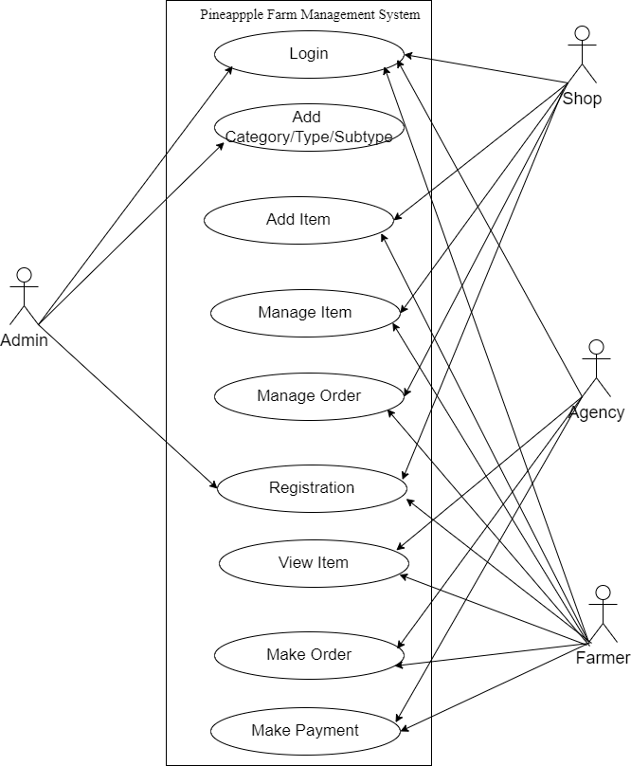

Fig 3.5 Use case Diagram for Pineapple Farm Management System

### **3.3.2 Activity Diagram**

Activity Diagrams describe how activities are coordinated to provide a service that can be at different levels of abstraction. Typically, an event needs to be achieved by some operations, particularly where the operation is intended to achieve a number of different things that require coordination, or how the events in a single-use case relate to one another, in particular, use cases where activities may overlap and require coordination. It is also suitable for modelling a collection of use cases coordinates to represent business workflows.

**Activity diagram of an Admin:**

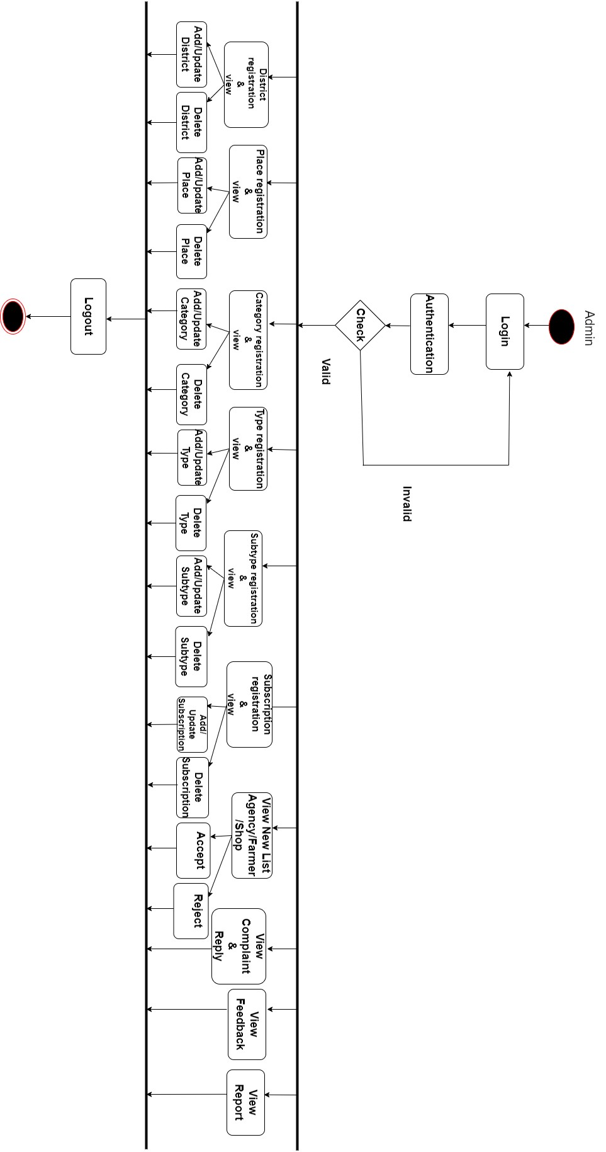

Fig 3.6 Activity Diagram for Admin

**Activity diagram of Agency: -**

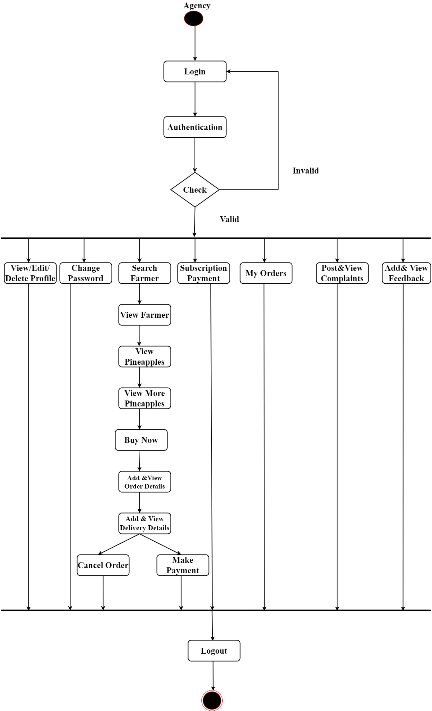

Fig 3.7 Activity Diagram for Agency

**Activity diagram of Farmer: -**

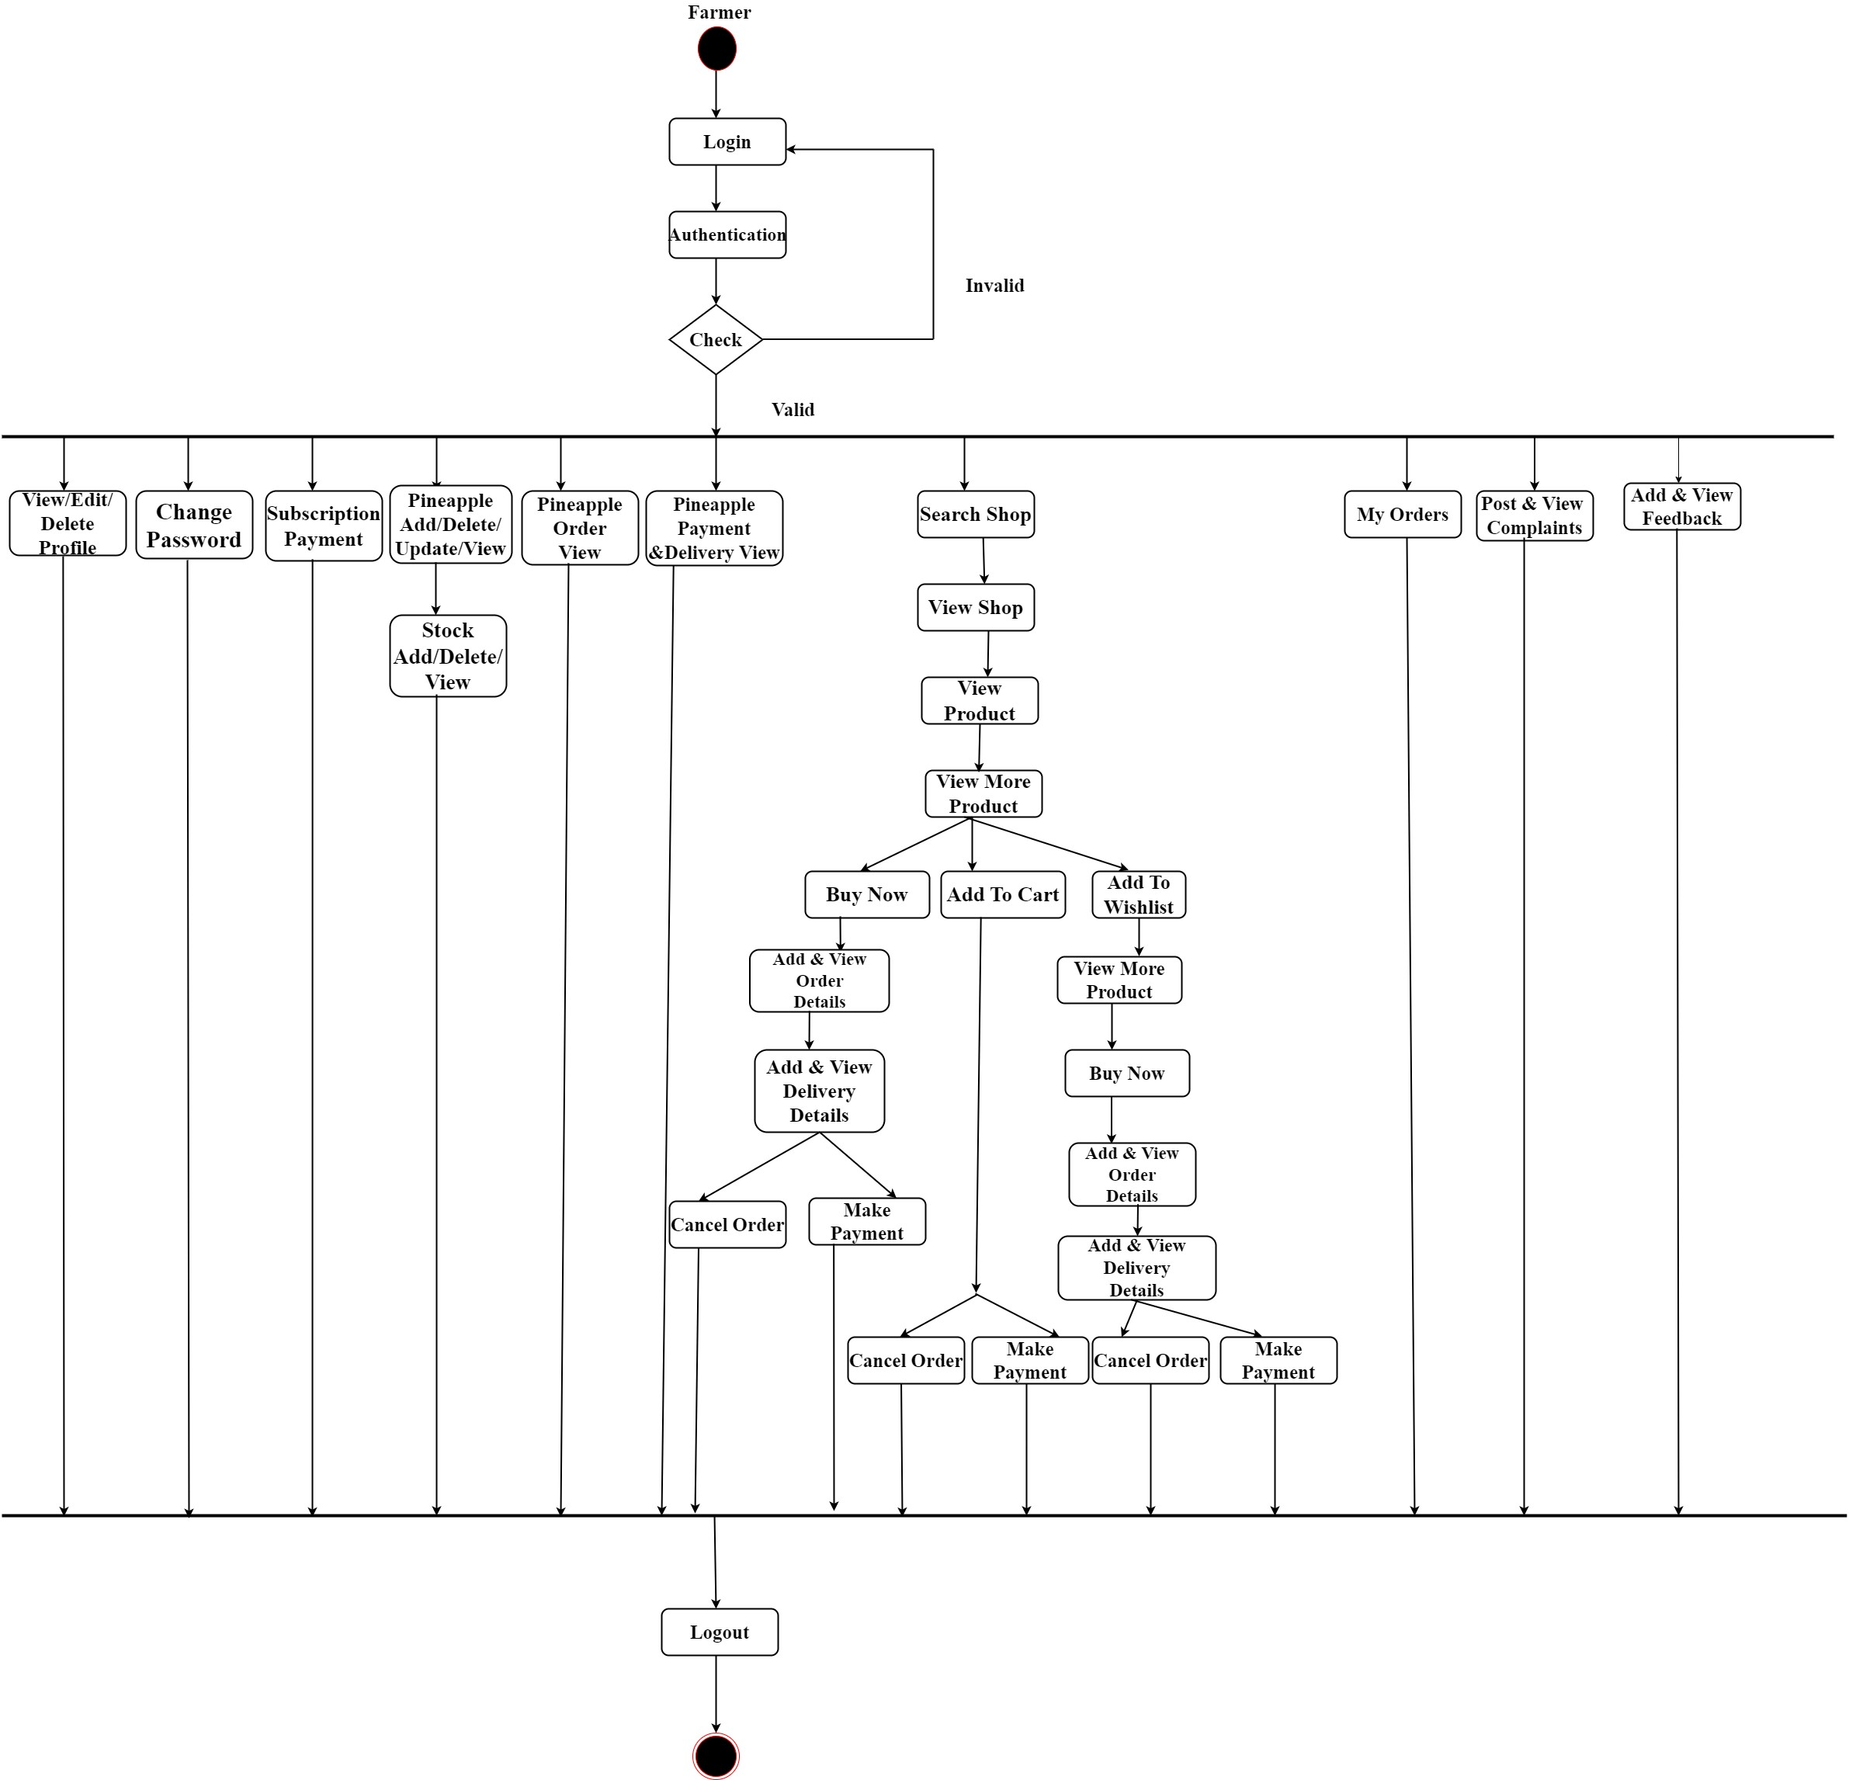

Fig 3.8 Activity Diagram for Farmer

**Activity diagram of Shop: -**

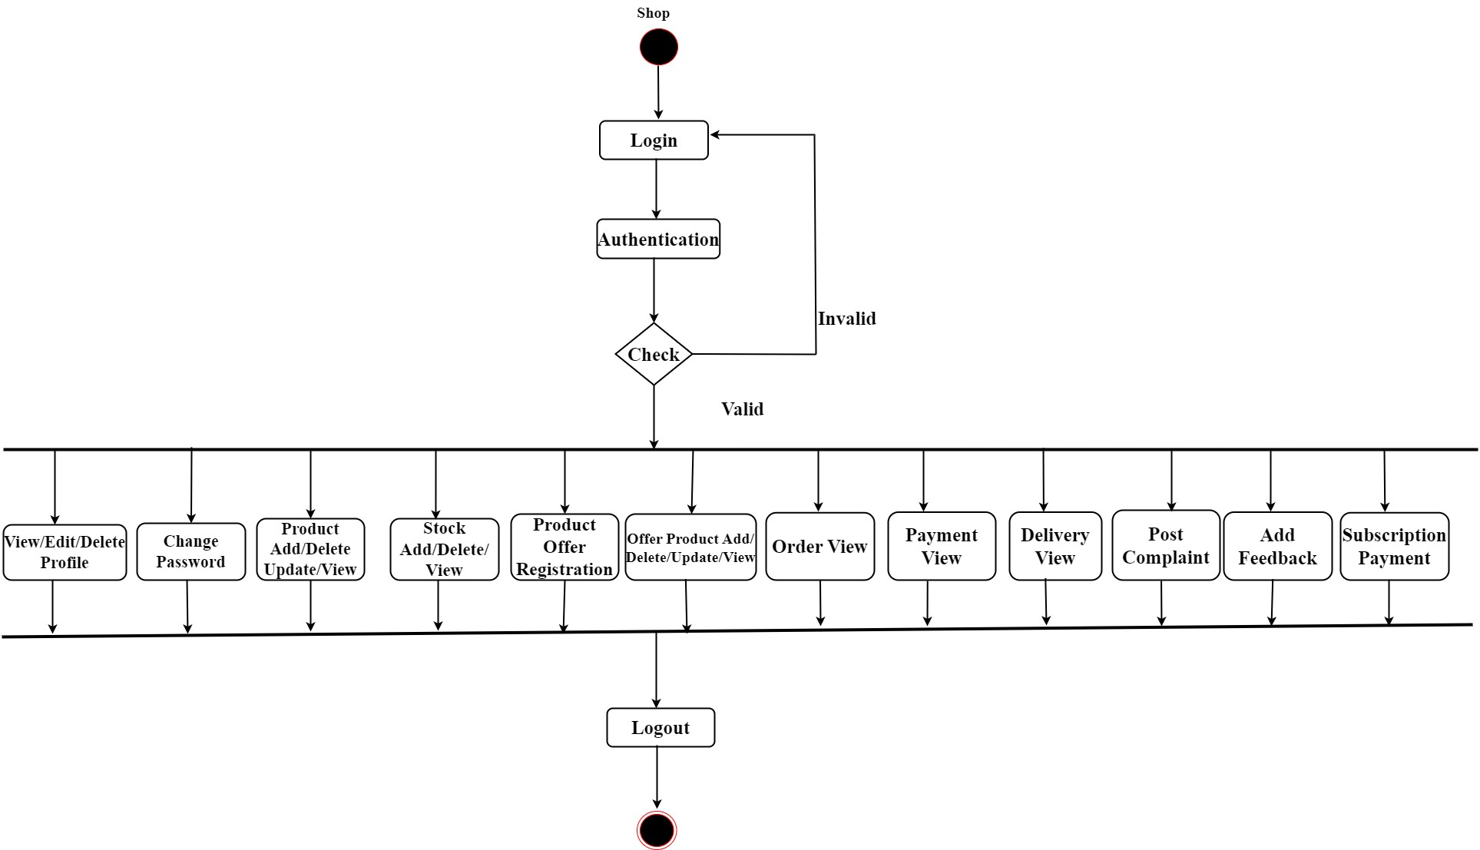

Fig 3.9Activity Diagram for Shop

### **3.3.3 Sequence Diagram**

Sequence diagrams, commonly used by developers, model the interactions between objects in a single-use case. They illustrate how the different parts of a system interact with each other to carry out a function, and the order in which the interactions occur when a particular use case is executed. In simpler words, a sequence diagram shows different parts of a system working in a ‘sequence’ to get something done. The following nodes and edges are typically drawn in a UML sequence diagram: lifeline, execution specification, message, combined fragment, interaction use, state invariant, continuation, and destruction occurrence. Major elements of the sequence diagram are shown below:

**Sequence diagram of the Admin:**

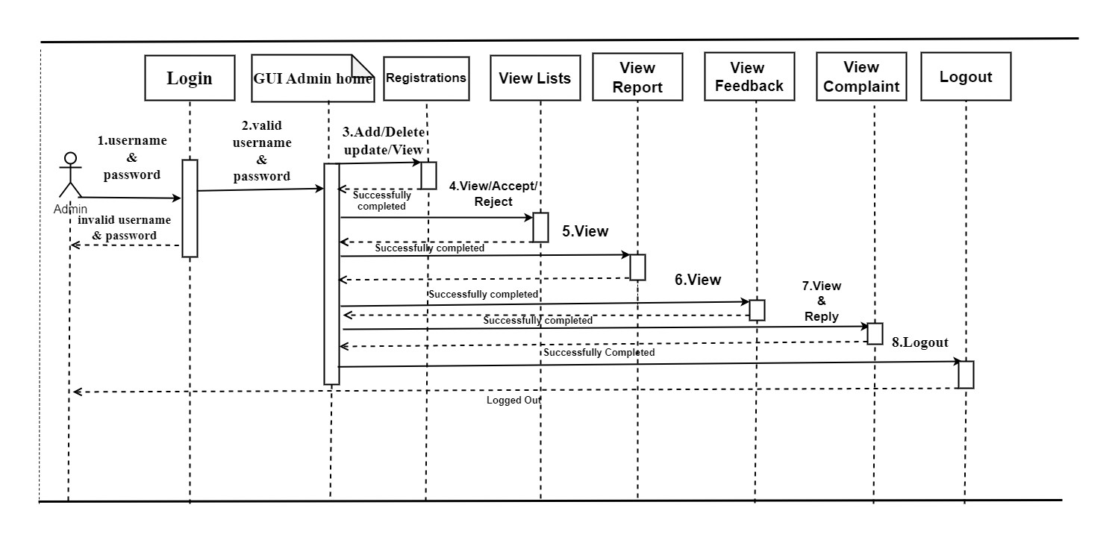

Fig 3.10 Sequence Diagram for Admin

**Sequence diagram of the Agency:**

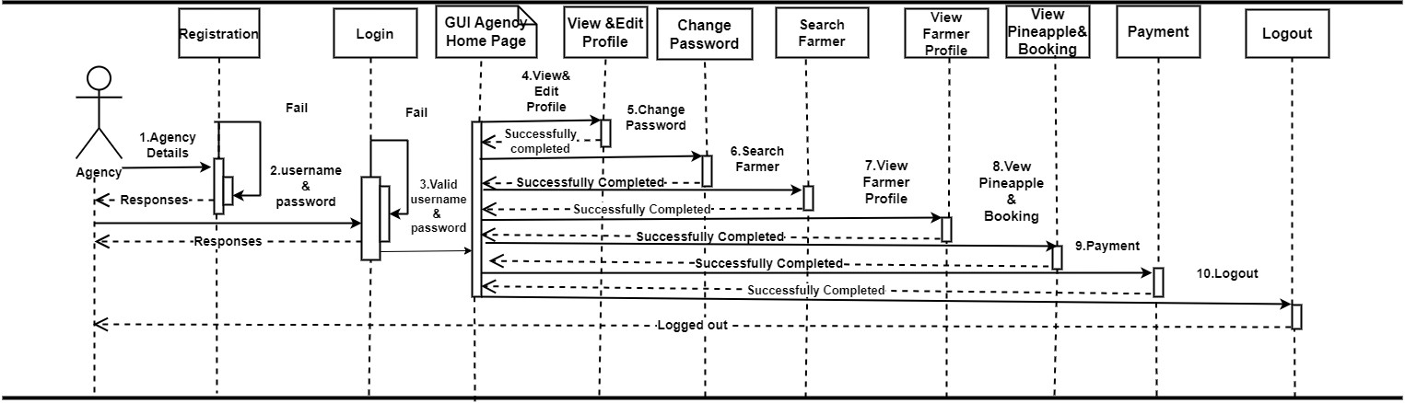

Fig 3.11 Sequence Diagram for Agency

**Sequence diagram of the Farmer:**

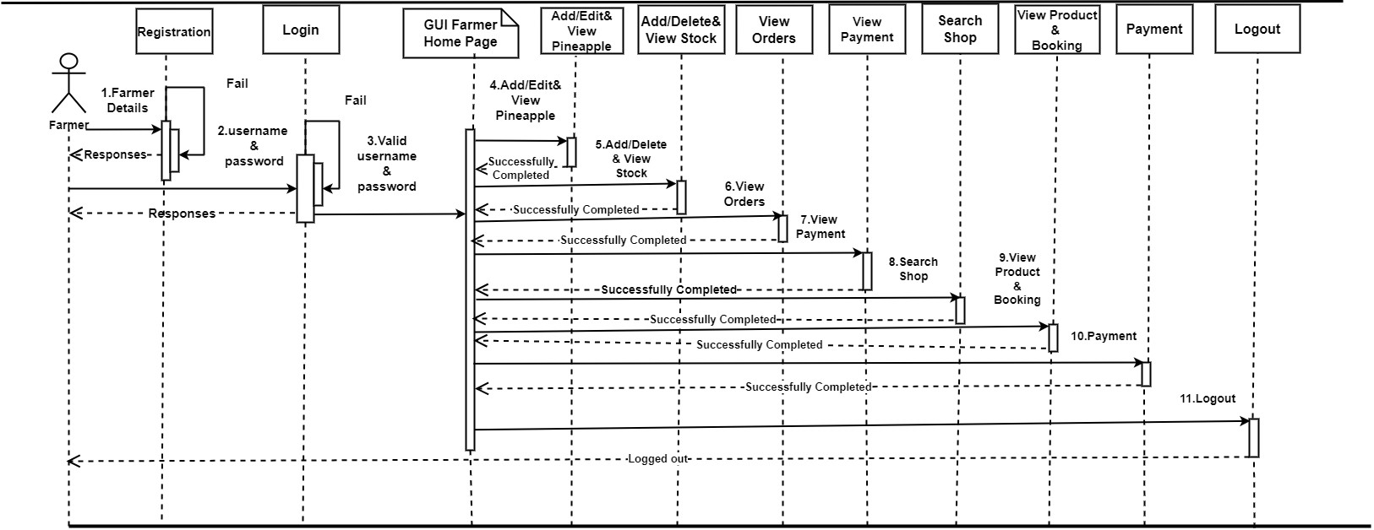

Fig 3.12 Sequence Diagram for Farmer

**Sequence diagram of the Shop:**

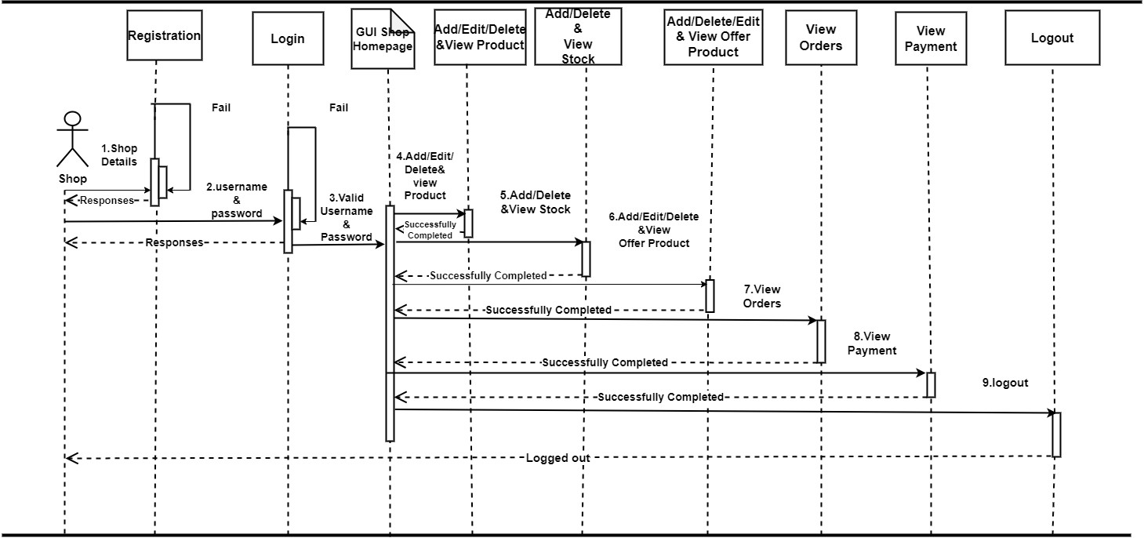

Fig 3.13 Sequence Diagram for Shop

**3.4 MODULAR DESIGN**

Any software comprises of many systems which contains several sub-systems, and those subsystems further contains their sub-systems. So, designing a complete system in one go comprising of each and every required functionality is a hectic work, and the process can have many errors because of its vast size. Thus, in order to solve this problem, the developing team breakdown the complete software into various modules. A module is defined as the unique and addressable components of the software which can be solved and modified independently without disturbing (or affecting in very small amount) other modules of the software. Thus, every software design should follow modularity. The process of breaking down a software into multiple independent modules where each module is developed separately is called Modularization. Effective modular design can be achieved if the partitioned modules are separately solvable, modifiable as well as compliable. Here separate compliable modules means that after making changes in a module there is no need of recompiling the whole software system.

**3.4.1 Modules Description**

**Registration**

This module handles the process of Admin and User registrations. It allows user to create accounts within the system by providing necessary information like name, email, contact details, and possibly additional details depending on the system's requirements.

**Authentication**

Responsible for user authentication and session management. It ensures that only registered and authorized users can access the system functionalities.

**Sales**

Manages the sales-related activities within the system.

**Booking**

Manages the process of booking resources, within the system.

**Payment**

Handles payment processing for products and Pineapple offered within the system.

**Report**

Provides functionalities to generate and view various reports based on system data.

## 3.5 INPUT DESIGN

The user interface design is very important for any application. The interface design describes how the software communicates within itself, to the system that is interpreted with it and with humans who use it. The input design is the process of converting the user-oriented inputs into the computer-based format. The data is fed into the system using simple inactive forms. The forms have been supplied with messages so that the user can enter data without facing any difficulty. The data are validated wherever requires in the project. This ensures that only the correct data have been incorporated into the system. The goal of designing input data is to make automation as easy and free from errors as possible. For providing a good input design for the application easy data input and selection features are adopted. The input design requirements such as user-friendliness, consistent format, and interactive dialogue for giving the right messages and help for the user at right are also considered for development for this project. Input Design is a part of the overall design. The input methods can be broadly classified into batch and online. Internal controls must be established for monitoring the number of inputs and for ensuring that the data are valid. The basic steps involved in input design are:

* Review input requirements.
* Decide how the input data flow will be implemented.
* Decide on the source document.
* Prototype on line input screens.
* Design the input screens.

The quality of the system input determines the quality of the system output. Input specifications describe the manner in which data enter the system for processing. Input design features can ensure the reliability of the system and produce results from accurate data. The input design also determines whether the user can interact efficiently with the system. In this system several forms are used as input screens for collecting data from the users. Forms contain textbox, dropdown, button etc. For entering values text box is used. For single selection dropdown, dropdown is used. For multiple selections, multiple dropdowns are used. Validation checking is done for all mandatory fields. Already Exist Validation is also provided in some forms to avoid repeated entries. If an attempt to re enter same values, an error message will be displayed.

## 3.6 OUTPUT DESIGN

Quality output is one, which meets the requirements of the end-user and presents the information clearly. In any system results of processing are communicated to the user and to the other system through outputs. In the output design, it is determined how the information is to be displayed for immediate need. It is the most important and direct source of information is to the user. Efficient and intelligent output design improves the system’s relationships with the user and helps in decision-making. The objective of the output design is to convey the information of all the past activities, current status and to emphasize important events. The output generally refers to the results and information that is generated from the system. Outputs from computers are required primarily to communicate the results of processing to the users. Output also provides a means of storage by copying the results for later reference in consultation. There is a chance that some of the end-users will not actually operate the input data or information through workstations, but will see the output from the system.

Two phases of the output design are:

1. Output Definition
2. Output Specification

Output Definition takes into account the type of output contents, its frequency, and its volume, the appropriate output media is determined for output. Once the media is chosen, the detailed specification of output documents is carried out. The nature of output required from the proposed system is determined during the logical design stage. It takes the outline of the output from the logical design and produces output as specified during the logical design phase.

In a project, when designing the output, the system analyst must accomplish the following:

* Determine the information to present.
* Decide whether to display, print, speak the information and select the output medium.
* Arrange the information in acceptable format.
* Decide how to distribute the output to the intended receipt.

Thus, by following the above specifications, a high-quality output can be generated. In this system, an output or response is given to the user after submission of each form. Output screens are well designed. In most of the form’s tables are used to display the output information to the user. Reports values are displayed in a table format.

# **CHAPTER 4 SYSTEM ENVIRONMENT**

## 4.1 INTRODUCTION

A software development environment (SDE) is the collection of hardware and software tools a system developer uses to build software systems. When you are developing software, you probably don’t want your users to see every messy part of your application creation process. In order to make sure you control what people see and when they have access to it, development teams use environments to create “stages” of the app which they consider good for releasing. Each environment has its own unique purpose. There are different standards of environments that are used in the industry, although almost every process starts at the ‘development’ stage and ends with ‘production’. Different organizations all have their own purposes and policies which dictate when and how each environment is used.

## 4.2 SOFTWARE REQUIREMENT SPECIFICATION

In Pineapple Farm Management System, there are 4 main Stakeholders. They are:

1. Administrator

2.Agency

3.Farmer

4.Shop

**Stakeholder: Admin**

* The proposed site should provide the provision for login by the owner with username and password.
* The proposed system Admin should have the provision for add ,update and delete district, place, category, subcategory, type subtype, subscription.
* The site should have a home page for Owner, with the options to view the agency new list, agency accepted list and agency rejected list.
* The site should have a home page for Owner, with the options to view the farmer new list, farmer accepted list and farmer rejected list.
* The site should have a home page for Owner, with the options to view the shop new list, shop accepted list and shop rejected list.
* The site should have a home page for Owner, with the options to view the complaints and give reply to the complaints.
* The site should have a home page for Owner, with the options to view the subscription payments paid by the agency, farmer and shop.
* The site should have a home page for Owner, with the options to view the feedbacks done by the agency, farmer and shop.
* The site should have a home page for Owner, with the options to send email confirmations for accepted agency, farmer and shop.
* The site should have a home page for Owner, with the options to generate various report.
* The site should have a home page for Owner, with the options to logout.

### **Stakeholder: Agency**

* The site should provide a registration for agency.
* The proposed site should provide the provision for login with username and password.
* The site should provide facility to view and edit the profile.
* The site should provide facility to change the password.
* The site should provide facility to buy pineapples from farmers .
* The site should provide facility to post complaint.
* The site should provide facility to view the complaint.
* The site should provide facility to view the reply of the complaint.
* The site should provide facility for subscription.
* The site should provide facility to create new password .
* The site should provide facility to add and view feedbacks .
* The site should provide facility to make payments .
* The site should provide facility to delete the account .
* The site should provide facility to logout .

### **Stakeholder: Farmer**

* The site should provide a registration for farmer.
* The proposed site should provide the provision for login with username and password.
* The site should provide facility to view and edit the profile.
* The site should provide facility to change the password.
* The site should provide facility to sale their pineapples to different agency.
* The site should provide facility to buy tools & fertilizers from different shop.
* The site should provide facility to review the products that they buy.
* The site should provide facility to view the review of the products.
* The site should provide facility to add and view feedbacks.
* The site should provide facility to add comments about products.
* The site should provide facility to post complaint.
* The site should provide facility to view the complaint.
* The site should provide facility to view the reply complaint.
* The site should provide facility to create new password.
* The site should provide facility to add products to cart.
* The site should provide facility to add products to wishlist.
* The site should provide facility to add, update and delete pineapples .
* The site should provide facility to add, update and delete stock .
* The site should provide facility to make payments.
* The site should provide facility to delete account .
* The site should provide facility for subscription.
* The site should provide facility to logout.

### **Stakeholder: Shop**

* The site should provide a registration for Shop.
* The proposed site should provide the provision for login with username and password.
* The site should provide facility to view and edit the profile.
* The site should provide facility to change the password.
* The site should provide facility to sale tools & fertilizers.
* The site should provide facility to add and view feedbacks.
* The site should provide facility to post complaint.
* The site should provide facility to view the complaint.
* The site should provide facility to view the reply of the complaint.
* The site should provide facility to add, update and delete products.
* The site should provide facility to add, update and delete stock.
* The site should provide facility to view the reply of the complaint.
* The site should provide facility to make payments.
* The site should provide facility to create new password.
* The site should provide facility for subscription.
* The site should provide facility to delete the account.
* The site should provide facility to logout.

## 4.3 HARDWARE REQUIREMENT SPECIFICATION

The selection of hardware configuring is a very task related to the software development, particularly inefficient RAM may affect adversely on the speed and corresponding on the efficiency of the entire system. The processor should be powerful to handle all the operations. The hard disk should have sufficient to solve the database and the application.

**Hardware used for development:**

|  |  |  |
| --- | --- | --- |
| CPU |  | : Intel Core i3 Processor |
| Memory |  | : 8 GB |
| Cache |  | : 6 MB |
| Hard Disk |  | : 1 TB |
| Monitor |  | : 15.6” Monitor |
| Keyboard |  | : Standard PS/2 Keyboard |
| Mouse |  | : HID-Compliant Mouse |

**Minimum Hardware Required for Implementation:**

|  |  |  |
| --- | --- | --- |
| CPU |  | : Pentium IV Processor |
| Memory |  | : 256 MB Above |
| Cache |  | : 512 KB Above |
| Hard Disk |  | : 20 GB Above |
| Monitor |  | : Any |
| Keyboard |  | : Any |
| Mouse |  | : Any |

## 4.4 TOOLS, PLATFORMS

#### This project is built upon the latest technology software.

#### Front end : HTML,CSS

#### Back end : ASP.NET,C#

#### Database : MICROSOFT SQL SERVER 2014

#### Development Tools : VISUAL STUDIO 2012

#### System : Windows 11

#### **4.4.1 Front End Tool**

#### **4.4.1.1 HTML,CSS**

#### Understanding the relationship between Hyper Text Markup Language (HTML) and Cascading Style Sheets (CSS) is crucial when you're building for the web. HTML makes up the structure and content of a website, while CSS styles the content. Web flow generates this code while you design/build on the Designer canvas.

#### Then, you can edit code in the inspector to temporarily change the rendered content in your browser. Since you’re only making changes locally (i.e., the changes are limited to your browser), your edits will disappear as soon as you refresh the page, and won’t be visible to other site visitors.

#### HTML determines a website’s content and structure while CSS determines the content’s styling. Imagine a website like a house: HTML is the house’s walls and foundation while CSS is the house’s paint color.HTML controls the website’s content and tells the browser what’s on the page. This includes content like headings, paragraphs, links, and images. In the past, web designers had to style HTML content with inline styles, line-by-line. This was tedious and made it difficult to update a site-wide style, like a font family or font size, because the web designer would have to individually update each element that uses the original font family or font size. But now, we use CSS. In the past, web designers had to style HTML content with inline styles, line-by-line. This was tedious and made it difficult to update a site-wide style, like a font family or font size, because the web designer would have to individually update each element that uses the original font family or font size. But now, we use CSS.

#### Back in the early days of the web, designers only had to know the most basic tags and attributes. But time passed and the internet became more complex, devices changed, and the way we interacted with the web became more personal.

#### As all that happened, it became necessary to retool. As the possibilities increased for what we could build and design, so did the complexity of everything behind- the-scenes.

#### Today, web developers use many languages and tools for building websites (e.g., HTML, CSS, JS, Java, code libraries, version control like GitHub, etc.) and there are many specific considerations to account for, like browser-specific quirks, browser versions, device sizes, image compression, load speeds, performance optimization, SEO, and more. This list is ever-

#### growing and, sometimes, web development feels unattainable. But that’s where Webflow comes in.

### **4.4.2 Back End Tool**

### **4.4.2.1 ASP.NET, C#**

ASP.NET is an open-source, server-side web-application framework designed for web development to produce dynamic web pages. It was developed by Microsoft to allow programmers to build dynamic web sites, applications and services. It was first released in January 2002 with version 1.0 of the .NET Framework and is the successor to Microsoft's Active Server Pages (ASP) technology. ASP.NET is built on the Common Language Runtime (CLR), allowing programmers to write ASP.NET code using any supported .NET language. The ASP.NET SOAP extension framework allows ASP.NET components to process SOAP messages. ASP.NET's successor is ASP.NET Core. It is a re-implementation of ASP.NET as a modular web framework, together with other frameworks like Entity Framework. The new framework uses the new open-source .NET Compiler Platform (codename "Roslyn") and is cross platform. ASP.NET MVC, ASP.NET Web API, and ASP.NET Web Pages (a platform using only Razor pages) have merged into a unified MVC C# (pronounced "C-sharp") is an object-oriented programming language from Microsoft that aims to combine the computing power of C++ with the programming ease of Visual Basic. C# is based on C++ and contains features similar to those of Java. C# is designed to work with Microsoft's .Net platform. Microsoft's aim is to facilitate the exchange of information and services over the Web, and to enable developers to build highly portable applications. C# simplifies programming through its use of Extensible Markup Language (XML) and Simple Object Access Protocol (SOAP) which allow access to a programming object or method without requiring the programmer to write additional code for each step. Because programmers can build on existing code, rather than repeatedly duplicating it, C# is expected to make it faster and less expensive to get new products and services to market. Microsoft is collaborating with ECMA, the international standards body, to create a standard for C#. International Standards Organization (ISO) recognition for C# would encourage other companies to develop their own versions of the language. Companies that are already using C# include Apex Software, Bunka Orient, Component Source, devSoft,FarPointTechnologies, LEAD Technologies, ProtoView, and Seagate Software.

**4.4.3 Database**

**4.4.3.1MICROSOFT SQL SERVER 2014**

Microsoft SQL Server is a relational database management system developed by Microsoft. As a database server, it is a software product with the primary function of storing and retrieving data as requested by other software applications— which may run either on the same computer or on another computer across a network (including the Internet). Microsoft markets at least a dozen different editions of Microsoft SQL Server, aimed at different audiences and for workloads ranging from small single-machine applications to large Internet-facing applications with many concurrent users. The main mode of retrieving data from a SQL Server database is querying for it. The query is expressed using a variant of SQL called T-SQL, a dialect Microsoft SQL Server shares with Sybase SQL Server due to its legacy. The query declaratively specifies what is to be retrieved. It is processed by the query processor, which figures out the sequence of steps that will be necessary to retrieve the requested data. The sequence of actions necessary to execute a query is called a query plan. There might be multiple ways to process the same query. For example, for a query that contains a join statement and a select statement, executing join on both the tables and then executing select on the results would give the same result as selecting from each table and then executing the join, but result in different execution plans. In such case, SQL Server chooses the plan that is expected to yield the results in the shortest possible time. This is called query optimization and is performed by the query processor itself. SQL Server includes a cost-based query optimizer which tries to optimize on the cost, in terms of the resources it will take to execute the query. Given a query, then the query optimizer looks at the database schema, the database statistics and the system load at that time. It then decides which sequence to access the tables referred in the query, which sequence to execute the operations and what access method to be used to access the tables. For example, if the table has an associated index, whether the index should be used or not: if the index is on a column which is not unique for most of the columns (low "selectivity"), it might not be worthwhile to use the index to access the data. Finally, it decides whether to execute the query concurrently or not. While a concurrent execution is more costly in terms of total processor time, because the execution is actually split to different processors might mean it will execute faster. Once a query plan is generated for a query, it is temporarily cached. For further invocations of the same query, the cached plan is used. Unused plans are discarded after some time. SQL Server also allows stored procedures to be defined. Stored procedures are parameterized T-SQL queries, that are stored in the server itself (and not issued by the client application as is the case with general queries). Stored procedures can accept values sent by the client as input parameters, and send back results as output parameters. They can call defined functions, and other stored procedures, including the same stored procedure (up to a set number of times). They can be selectively provided access to. Unlike other queries, stored procedures have an associated name, which is used at runtime to resolve into the actual queries. Also because the code need not be sent from the client every time (as it can be accessed by name), it reduces network traffic and somewhat improves performance. Execution plans for stored procedures are also cached as necessary.

### **4.4.4 Development Tool**

**4.4.4.1VISUAL STUDIO 2012**

Microsoft Visual Studio is an integrated development environment (IDE) from Microsoft. It is used to develop computer programs, as well as websites, web apps, web services and mobile apps. Visual Studio uses Microsoft software development platforms such as Windows API, Windows Forms, Windows Presentation Foundation, Windows Store and Microsoft Silverlight. It can produce both native code and managed code. Visual Studio includes a code editor supporting IntelliSense (the code completion component) as well as code refactoring. The integrated debugger works both as a source-level debugger and a machine-level debugger. Other built-in tools include a code profiler, designer for building GUI applications, web designer, class designer, and database schema designer. It accepts plug-ins that expand the functionality at almost every level—including adding support for source control systems (like Subversion and Git) and adding new toolsets like editors and visual designers for domain-specific languages or toolsets for other aspects of the software development lifecycle (like the Azure DevOps client: Team Explorer). Visual Studio supports 36 different programming languages and allows the code editor and debugger to support (to varying degrees) nearly any programming language, provided a language-specific service exists. Built-in languages include C, C++, C++/CLI, Visual Basic .NET, C#, F#, JavaScript, TypeScript, XML, XSLT, HTML, and CSS. Support for other languages such as Python, Ruby, Node.js, and M among others is available via plug-ins. Java (and J#) were supported in the past. The most basic edition of Visual Studio, the Community edition, is available free of charge. The slogan for Visual Studio Community edition is "Free, fully-featured IDE for students, open-source and individual developers".

#### **4.4.5 Operating System**

**Windows 11** is the latest major release of [Microsoft](https://en.wikipedia.org/wiki/Microsoft)'s [Windows NT](https://en.wikipedia.org/wiki/Windows_NT) [operating system](https://en.wikipedia.org/wiki/Operating_system), released on October 5, 2021. It succeeded [Windows 10](https://en.wikipedia.org/wiki/Windows_10) (2015) and is available for free for any Windows 10 devices that meet the new Windows 11 system requirements.

Windows 11 features major changes to the [Windows shell](https://en.wikipedia.org/wiki/Windows_shell) influenced by cancelled [Windows 10X](https://en.wikipedia.org/wiki/Windows_10X), including a redesigned [Start menu](https://en.wikipedia.org/wiki/Start_menu), the replacement of its "live tiles" with a separate "Widgets" panel on the [taskbar](https://en.wikipedia.org/wiki/Taskbar), the ability to create tiled sets of windows that can be minimized and restored from the taskbar as a group, and new gaming technologies inherited from [Xbox Series X and Series S](https://en.wikipedia.org/wiki/Xbox_Series_X_and_Series_S) such as [Auto HDR](https://en.wikipedia.org/wiki/High-dynamic-range_video) and [Direct Storage](https://en.wikipedia.org/wiki/DirectStorage) on compatible hardware. [Internet Explorer](https://en.wikipedia.org/wiki/Internet_Explorer) (IE) has been replaced by the [Chromium](https://en.wikipedia.org/wiki/Chromium_(web_browser))-based [Microsoft Edge](https://en.wikipedia.org/wiki/Microsoft_Edge) as the default web browser, like its predecessor, [Windows 10](https://en.wikipedia.org/wiki/Windows_10), and [Microsoft Teams](https://en.wikipedia.org/wiki/Microsoft_Teams) is integrated into the Windows shell. Microsoft also announced plans to allow more flexibility in software that can be distributed via the [Microsoft Store](https://en.wikipedia.org/wiki/Microsoft_Store) and to support [Android](https://en.wikipedia.org/wiki/Android_(operating_system)) [apps](https://en.wikipedia.org/wiki/Mobile_app) on Windows 11 (including a partnership with [Amazon](https://en.wikipedia.org/wiki/Amazon_Appstore) to make its [app store](https://en.wikipedia.org/wiki/App_store) available for the function).Citing security considerations, the system requirements for Windows 11 were increased over Windows 10. Microsoft only officially supports the operating system on devices using an [eighth-generation](https://en.wikipedia.org/wiki/Coffee_Lake) [Intel Core](https://en.wikipedia.org/wiki/Intel_Core) CPU or newer (with some minor exceptions), a second-generation [AMD Ryzen](https://en.wikipedia.org/wiki/Ryzen) CPU or newer, or a [Qualcomm Snapdragon 850](https://en.wikipedia.org/wiki/List_of_Qualcomm_Snapdragon_systems_on_chips#Mobile_Compute_Platforms) [ARM](https://en.wikipedia.org/wiki/ARM_architecture) [system-on-chip](https://en.wikipedia.org/wiki/System_on_a_chip) or newer, with [UEFI](https://en.wikipedia.org/wiki/UEFI) and [Trusted Platform Module](https://en.wikipedia.org/wiki/Trusted_Platform_Module) (TPM) 2.0 supported and enabled (although Microsoft may provide exceptions to the TPM 2.0 requirement for OEMs). While the OS can be installed on unsupported processors, Microsoft does not guarantee the availability of [updates](https://en.wikipedia.org/wiki/Windows_Update). Windows 11 removed support for [32-bit](https://en.wikipedia.org/wiki/32-bit_computing) [x86](https://en.wikipedia.org/wiki/X86) and 32-bit ARM CPUs and devices that use [BIOS](https://en.wikipedia.org/wiki/BIOS) firmware.

Windows 11 has received a mostly positive reception. Pre-release coverage of the operating system focused on its stricter hardware requirements, with discussions over whether they were legitimately intended to improve the security of Windows or as a ploy to [upsell](https://en.wikipedia.org/wiki/Upsell) customers to newer devices and over the [e-waste](https://en.wikipedia.org/wiki/E-waste) associated with the changes. Upon release, it was praised for its improved visual design, window management, and stronger focus on security, but was criticized for various modifications to aspects of its user interface that were seen as worse than its predecessor; some were seen as an attempt to dissuade users from switching to competing applications. As of October 2023, Windows 11, at 24.42% worldwide, is the second most popular Windows version in use, with its predecessor Windows 10 at three times the market share. Windows 11 has an estimated 16.62% share of all [PCs](https://en.wikipedia.org/wiki/Personal_Computer) (the rest being other Windows editions and other operating systems such as [macOS](https://en.wikipedia.org/wiki/MacOS) and [Linux](https://en.wikipedia.org/wiki/Linux)), and an estimated 7.54% share of all devices (including mobile, tablet and console) are running Windows 11.

# **CHAPTER 5 SYSTEM IMPLEMENTATION**

## 5.1 INTRODUCTION

The Pineapple Farm Management System is a comprehensive online platform designed to streamline and enhance the efficiency of pineapple cultivation processes. This system empowers farmers to seamlessly sell their pineapples produce, procure essential tools and fertilizers for cultivation. Additionally, the platform facilitates direct transactions between pineapple agencies and farmers, providing a centralized marketplace. The key features of the system are: Farmers can list and sell their pineapples. Pineapple agencies can directly purchase from farmers, fostering a transparent and efficient marketplace. Shop owners can list and sell agricultural tools and fertilizers. Farmers can easily purchase necessary supplies for their pineapple cultivation. Intuitive design for easy navigation by farmers, shop owners, and pineapple agencies. Secure login and transaction mechanisms to ensure data privacy. Shop owners can manage their inventory of tools and fertilizers effectively. Farmers can keep track of their sales and purchases through the system. Farmers can provide feedback and ratings for purchased tools and fertilizers fostering trust within the community. Automated notifications for order confirmations and delivery updates. By integrating these features, the Pineapple Farm Management System aims to create a digital ecosystem that enhances the overall productivity and profitability of pineapple cultivation while fostering collaboration between farmers, agencies, and agricultural suppliers.

## 5.2 CODING

Coding is a list of step-by-step instructions that get computers to do what you want them to do. This step is also called programming phase. The performance of software design starts by using program code with appropriate programming language and developing error free executable programs in efficient manner. Coding is undertaken once the design phase is complete and the design documents have been successfully reviewed. Computer Coding is term used for writing Codes & executing it for getting desired output. In this phase, every module identified and specified in the design document is independently coded and unit tested.

• The input to the coding phase is the design document.

• During the coding phase, various modules identified in the design document are coded according to the respective module specifications. In this phase, each module identified and specified in the design document is independently coded and unit tested. A coding standard gives a regular form to the codes written by different engineers.

• It provides sound understanding of the code.

• It encourages good programming practice.

**5.2.1 Coding Standards**

Coding standards in C# are a set of rules and conventions that developers follow when writing code. They include guidelines for naming variables, classes, and methods, as well as formatting rules for indentation, spacing, and line length. Standards also cover aspects like commenting code to explain its purpose and documenting public APIs using XML comments. Additionally, coding standards dictate practices for error handling, such as using try-catch blocks and logging exceptions. They emphasize organizing code logically into namespaces, classes, and methods, following principles like the Single Responsibility Principle (SRP) to keep code focused and maintainable. Furthermore, coding standards encompass best practices for version control, testing, and security. This includes writing unit tests for critical functionality, using meaningful commit messages in version control systems like Git, and implementing security measures such as input sanitization and parameterized queries to prevent common vulnerabilities like injection attacks. By adhering to coding standards, developers ensure that their code is consistent, readable, and follows industry best practices, ultimately leading to higher-quality software with fewer bugs and easier maintenance.

### **5.2.2 Sample Codes**

Here is the sample code of Agency Registration:

<%@ Page Title="" Language="C#" MasterPageFile="~/Guest/GuestMaster.master" AutoEventWireup="true" CodeFile="Agencyregistration.aspx.cs" Inherits="Guest_Default" %>

<asp:Content ID="Content1" ContentPlaceHolderID="head" Runat="Server">

<style type="text/css">

.auto-style1 {

width: 100%;

}

.auto-style2 {

width: 258px;

}

.auto-style3 {

width: 258px;

height: 26px;

}

.auto-style4 {

height: 26px;

}

.auto-style5 {

width: 258px;

height: 30px;

}

.auto-style6 {

height: 30px;

}

.auto-style7 {

width: 258px;

height: 33px;

}

.auto-style8 {

height: 33px;

}

</style>

</asp:Content>

<asp:Content ID="Content2" ContentPlaceHolderID="ContentPlaceHolder1" Runat="Server">

<table class="auto-style1">

<tr>

<td class="auto-style2">Agency Name</td>

<td>

<asp:TextBox ID="txtname" runat="server" Width="300px"></asp:TextBox>

</td>

</tr>

<tr>

<td class="auto-style2">District</td>

<td>

<asp:DropDownList ID="dddistrict" runat="server" Width="300px" AutoPostBack="True" OnSelectedIndexChanged="dddistrict_SelectedIndexChanged">

</asp:DropDownList>

</td>

</tr>

<tr>

<td class="auto-style2">Place</td>

<td>

<asp:DropDownList ID="ddplace" runat="server" Width="300px">

</asp:DropDownList>

</td>

</tr>

<tr>

<td class="auto-style2">Email</td>

<td>

<asp:TextBox ID="txtemail" runat="server" Width="300px"></asp:TextBox>

</td>

</tr>

<tr>

<td class="auto-style2">Contact No</td>

<td>

<asp:TextBox ID="txtcontact" runat="server" Width="300px"></asp:TextBox>

</td>

</tr>

<tr>

<td class="auto-style2">User Name</td>

<td>

<asp:TextBox ID="txtuser" runat="server" Width="300px"></asp:TextBox>

</td>

</tr>

<tr>

<td class="auto-style2">Password</td>

<td>

<asp:TextBox ID="txtpassword" runat="server" Width="300px"></asp:TextBox>

</td>

</tr>

<tr>

<td class="auto-style5">Confirm Password</td>

<td class="auto-style6">

<asp:TextBox ID="txtconfirmpassword" runat="server" Width="300px"></asp:TextBox>

</td>

</tr>

<tr>

<td class="auto-style2">Address</td>

<td>

<asp:TextBox ID="txtaddress" runat="server" Height="50px" Width="300px"></asp:TextBox>

</td>

</tr>

<tr>

<td class="auto-style2">Proof</td>

<td>

<asp:FileUpload ID="fileProof" runat="server" Width="305px" />

</td>

</tr>

<tr>

<td class="auto-style2">Logo</td>

<td>

<asp:FileUpload ID="fileLogo" runat="server" Width="305px" />

</td>

</tr>

<tr>

<td class="auto-style7"></td>

<td class="auto-style8">

<asp:Button ID="btnsubmit" runat="server" OnClick="btnsubmit_Click" Text="Submit" Width="80px" />

</td>

</tr>

<tr>

<td class="auto-style2">&nbsp;</td>

<td>&nbsp;</td>

</tr>

<tr>

<td class="auto-style3"></td>

<td class="auto-style4">

</td>

</tr>

<tr>

<td class="auto-style3"></td>

<td class="auto-style4"></td>

</tr>

<tr>

<td class="auto-style2">&nbsp;</td>

<td>&nbsp;</td>

</tr>

<tr>

<td class="auto-style2">&nbsp;</td>

<td>&nbsp;</td>

</tr>

<tr>

<td class="auto-style2">&nbsp;</td>

<td>&nbsp;</td>

</tr>

<tr>

<td class="auto-style2">&nbsp;</td>

<td>&nbsp;</td>

</tr>

<tr>

<td class="auto-style2">&nbsp;</td>

<td>&nbsp;</td>

</tr>

<tr>

<td class="auto-style2">&nbsp;</td>

<td>&nbsp;</td>

</tr>

<tr>

<td class="auto-style2">&nbsp;</td>

<td>&nbsp;</td>

</tr>

</table>

</asp:Content>

**Agencyregistration.aspx.cs**

using System;

using System.Collections.Generic;

using System.Linq;

using System.Web;

using System.Web.UI;

using System.Web.UI.WebControls;

using System.IO;

using System.Data.SqlClient;

using System.Data;

public partial class Guest_Default : System.Web.UI.Page

{

SqlConnection con = new SqlConnection("Data Source=LAPTOP-1P4VELIR;Initial Catalog=db_pinapplefarm;Integrated Security=True");

protected void Page_Load(object sender, EventArgs e)

{

con.Open();

if (!IsPostBack)

{

fillDistrict();

}

}

protected void btnsubmit_Click(object sender, EventArgs e)

{

string proofName = Path.GetFileName(fileProof.PostedFile.FileName.ToString());

fileProof.SaveAs(Server.MapPath("../Assests/AgencyDocs/" + proofName));

string logoName = Path.GetFileName(fileLogo.PostedFile.FileName.ToString());

fileLogo.SaveAs(Server.MapPath("../Assests/AgencyDocs/" + logoName));

string insQry = "insert into tbl_agency(agency_name,place_id,agency_email,agency_contact,agency_username,agency_password,agency_confirmpass,agency_address,agency_proof,agency_logo,agency_regdate,agency_pincode)values('" + txtname.Text + "' ,'" + ddplace.SelectedValue + "','" + txtemail.Text + "','" + txtcontact.Text + "','"+txtuser.Text+"','"+txtpassword.Text+"','"+txtconfirmpassword.Text+"','"+txtaddress.Text+"','"+proofName+"','"+logoName+"','"+DateTime.Now.ToShortDateString()+"','"+txtpin.Text+"')";

SqlCommand cmd = new SqlCommand(insQry, con);

cmd.ExecuteNonQuery();

Response.Write("<script>alert('Your Registration Successfull')</script>");

}

protected void fillDistrict()

{

string selQry = "select * from tbl_district";

SqlDataAdapter adp = new SqlDataAdapter(selQry, con);

DataTable dt = new DataTable();

adp.Fill(dt);

dddistrict.DataSource = dt;

dddistrict.DataTextField = "district_name";

dddistrict.DataValueField = "district_id";

dddistrict.DataBind();

dddistrict.Items.Insert(0, "--select--");

}

protected void dddistrict_SelectedIndexChanged(object sender, EventArgs e)

{

string selQry = "select * from tbl_place where district_id='" + dddistrict.SelectedValue + "'";

SqlDataAdapter adp = new SqlDataAdapter(selQry, con);

DataTable dt = new DataTable();

adp.Fill(dt);

ddplace.DataSource = dt;

ddplace.DataTextField = "place_name";

ddplace.DataValueField = "place_id";

ddplace.DataBind();

ddplace.Items.Insert(0, "--select--");

}

protected void txtcontact_TextChanged(object sender, EventArgs e)

{

string selQry = "select * from tbl_agency where agency_contact='" + txtcontact + "'";

SqlDataAdapter adp = new SqlDataAdapter(selQry, con);

DataTable dt = new DataTable();

adp.Fill(dt);

if (dt.Rows.Count > 0)

{

lbmsg.Text = "Already Exists....";

txtcontact.Text = "";

}

else

{

lbmsg.Text = "Available....";

}

}

protected void txtuser_TextChanged(object sender, EventArgs e)

{

string selQry = "select * from tbl_agency where agency_username='"+txtuser.Text+ "'";

SqlDataAdapter adp = new SqlDataAdapter(selQry, con);

DataTable dt = new DataTable();

adp.Fill(dt);

if (dt.Rows.Count > 0)

{

lbmsg1.Text = "Already Exists....";

txtuser.Text = "";

}

else

{

lbmsg1.Text = "Available....";

}

}

protected void txtemail_TextChanged1(object sender, EventArgs e)

{

string selQry = "select * from tbl_agency where agency_email='" + txtemail.Text + "'";

SqlDataAdapter adp = new SqlDataAdapter(selQry, con);

DataTable dt = new DataTable();

adp.Fill(dt);

if (dt.Rows.Count > 0)

{

lbmsg2.Text = "Already Exists....";

txtemail.Text = "";

}

else

{

lbmsg2.Text = "Available....";

}

}

protected void ddsecurity_SelectedIndexChanged(object sender, EventArgs e)

{

string insQry="insert into tbl_agency (agency_securityqns,agency_securityans)values('"+ddsecurity.Text+"','"+txtsecurity.Text+"')";

SqlCommand cmd = new SqlCommand(insQry,con);

cmd.ExecuteNonQuery();

}}

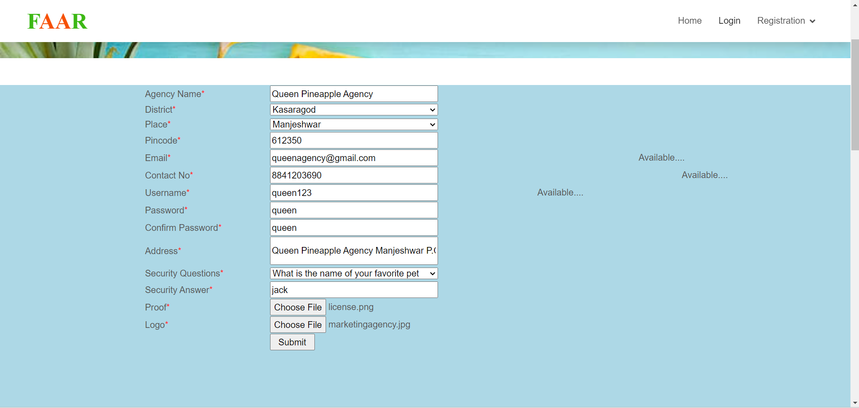

Fig 5.1. Agency Registration Form

### **5.2.3 Code Validation & Optimization**

Software/Code validation is often considered to be overwhelming for some organizations. With all the requirements and guidance specified in the standards and regulations, it appears to be a monumental task. However, it is not as complex as some may think. This tangled web can be simplified so that it is more easily understood and not just meet regulatory requirements but serve as a useful business tool as well. While very few software systems are developed in- house anymore, many of the systems used are configurable to meet your business needs. The regulations state, that these configured systems must be validated for their intended use. Depending on the risk and complexity of the software, different levels of validation rigor should be performed.

Optimization is a program transformation technique, which tries to improve the code by making it consume fewer resources (i.e. CPU, Memory) and deliver high speed. In optimization, high-level general programming constructs are replaced by very efficient low- level programming codes.

A code optimizing process must follow the three rules given below:

* The output code must not, in any way, change the meaning of the program.
* Optimization should increase the speed of the program and if possible, the program should demand a smaller number of resources.
* Optimization should itself be fast and should not delay the overall compiling process.

## 5.3 DEBUGGING

In software engineering, debugging is the process of fixing a bug in the software. In other words, it refers to identifying, analysing, and removing errors. This activity begins after the software fails to execute properly and concludes by solving the problem and successfully testing the software. It is an extremely complex and tedious task because errors need to be resolved at all stages of debugging. Debugging Process:

Steps involved in debugging are:

• Problem identification and report preparation.

• Assigning the report to the software engineer to the defect to verify that it is genuine.

• Defect Analysis using modelling, documentation, finding and testing candidate flaws, etc.

• Defect Resolution by making required changes to the system.

• Validation of corrections.

## 5.4 UNIT TESTING

Unit testing is a level of software testing where individual units/ components of software are tested. The purpose is to validate that each unit of the software performs as designed. A unit is the smallest testable part of software. It usually has one or a few inputs and usually a single output. The modules of the system are tested separately. The testing is carried out during programming stage itself. In this testing step each module is found to working satisfactory as regard to the expected output from the module. There are some validation checks for verifying the data input given by the user which both the formal and validity of the entered. It is very easy to find error debug the system. We have continued Unit testing from the starting of the coding phase itself. Whenever we complete one small sub module, some amount of testing was done based on the requirements to see if the functionality is aligned to the gathered requirements. Unit testing is testing changes made in existing or new programs. Unit test cases embody characteristics that are critical to the success of the unit. These characteristics can indicate appropriate use of a unit as well as negative behaviours that are to be trapped by the unit.

Table 5.1:test plan

|  |  |  |
| --- | --- | --- |
| **Test Level** | **Project Team** | **External Party** |
| Unit Testing | T |  |
| Integration Testing | T |  |
| Validation Testing | T | T |
| System Testing | T | T |

Table5.2:test case

|  |  |  |  |
| --- | --- | --- | --- |
|  | **TEST CASE FOR PINEAPPLE FARM MANAGEMENT SYSTEM LOGIN SCREEN** | | |
| **Test Steps** | **Expected Result** | **Actual Result** | **Pass/ Fail** |
| Run the application and navigate to  login screen. | Login screen Contains two fields for entering user name & password and login button should be present. | For entering username & password together with a login button is available. | Pass |
| Enter a valid username & password and press the login button. | Admin must  successfully login to the  admin dashboard. | Login successful and navigate to Admin dashboard. | Pass |
| Enter a valid username & invalid password and press the login button. | A message should be displayed that invalid login. | A message should be displayed that invalid login. | Pass |
| Enter a valid user name and leave password field and press login button. | A message should be displayed that enter password. | A message should be displayed that enter password. | Pass |
| Press login button without  entering username & password. | A message should be displayed that enter username and password. | A message should be displayed that enter username and password. | Pass |
| Enter invalid data in username & password field and press login button. | A message should be displayed that Invalid Login. | A message should be displayed that Invalid Login. | Pass |

# **CHAPTER 6 SYSTEM TESTING**

## 6.1 INTRODUCTION

The objective of system testing is to ensure that all individual programs are working as expected, that the programs link together to meet the requirements specified and to ensure that the computer system and the associated clerical and other procedures work together. The initial phase of system testing is the responsibility of the analyst who determines what conditions are to be tested, generates test data, produced a schedule of expected results, runs the tests, and compares the computer-produced results with the expected results. The analyst may also be involved in procedures testing. When the analyst is satisfied that the system is working properly, he hands it over to the users for testing. The importance of system testing by the user must be stressed. Ultimately it is the user must verify the system and give the go-ahead. During testing, the system is used experimentally to ensure that the software does not fail, i.e., that it will run according to its specifications and in the way, users expect it to. Special test data is input for processing (test plan) and the results are examined to locate unexpected results. A limited number of users may also be allowed to use the system so analysts can see whether they try to use it in unexpected ways. It is preferable to find these surprises before the organization implements the system and depends on it. In many organizations, testing is performed by persons other than those who write the original programs.

## 6.2 INTEGRATION TESTING

Integration testing (sometimes called integration and testing, abbreviated I&T) is the phase in software testing in which individual software modules are combined and tested as a group. Software components may be integrated in an iterative way or together ("big bang"). Normally the former is considered a better practice since it allows interface issues to be located more quickly and fixed. Data can be lost across an interface; one module can have an adverse effort on the other sub-functions when combined by, may not produce the desired major functions. Integrated testing is the systematic testing for constructing the uncover errors within the interface. This testing was done with sample data. The developed system has run success full for this sample data. The need for an integrated test is to find the overall system performance. Integration testing is a logical extension of unit testing. In its simplest form, two units that have already been tested are combined into a component and the interface between them is tested. A component, in this sense, refers to an integrated aggregate of more than one unit. Integration testing identifies problems that occur when units are combined. By using a test plan that requires you to test each unit and ensure the viability of each before combining units, you know that any errors discovered when combining units are likely related to the interface between units. This method reduces the number of possibilities to a far simpler level of analysis. Progressively larger groups of tested software components corresponding to elements of the architectural design are integrated and tested until the software works as a system.

## 6.3 SYSTEM TESTING

System testing is the testing and is used to ensure that by putting the software in different environments it still works. It is done with executing the software system testing the application is working correctly from the point of view of a user. The main purpose of this system testing is to evaluate the system’s compliance with the specified requirements. Whole system is tested as per the requirements. Blackbox type testing that is related to overall requirements specifications, covers all combined parts of a system.

### **6.3.1 Test Plan & Test Cases**

A test case is a set of conditions or variables under which a tester will determine whether a system under test satisfies requirements or works correctly. The process of developing test cases can also help find problems in the requirements or design on an application.

A test plan is a detailed document that describes the test strategy, objectives, schedule, estimation, deliverables, and resources required to perform testing for a software product. Test Plan helps us determine the effort needed to validate the quality of the application under test. The test plan serves as a blueprint to conduct software testing activities as a defined process, which is minutely monitored and controlled by the test manager.

Table 6.1:test plan

|  |  |  |
| --- | --- | --- |
| **Test Level** | **Project Team** | **External Party** |
| Unit Testing | T |  |
| Integration Testing | T |  |
| Validation Testing | T | T |
| System Testing | T | T |

Table 6.2: Admin Login Test Case Report

|  |  |  |  |
| --- | --- | --- | --- |
| **Function** | **Description** | **% Test case executed** | **% Test passed** |
| Login | Open the application | 100% | 97% |
| Login | Enter valid username and password | 100% | 97% |

Table 6.3:test case

|  |  |  |  |
| --- | --- | --- | --- |
|  | **TEST CASE FOR PINEAPPLE FARM MANAGEMENT SYSTEM LOGIN SCREEN** | | |
| **Test Steps** | **Expected Result** | **Actual Result** | **Pass/ Fail** |
| Run the application and navigate to  login screen. | Login screen Contains two fields for entering user name & password and login button should be present. | For entering username & password together with a login button is available. | Pass |
| Enter a valid username & password and press the login button. | Admin must  successfully login to the  admin dashboard. | Login successful and navigate to Admin dashboard. | Pass |
| Enter a valid username & invalid password and press the login button. press the login button. | A message should be displayed that invalid login. | A message should be displayed that invalid login. | Pass |
| Enter a valid user name and leave password field and press login button. | A message should be displayed that enter password. | A message should be displayed that enter password. | Pass |
| Press login button without  entering username & password. | A message should be displayed that enter username and password. | A message should be displayed that enter username and password. | Pass |
| Enter invalid data in username & password field and press login button. | A message should be displayed that Invalid Login. | A message should be displayed that Invalid Login. | Pass |

# **CHAPTER 7 SYSTEM MAINTENANCE**

## 7.1 INTRODUCTION

Software Maintenance is the process of modifying a software product after it has been delivered to the customer. The main purpose of software maintenance is to modify and update software applications after delivery to correct faults and to improve performance.

Need for Software Maintenance must be performed in order to:

* Correct faults.
* Improve the design.
* Implement enhancements.
* Interface with other systems.
* Accommodate programs so that different hardware, software, system features, and telecommunications facilities can be used.
* Migrate legacy software.
* Retire software.

## 7.2 MAINTENANCE

The definition of software maintenance can be given by describing four activities that are undertaken after the program is released for use. The first maintenance activity occurs since it is unreasonable to assume that software testing will uncover all errors in a large software system. The process of including the diagnosis and correction of one or more errors is called corrective maintenance. The second activity that contributes to a definition of maintenance occurs since rapid change is encountered in every aspect of computing. Therefore, adaptive maintenance modifies to properly interface with a changing environment.

The third activity involves recommendations for new capabilities, modification to the exiting function, and general enhancement when the software is used. To satisfy requests, prefecture maintenance is performed. The fourth maintenance activity occurs when software is changed to improve future maintainability or reliability. This is called preventive maintenance.

# **CHAPTER 8 SYSTEM SECURITY MEASURES**

**8.1 INTRODUCTION**

Project security is defined as, the invested parties having correct protocols to access the project. It means that everyone involved should have the access to information and data according to their role. The encryption of the data is crucial in project management security and the data should not be available to everyone. Information and physical security both are important in this regard, and we will be discussing both below. Several steps you can take will make your project more secure and ensure its success.

**8.2 OPERATING SYSTEM LEVEL SECURITY**

The process of ensuring OS availability, confidentiality, and integrity is known as operating system security. OS security refers to the processes or measures taken to protect the operating system from dangers, including viruses, worms, malware, and remote hacker intrusions. Operating system security comprises all preventive-control procedures that protect any system assets that could be stolen, modified, or deleted if OS security is breached.

In this project there are various ways to ensure operating system security. These are as follows:

**Username/Password**: Each stakeholder like Admin, Farmer, Agency and Shop contains a unique username and password that should be input correctly before login to the system.

**User Identification**: These techniques usually include type of user along with the login window. This authentication is based on user type and is compared to database samples already in the system. Users can only allow access if there is a match.

**8.3 DATABASE LEVEL SECURITY**

SQL security is an essential aspect of managing and maintaining a SQL database. Proper security measures help protect your data from unauthorized access, data breaches, and other malicious activities. Below are some important considerations and best practices for enhancing the security of your SQL database:

• Secure Authentication:

Use strong passwords: Set strong passwords for all SQL user accounts and avoid using default or easily guessable passwords.

Use SSL/TLS: Enable SSL/TLS encryption to secure data transmission between the client and the server.

• User Privileges:

Grant minimum privileges: Give each user only the necessary privileges required for their tasks. Avoid granting unnecessary permissions.

Use separate accounts: Create separate accounts for administrative tasks and application usage. Do not use the root account for routine operations.

• Firewall Protection:

Restrict access: Limit access to your SQL server only to trusted hosts and networks. Use firewalls to control incoming connections.

• Regular Updates:

Keep SQL updated: Stay up to date with the latest SQL releases and security patches to protect against known vulnerabilities.

• Backup and Recovery:

Regular backups: Implement a reliable backup strategy to ensure data can be restored in case of data loss or security incidents.

• Auditing and Monitoring:

Enable logging: Enable logging features in MySQL to monitor and review activities on the database server.

Monitor for anomalies: Implement monitoring tools to detect suspicious activities and potential security breaches.

• Parameterized Queries:

Use prepared statements or parameterized queries to prevent SQL injection attacks.

• Input Validation:

Validate and sanitize all input from users and applications to prevent malicious data from being executed as queries.

• Avoid Exposing Sensitive Information:

Be cautious with error messages: Ensure that error messages do not reveal sensitive information about your database structure or credentials.

• Least Privilege Principle:

Follow the principle of least privilege, which means granting the minimum permissions required to perform specific tasks.

• Disable Unnecessary Features:

Disable any unnecessary SQL features to reduce the attack surface.

• Application Security:

Ensure that your applications are also secure, as vulnerabilities in the application layer can impact the security of the database.

• Regular Security Reviews:

Conduct periodic security reviews and assessments to identify and address potential vulnerabilities.

**8.4 SYSTEM LEVEL SECURITY**

System level security is a crucial aspect of the overall security framework for the Pineappple Farm Management System. It is designed to safeguard the entire system infrastructure, including servers, network components, and critical resources, from potential security breaches and unauthorized access. Access control is a primary consideration in the system level security of the Pineapple Farm Management System. Strict access controls are enforced to restrict both physical and logical access to servers and computing resources. Only authorized personnel with the necessary credentials and privileges are allowed to access and manage system components. To fortify the system against network-based attacks, firewalls are deployed to monitor and regulate incoming and outgoing traffic.

Intrusion detection and prevention systems (IDPS) are also implemented to promptly detect and respond to any suspicious activities or potential threats.

Frequent system patches and updates are applied to address known vulnerabilities and security issues. Moreover, robust antivirus and anti-malware software are installed to proactively detect and prevent any malicious software from infiltrating the system.

Secure configurations and settings at the system level are utilized to minimize potential attack surfaces for the Pineapple Fram Management System. Unnecessary services are disabled, and default configurations are modified to enhance the system's overall security posture. Continuous monitoring of system logs is implemented to track system activities, detect anomalies, and investigate potential security incidents. Analysing logs helps identify any unauthorized access attempts or unusual behaviour, enabling timely responses to potential threats. Physical security measures are also in place to safeguard the physical infrastructure of the Pineapple Farm Management System. Servers and data centres are housed in secure facilities with restricted access to prevent unauthorized physical entry. By implementing robust system level security practices, the Pineapple Farm Management System ensures the integrity, confidentiality, and availability of data, promoting a safe and secure environment for managing Pineapple farm-related activities and transactions.

**CHAPTER 9 SYSTEM PLANNING AND SCHEDULING**

**9.1 INTRODUCTION**

Project Planning and Scheduling’, though separate, are two sides of the same coin in project management. Fundamentally, ‘Project planning’ is all about choosing and designing effective policies and methodologies to attain project objectives. While ‘Project scheduling’ is a procedure of assigning tasks to get them completed by allocating appropriate resources within an estimated budget and timeframe.

The basis of project planning is the entire project. Unlikely, project scheduling focuses only on the project-related tasks, the project start/end dates and project dependencies. Thus, a ‘project plan’ is a comprehensive document that contains the project aims, scope, costing, risks, and schedule. And a project schedule includes the estimated dates and sequential project tasks to be executed.

**9.2 PLANNING A SOFTWARE PROJECT**

A Software Project is the complete methodology of programming advancement from requirement gathering to testing and support, completed by the execution procedures, in a specified period to achieve intended software product. Need of Software Project Management: Software development is a sort of all new streams in world business, and there is next to no involvement in structure programming items. Most programming items are customized to accommodate customer's necessities.

The most significant is that the underlying technology changes and advances so generally and rapidly that experience of one element may not be connected to the other one. All such business and ecological imperatives bring risk in software development; hence, it is fundamental to manage software projects efficiently. Software manager is responsible for planning and scheduling project development. They manage the work to ensure that it is completed to the required standard. They monitor the progress to check that the event is on time and within budget. The project planning must incorporate the major issues like size & cost estimation scheduling, project monitoring, personnel selection evaluation & risk management. To plan a successful software project, I must understand:

• Scope of work to be completed

• Risk analysis

• The resources mandatory

• The project to be accomplished

• Record of being followed

**9.2.1. Steps Involved in Planning a System**

• Define project objectives.

• Break the project into a list of deliverables and milestones.

• Define tasks for each deliverable and milestone.

• Estimate the time and resources needed for completion.

• Identify risks.

• Identify stakeholders and obtain their input.

• Identify requirements.

**9.3 GANNT CHART**

A Gannt chart is a horizontal bar chart that visually represents a project plan over time. Modern Gannt charts typically show you the status of as well as who’s responsible for each task in the project. In other words, a Gantt chart is a super-simple way to keep you out of a project pinch.

Key parts of a Gannt chart

• Task list: Runs vertically down the left of the Gannt chart to describe project work and may be organized into groups and subgroups.

• Timeline: Runs horizontally across the top of the Gannt chart and shows months, weeks, days, and years

• Dateline: A vertical line that highlights the current date on the Gannt chart

• Bars: Horizontal markers on the right side of the Gannt chart that represent tasks and show progress, duration, and start and end dates

• Milestones: Yellow diamonds that call out major events, dates, decisions, and deliverables

• Dependencies: Light Gray lines that connect tasks that need to happen in a certain order

• Progress: Shows how far along work is and may be indicated by % Complete and/or bar shading

• Resource assigned: Indicates the person or team responsible for completing a task.

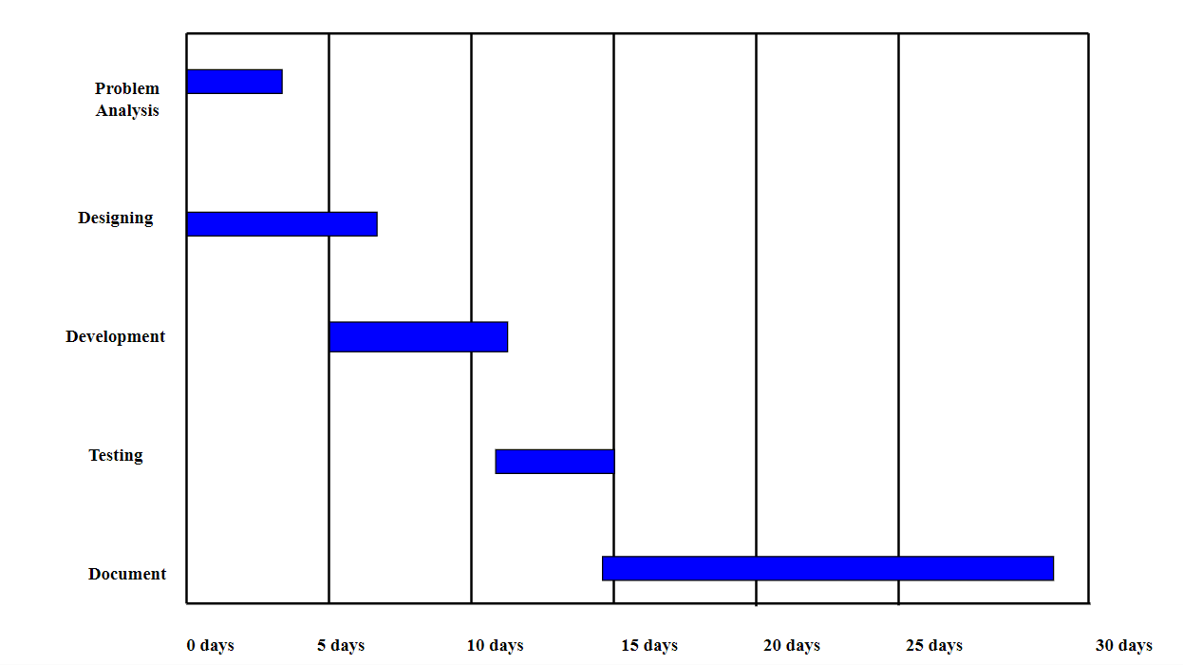

Fig 9.1 Gannt Chart

**9.4 PERT CHART**

A PERT chart is a project management tool used to schedule, organize, and coordinate task within a project. PERT stands for Program Evaluation Review Technique, a methodology developed by the US Navy in the 1950s to manage the Polar submarines missile program. A PERT chart presents a graphic illustration of a project as a network diagram consisting of numbered nodes (either circles or rectangles) representing events.

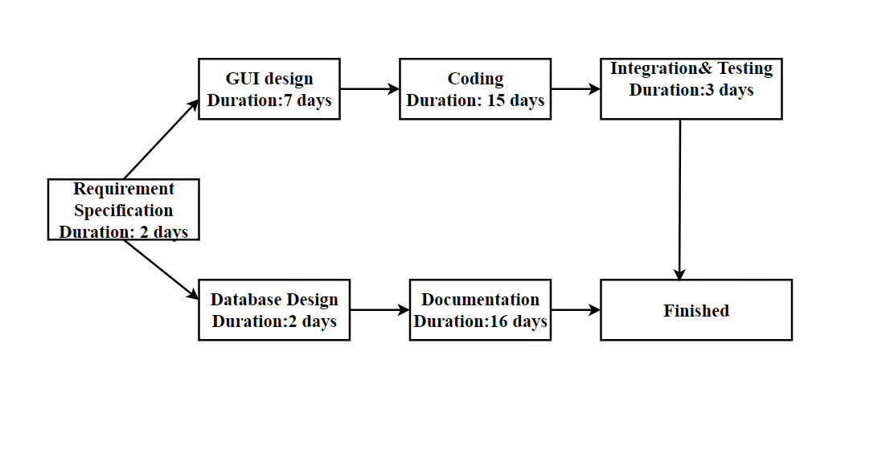

Fig 9.2 Pert Chart

**CHAPTER 10 SYSTEM COST ESTIMATION**

**10.1 INTRODUCTION**

Software cost estimation is the process of predicting the effort required to develop a software system. For any new software project, it is necessary to know how much it will cost to develop and how much development time it will take. These estimates are needed before development is initiated, but how is this done? Several estimation procedures have been developed and have the following attributes in common.

• Project scope must be established in advance.

• Software metrics are used as a support from which evaluation is made.

• The project is broken into small PCs which are estimated individually.

• To achieve true cost & schedule estimate, several options arise.

• Delay estimation

• Used symbol decomposition techniques to generate project cost and schedule estimates.

• Acquire one or more automated estimation tools.

Uses of Cost Estimation are during the planning stage, one needs to choose how many engineers are required for the project and to develop a schedule and in monitoring the project's progress, one needs to access whether the project is progressing according to the procedure and takes corrective action, if necessary.

**10.2 FUNCTION POINT BASED ESTIMATION**

Function points measure the size of an application system based on the functional view of the system. The size is determined by counting the number of inputs, outputs, queries, internal files, and external files in the system and adjusting that total for the functional complexity of the system.

# **CHAPTER 11 FUTURE ENHANCEMENT AND SCOPE OF FURTHER DEVELOPMENT**

## 11.1 INTRODUCTION

The purpose of “PINEAPPLE FARM MANAGEMENT SYSTEM” is to develop a system for farmers to sell their pineapple to agencies and they can also buy fertilizers and tools for their agricultural from different shops. In the future the pineapple farm management system implement a system for tracking the entire supply chain process, from planting to harvesting to delivery. This could include features like real-time inventory management, logistics tracking, and quality control measures to ensure the freshest produce reaches consumers. Develop tools to help farmers manage their finances more effectively. This could include features like budgeting tools, expense tracking, and financial analytics to help farmers make informed decisions about their operations. Integrate weather forecasting data into the system to help farmers plan their planting and harvesting schedules more effectively. This could include features like alerts for upcoming weather events and recommendations for adjusting farming practices based on weather conditions. Use data analytics to provide farmers with valuable insights into their operations. This could include trends analysis, yield forecasting, and recommendations for optimizing farming practices to improve productivity and profitability. Create a mobile app version of the system to allow farmers to manage their operations on the go. This could include features like remote monitoring of farm activities, instant notifications, and mobile payment capabilities for buying/selling produce and supplies. Integrate Internet of Things (IoT) devices into the system to enable real-time monitoring of environmental conditions like soil moisture, temperature, and humidity. This could help farmers optimize their irrigation and fertilization practices for better crop yields.

## 11.2 MERITS OF THE SYSTEM

The merits of Pineapple Farm Management System are as follows:

* It is a very flexible and user-friendly system.
* It reduces the effort of maintaining records in this system.
* It reduces time and human effort which exists in the system.
* The backup facility is available in this proposed system. Hence it prevents data loss.
* It is easy to maintain records.
* It centralizes farm management tasks such as selling pineapples, purchasing agricultural tools and fertilizers, making operations more efficient.
* Farmers can easily sell their pineapples to agencies, ensuring a reliable market for their produce.
* Pineapple agencies have direct access to a steady supply of pineapples from farmers.
* Farmers can conveniently purchase agricultural tools and fertilizers from different shops within the system.
* With transactions recorded within the system, there is greater transparency in financial dealings between farmers, agencies, and shops.

## 11.3 LIMITATION OF THE SYSTEM

Farmers with low literacy levels or who speak different languages may struggle to navigate the system, because local languages are not available in the system.

## 11.4 FUTURE ENHANCEMENT OF THE SYSTEM

The future enhancement of the pineapple farm management system includes facilitating farmers by offering labour assistance and providing comprehensive information on farming fields available for rent. Implement a system for tracking the entire supply chain process, from planting to harvesting to delivery. This could include features like real-time inventory management, logistics tracking, and quality control measures to ensure the freshest produce reaches consumers. Develop tools to help farmers manage their finances more effectively. This could include features like budgeting tools, expense tracking, and financial analytics to help farmers make informed decisions about their operations. Integrate weather forecasting data into the system to help farmers plan their planting and harvesting schedules more effectively. This could include features like alerts for upcoming weather events and recommendations for adjusting farming practices based on weather conditions. Use data analytics to provide farmers with valuable insights into their operations. This could include trends analysis, yield forecasting, and recommendations for optimizing farming practices to improve productivity and profitability. Create a mobile app version of the system to allow farmers to manage their operations on the go. This could include features like remote monitoring of farm activities, instant notifications, and mobile payment capabilities for buying/selling produce and supplies. Integrate Internet of Things (IoT) devices into the system to enable real-time monitoring of environmental conditions like soil moisture, temperature, and humidity. This could help farmers optimize their irrigation and fertilization practices for better crop yields.

**CONCLUSION**

The project “Pineapple Farm Management System” is a project which offers a seamless platform for farmers to sell their produce, purchase agricultural tools and fertilizers, while also enabling agencies to procure pineapples directly from farmers. Additionally, the system facilitates shops to efficiently market and sell their products to farmers, fostering a mutually beneficial ecosystem that enhances productivity and profitability within the pineapple farming industry. All the requirements’ specifications were followed as for as possible and few additional features were added that can make the application more user friendly and less complicated. The project was successfully completed within the time span allotted. All the modules are tested separately and put together to form the main system. Finally, the system is tested with real data and it worked successfully. Thus, the system has fulfilled the entire objective defined.

# **ANNEXURE**

**ORGANIZATION PROFILE**

Progressive Software Solutions and Training is IT Service Company that cost effectively provides cutting edge Information Technology services to a global clientele spread across the globe. We provide a wide range of IT services and solutions. Their mission is to enhance business effectiveness by providing cost-effective, innovative and quality information technology and services to students. It helps companies align Information Technology with their organization goals and business objectives, while ensuring enhanced operational efficiency, greater flexibility and substantial cost savings. They aim at Total Student Satisfaction. They focus on the requirements and expectations of their students and strive to exceed them so as to provide world class products and services through continuous innovations and improvement of their services. Their Goal is to maintain and grow a culture of IT engineering and customer service excellence through a continuous process improvement program. Progressive provides a cutting edge through modern technologies and qualified professionals. They are delivering high end technical solutions which meet customer requirements in richly acceptable manner

**DOCUMENT GLOSSARY, FIGURES, TABLES**

**GLOSSARY**

|  |  |
| --- | --- |
| PK | : Primary Key |
| FK | : Foreign Key |
| ER | : Entity Relationship |
| SQL | : Structured Query Language |
| OS | : Operating System |
| DBMS | : Data Base Management System |
| NF | : Normal Forms |
| CPU | : Central Processing Unit |
| IDE | : Integrated Development Environment |
| VS | : Visual Studio |
| UML | : Unified Modeling Language |
| SRS | : Software Requirement Specification |
| SDE | : Software Development Environment |
| SDLC | : Software Development Life Cycle  **LIST OF FIGURES**   |  |  |  | | --- | --- | --- | | **Fig. No** | **Figure Name** | **Page No** | | Fig 3.1 | ER Diagram for Admin | 14 | | Fig 3.2 | ER Diagram for Agency | 15 | | Fig 3.3 | ER Diagram for Farmer | 16 | | Fig 3.4 | ER Diagram for Shop | 17 | | Fig 3.5 | Use Case Diagram | 47 | | Fig 3.6 | Activity Diagram for Admin | 49 | | Fig 3.7 | Activity Diagram for Agency | 50 | | Fig 3.8 | Activity Diagram for Framer | 51 | | Fig 3.9 | Activity Diagram for shop | 52 | | Fig 3.10 | Sequence Diagram for Admin | 53 | | Fig 3.11 | Sequence Diagram for Agency | 54 | | Fig 3.12 | Sequence Diagram for Farmer | 55 | | Fig 3.13 | Sequence Diagram for shop | 56 | | Fig 9.1 | Gantt Chart | 96 | | Fig 9.2 | Pert Chart | 96 | |

**LIST OF TABLES**

|  |  |  |
| --- | --- | --- |
| **Table No.** | **Table Name** | **Page No.** |
| table 2.1 | Hardware part specification Table | 8 |
| table 3.1 | tbl_admin | 19 |
| table 3.2 | tbl_district | 20 |
| table 3.3 | tbl_place | 20 |
| table 3.4 | tbl_agency | 21 |
| table 3.5 | tbl_shop | 22 |
| table 3.6 | tbl_farmer | 24 |
| table 3.7 | tbl_regtype | 25 |
| table 3.8 | tbl_complaint | 26 |
| table 3.9 | tbl_shoproduct | 27 |
| table 3.10 | tbl_shopstock | 28 |
| table 3.11 | tbl_farmerproduct | 29 |
| table 3.12 | tbl_farmerstock | 30 |
| table 3.13 | tbl_category | 31 |
| table 3.14 | tbl_farmerproductbooking | 31 |
| table 3.15 | tbl_type | 32 |
| table 3.16 | tbl_subtype | 33 |
| table 3.17 | tbl_productbooking | 34 |
| table 3.18 | tbl_agencydeliverydetails | 36 |
| table 3.19 | tbl_cart | 37 |
| table 3.20 | tbl_comment | 38 |
| table 3.21 | tbl_productreview | 39 |
| table 3.22 | tbl_feedback | 40 |
| table 3.23 | tbl_offer | 41 |
| table 3.24 | tbl_offerproduct | 42 |
| table 3.25 | tbl_purchase | 43 |
| table 3.26 | tbl_farmerdeliverydetails | 44 |
| table 3.27 | tbl_subscriptionpayment | 45 |
| table 3.28 | tbl_wishlist | 46 |
| table 6.1 | Test plan | 86 |
| table 6.2 | Admin Login Test Case Report | 87 |
| table 6.3 | Test Case for Pineapple Farm Management System | 87 |

## REFERENCES

* + 1. Waman S Jawadekar – Software Engineering principles & Practice‖- 2nd EditionTata,Mc- GrawHilll Publishing Co. Ltd.
    2. Ferdows, Kasra, and Steven J. Spear. "Competitive Advantage:

Competing on Capabilities." Harvard Business Review, 2021

* + 1. Silver, Edward A., and David F. Pyke. "Inventory Management and Production Planning and Scheduling." CRC Press, 2020
    2. Fashion Industry Statistics: The State of the Apparel Market in 2022." Edited by FashionUnited, FashionUnited, 2022
    3. Brown, Stephen. "Strategic Retail Management: Text and International Cases." Routledge, 2019
    4. https://online.visual-paradigm.com/app/diagrams/

**CODING**

**Login.aspx**

<asp:Content ID="Content1" ContentPlaceHolderID="head" Runat="Server">

<style type="text/css">

body {

font-family: Arial, sans-serif;

background-color: #f4f4f4;

}

.login-container {

max-width: 400px;

min-width:400px;

background-color: #fff;

border: 1px solid #ddd;

padding: 20px;

border-radius: 5px;

box-shadow: 0 2px 4px rgba(0, 0, 0, 0.1);

padding:30px;

}

.login-container h2 {

margin-bottom: 20px;

text-align: center;

}

.form-group {

margin-bottom: 20px;

}

.form-group label {

font-weight: bold;

display: block;

margin-bottom: 5px;

}

.form-group input[type="text"],

.form-group input[type="password"] {

width: 100%;

padding: 10px;

border: 1px solid #ccc;

border-radius: 3px;

box-sizing: border-box;

}

.form-group .error-message {

color: #00CC00;

margin-top: 5px;

}

.form-group .forgot-password {

margin-top: 10px;

text-align: right;

}

.form-group .forgot-password a {

color: #007bff;

text-decoration: none;

}

.form-group .forgot-password a:hover {

text-decoration: underline;

}

.form-group .btn-login {

background-color: #007bff;

color: #fff;

border: none;

padding: 10px 20px;

border-radius: 3px;

cursor: pointer;

}

.form-group .btn-login:hover {

background-color: #0056b3;

}

</style>

</asp:Content>

<asp:Content ID="Content2" ContentPlaceHolderID="ContentPlaceHolder1" Runat="Server" >

<div style="padding:30px;display:flex;justify-content:center;">

<div class="login-container">

<h2>Login</h2>

<div class="form-group">

<label for="txtemail">Email/Username<span class="auto-style10">*</span></label>

<asp:TextBox ID="txtemail" runat="server" CssClass="form-control"></asp:TextBox>

<asp:RequiredFieldValidator ID="RequiredFieldValidator1" runat="server" ControlToValidate="txtemail" ErrorMessage="Enter username" CssClass="error-message"></asp:RequiredFieldValidator>

</div>

<div class="form-group">

<label for="txtpassword">Password<span class="auto-style10">*</span></label <asp:TextBox ID="txtpassword" runat="server" TextMode="Password" CssClass="form-control"></asp:TextBox>

<asp:RequiredFieldValidator ID="RequiredFieldValidator2" runat="server" ControlToValidate="txtpassword" ErrorMessage="Enter password" CssClass="error-message"></asp:RequiredFieldValidator>

</div>

<div class="form-group">

<asp:Button ID="btnLogin" runat="server" OnClick="btnLogin_Click" Text="Login" CssClass="btn-login" />

</div>

<div class="form-group">

<asp:Label ID="lblmsg" runat="server" CssClass="error-message"></asp:Label>

</div>

<div class="form-group forgot-password">

<asp:LinkButton ID="LinkButton1" runat="server" CausesValidation="False" OnClick="LinkButton1_Click1">Forgot password</asp:LinkButton>

</div>

</div>

</div>

</asp:Content>

**Login.aspx.cs**

using System;

using System.Collections.Generic;

using System.Linq;

using System.Web;

using System.Web.UI;

using System.Web.UI.WebControls;

using System.Data.SqlClient;

using System.Data;

public partial class Guest_Default : System.Web.UI.Page

{

SqlConnection con = new SqlConnection("Data Source=LAPTOP-1P4VELIR;Initial Catalog=db_pinapplefarm;Integrated Security=True");

protected void Page_Load(object sender, EventArgs e)

{

con.Open();

}

protected void LinkButton1_Click(object sender, EventArgs e)

{

Response.Redirect("Shopregistration.aspx");

}

protected void btnLogin_Click(object sender, EventArgs e)

{

string selAdmin = "select * from tbl_admin where admin_email='" + txtemail.Text + "' and admin_password='" + txtpassword.Text + "'";

SqlDataAdapter adpAdmin = new SqlDataAdapter(selAdmin, con);

DataTable dtAdmin = new DataTable();

adpAdmin.Fill(dtAdmin);

string selAgency = "select * from tbl_agency where (agency_username='" + txtemail.Text + "' or agency_email='" + txtemail.Text + "') and agency_password='" +txtpassword.Text + "' and agency_status='1'";

SqlDataAdapter adpAgency = new SqlDataAdapter(selAgency, con);

DataTable dtAgency = new DataTable();

adpAgency.Fill(dtAgency);

string selFarmer = "select * from tbl_farmer where (farmer_username='" + txtemail.Text + "'or farmer_email='"+txtemail.Text+"') and farmer_password='" + txtpassword.Text + "' and farmer_status='1'";

SqlDataAdapter adpFarmer = new SqlDataAdapter(selFarmer, con);

DataTable dtFarmer = new DataTable();

adpFarmer.Fill(dtFarmer);

string selShop = "select * from tbl_shop where (shop_username='" + txtemail.Text + "' or shop_email='"+txtemail.Text+"') and shop_password='" + txtpassword.Text + "' and shop_status='1'";

SqlDataAdapter adpShop = new SqlDataAdapter(selShop, con);

DataTable dtShop = new DataTable();

adpShop.Fill(dtShop);

if (dtAdmin.Rows.Count > 0)

{

Session["adminid"] = dtAdmin.Rows[0]["admin_id"].ToString();

Session["adminname"] = dtAdmin.Rows[0]["admin_name"].ToString();

Response.Redirect("../Admin/index.html");

}

else if (dtAgency.Rows.Count > 0)

{

Session["subType"] = "Agency";

Session["agencyid"] = dtAgency.Rows[0]["agency_id"].ToString();

Session["agencyname"] = dtAgency.Rows[0]["agency_name"].ToString();

Response.Redirect("../Agency/index.html");

}

else if (dtFarmer.Rows.Count > 0)

{

Session["subType"] = "Farmer";

Session["farmerid"] = dtFarmer.Rows[0]["farmer_id"].ToString();

Session["farmername"] = dtFarmer.Rows[0]["farmer_name"].ToString();

Response.Redirect("../Farmer/index.html");

}

else if (dtShop.Rows.Count > 0)

{

Session["subType"] = "Shop";

Session["shopid"] = dtShop.Rows[0]["shop_id"].ToString();

Session["shopname"] = dtShop.Rows[0]["shop_name"].ToString();

Response.Redirect("../Shop/index.html");

}

else

{

lblmsg.Text = "Invalid Login!!!";

}

}

protected void lbfarmer_Click(object sender, EventArgs e)

{

Response.Redirect("Farmerregistration.aspx");

}

protected void lbagency_Click(object sender, EventArgs e)

{

Response.Redirect("Agencyregistration.aspx");

}

protected void LinkButton1_Click1(object sender, EventArgs e)

{

Response.Redirect("Forgotpassword.aspx");

}}

**SCREEN SHOTS**

**GUEST**



Guest Homepage

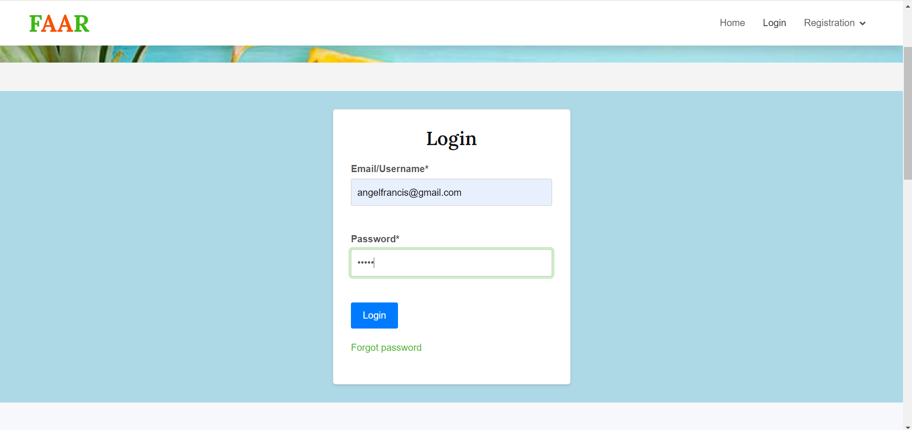

Login Page

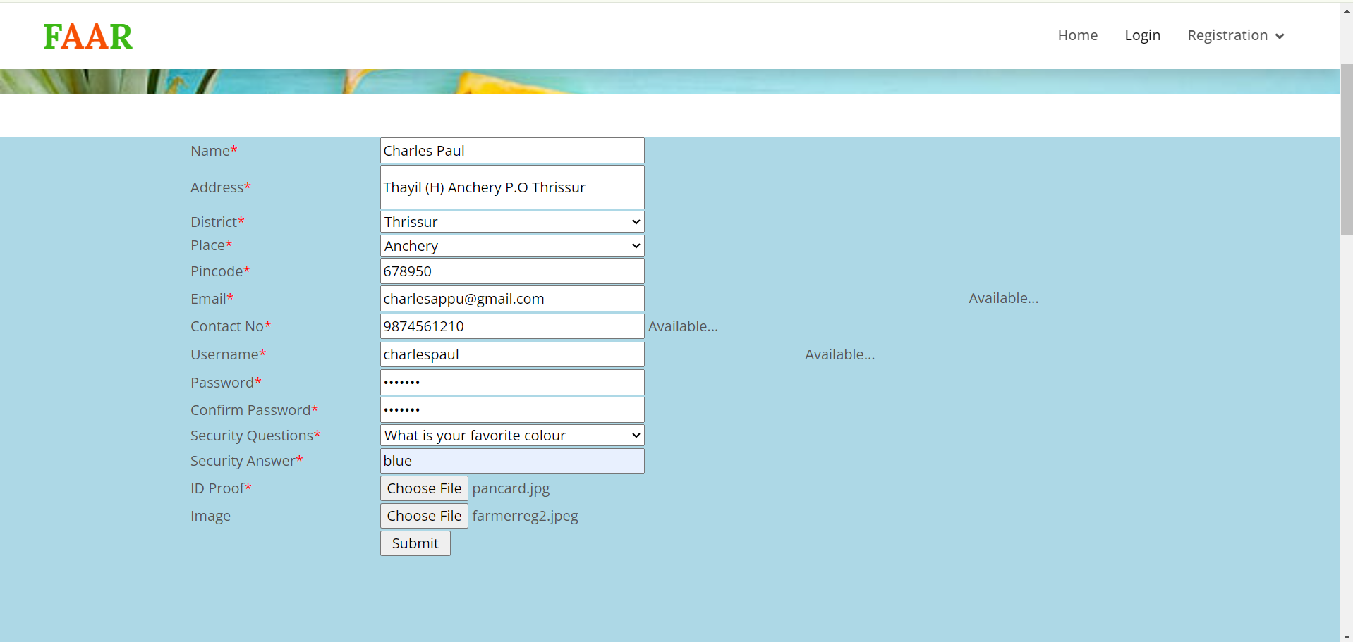

Farmer Registration

**ADMIN**

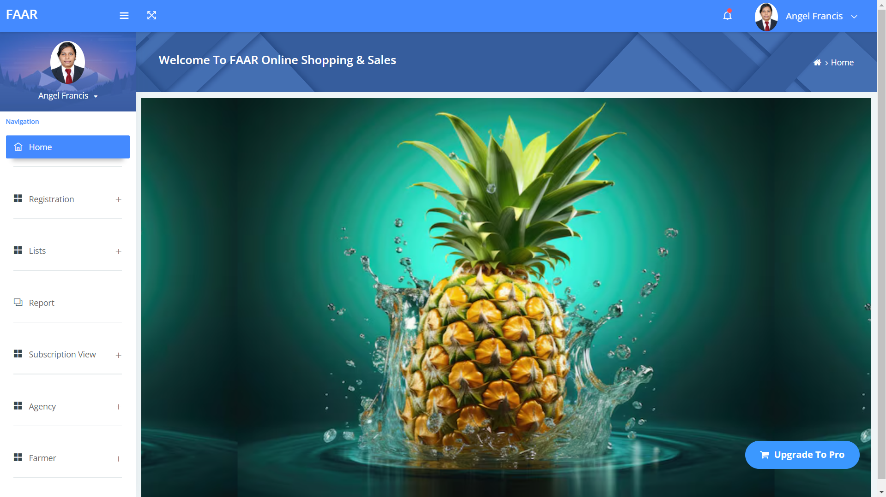

Admin Homepage

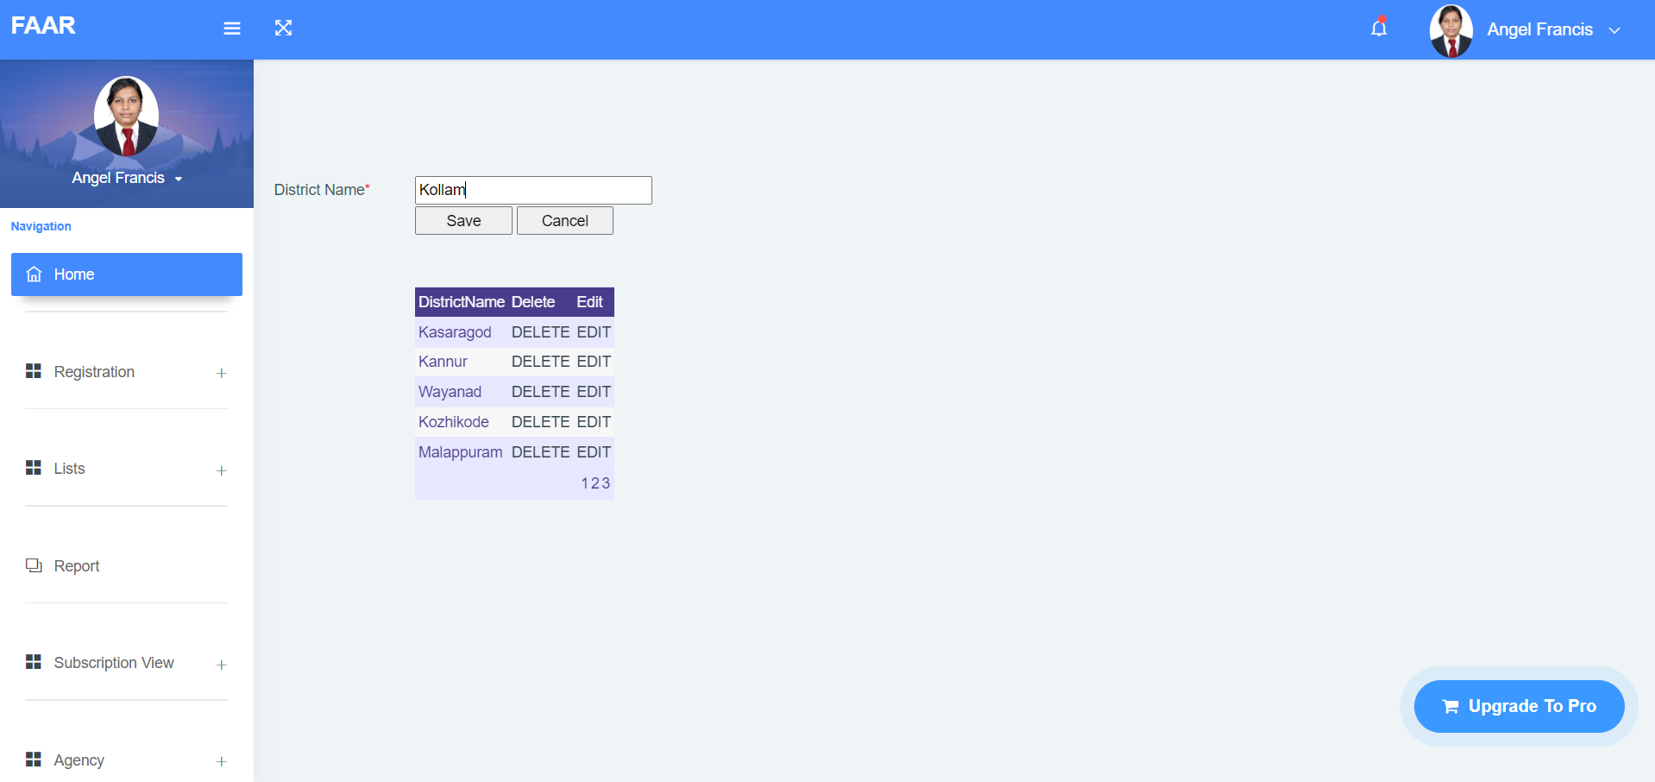

District Registration & View

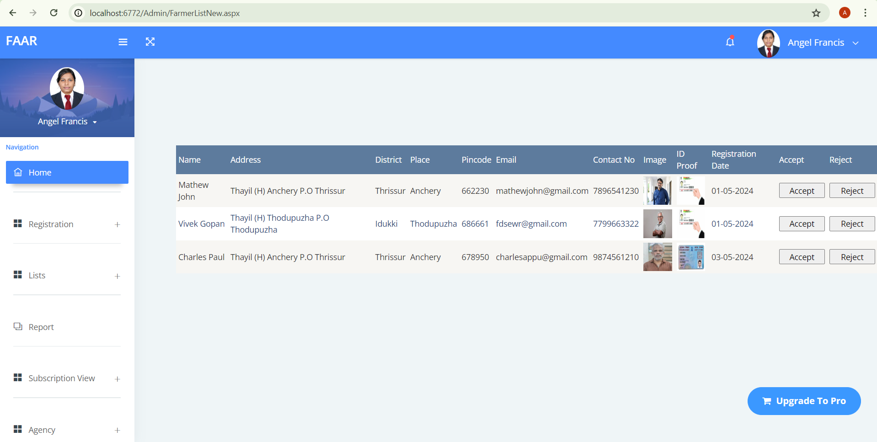

Farmer New Registration List

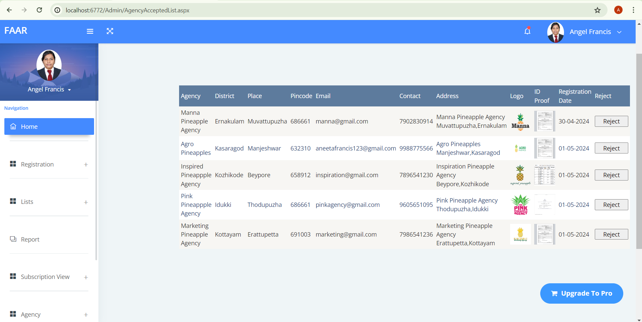

Agency Accepted Registration List

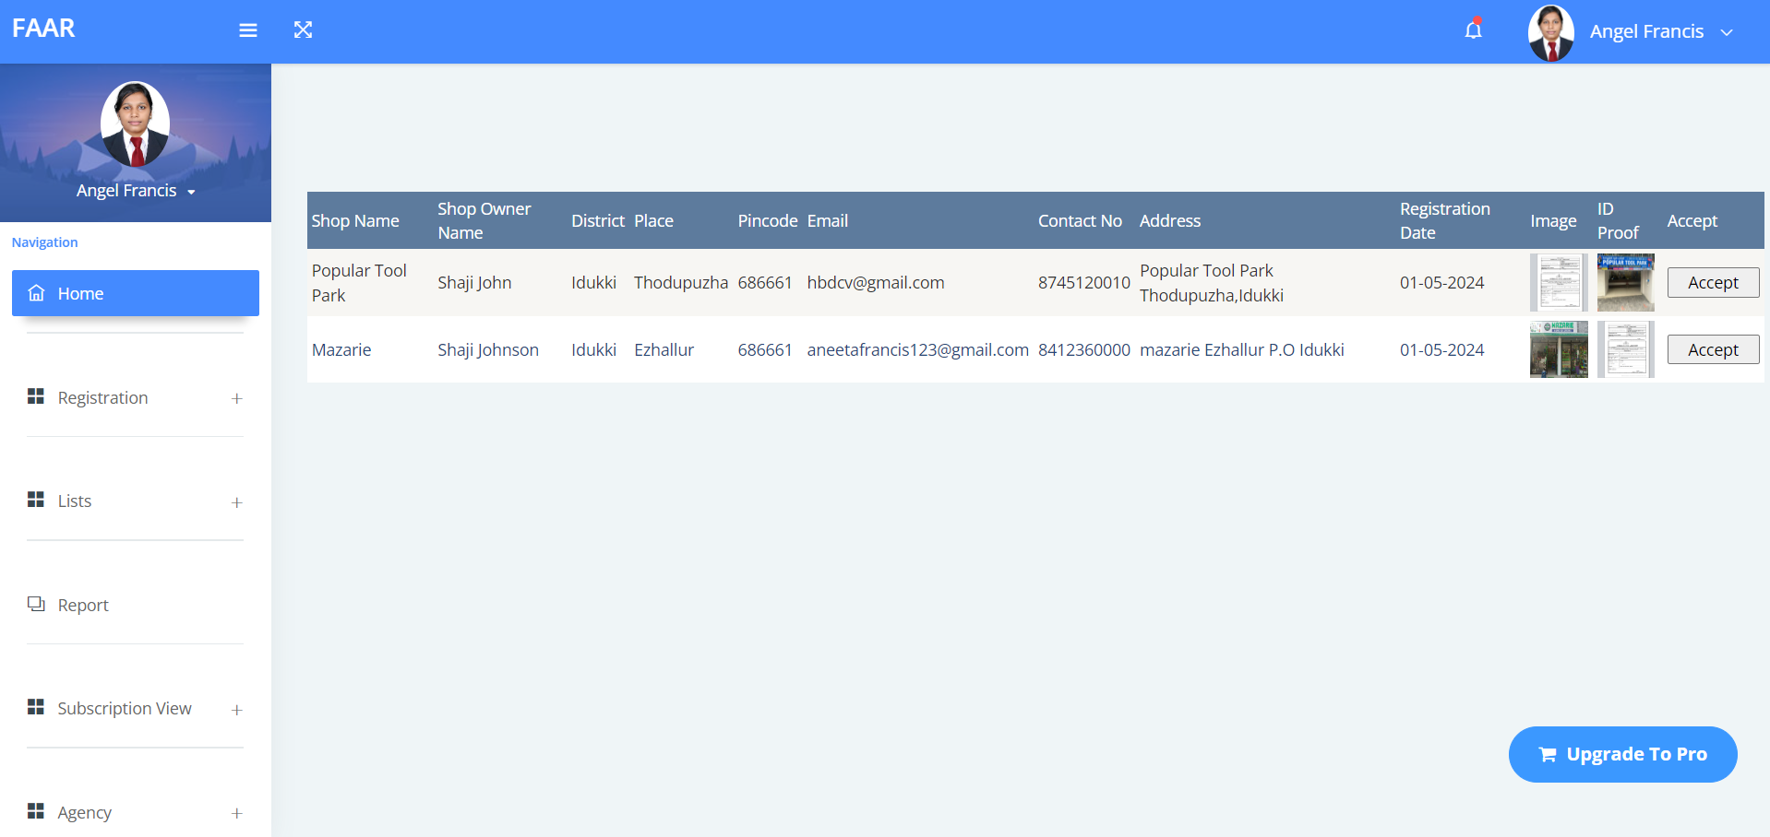

Shop Rejected Registration List

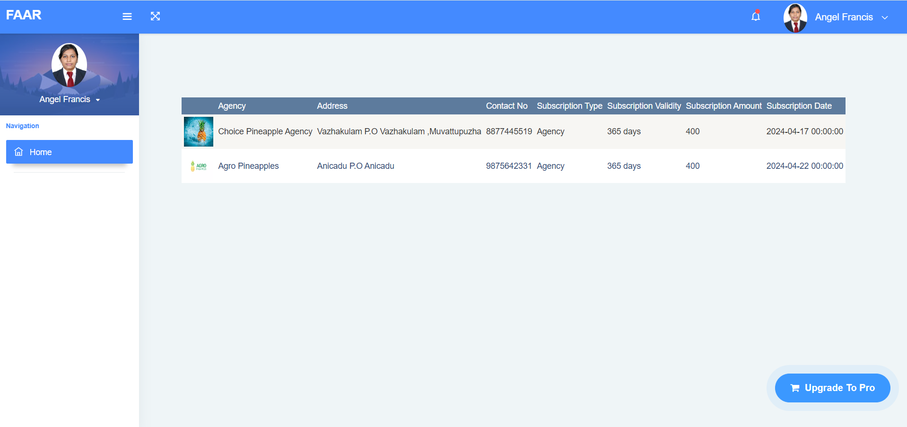

Agency Subscription Payment View

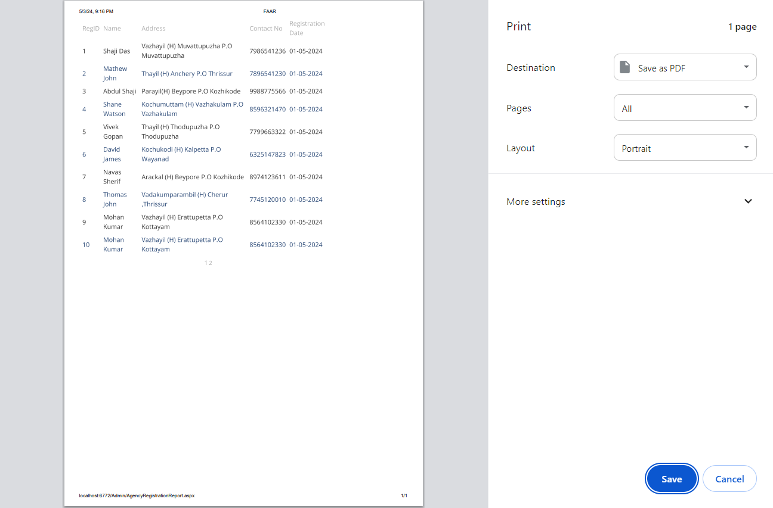

Farmer Registration Report Export into PDF

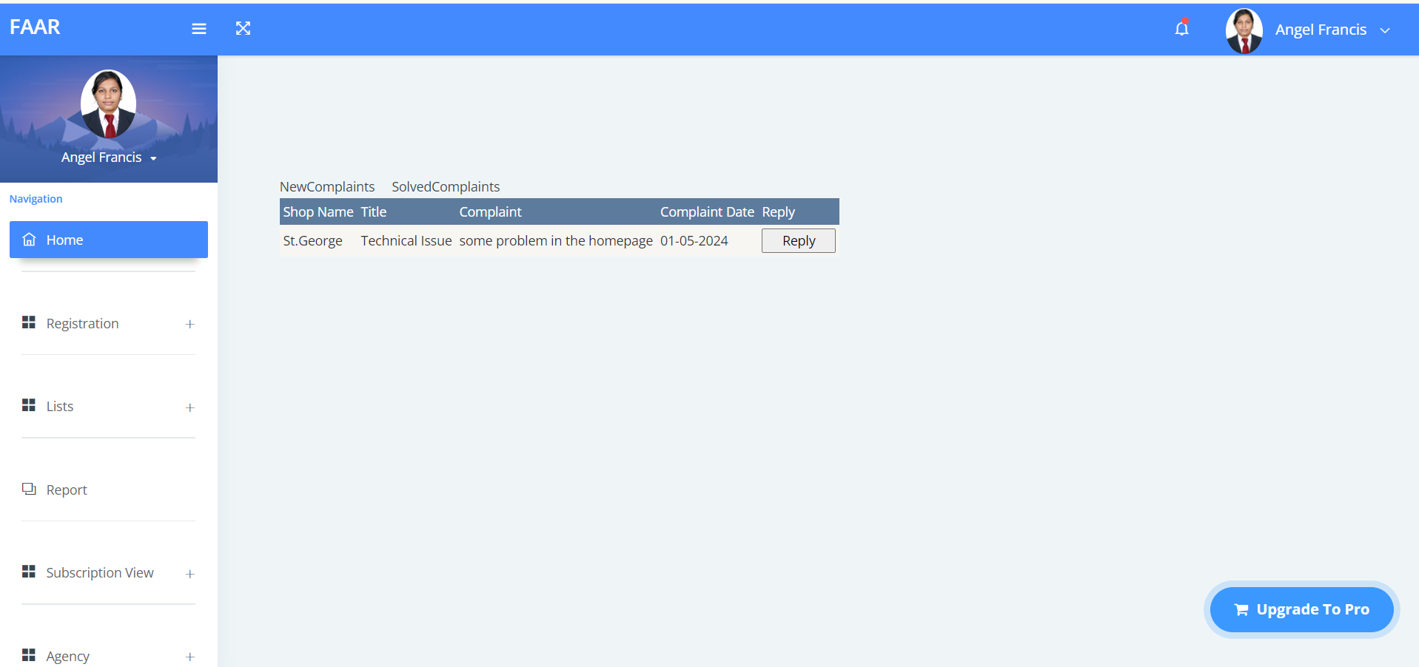

Shop Complaint View & Reply

**AGENCY**

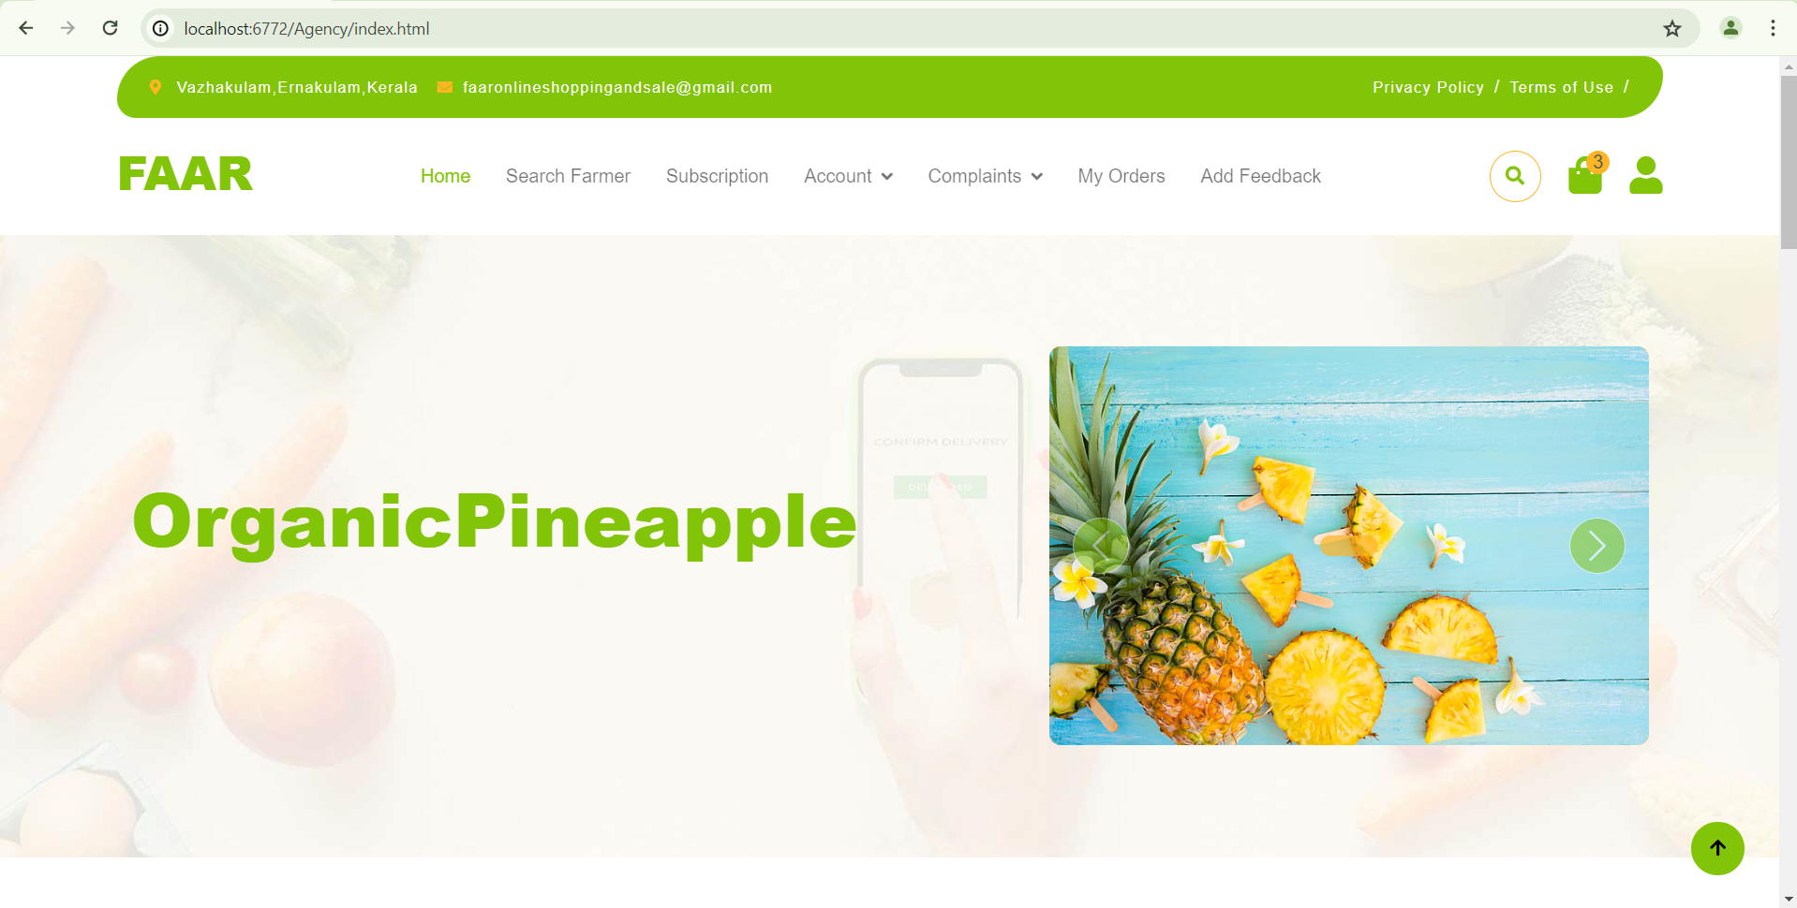

Agency Homepage

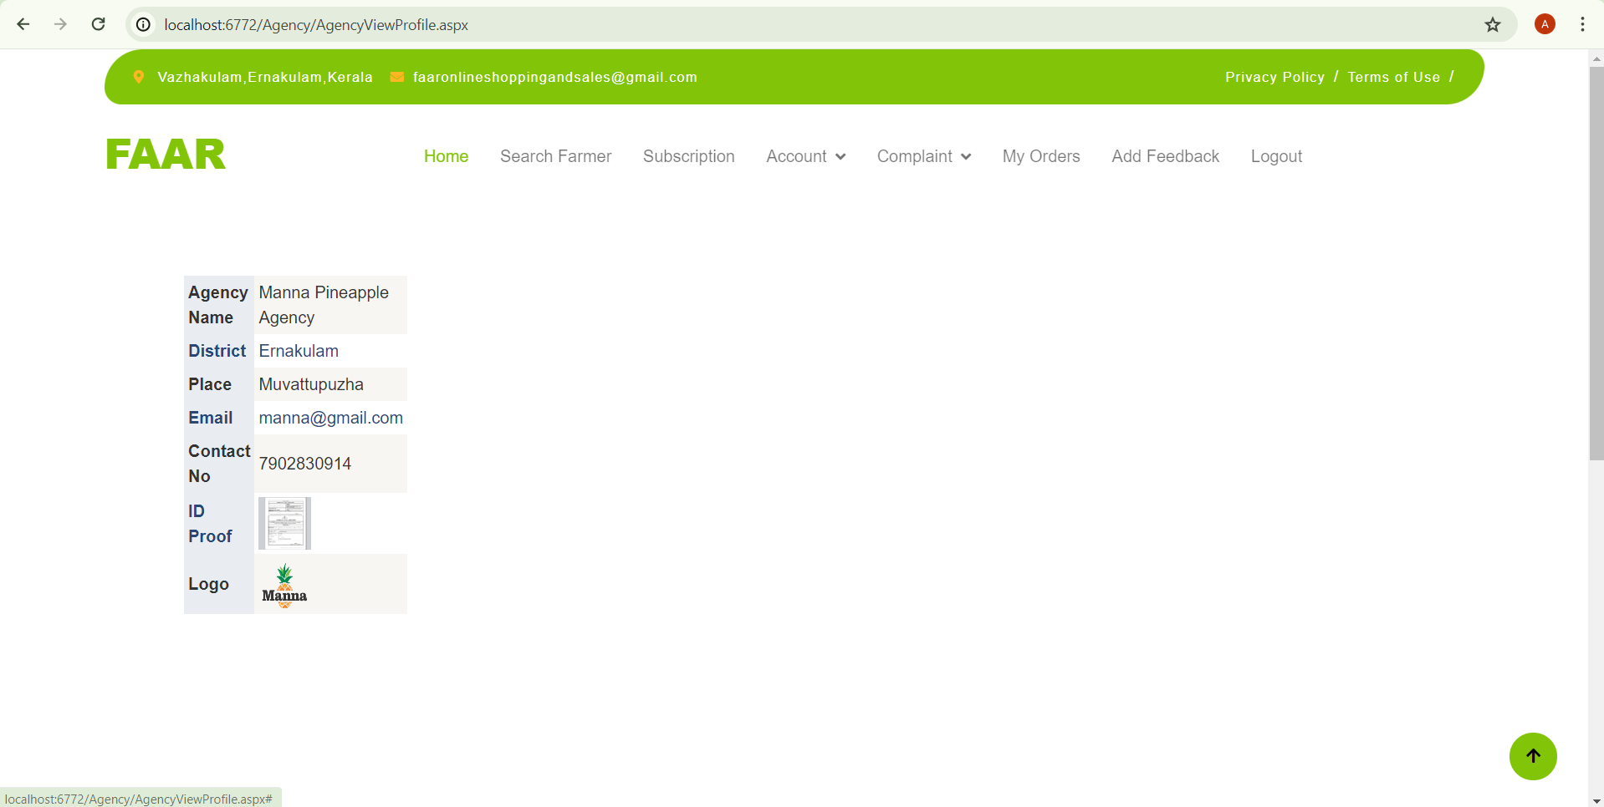

Agency Account View

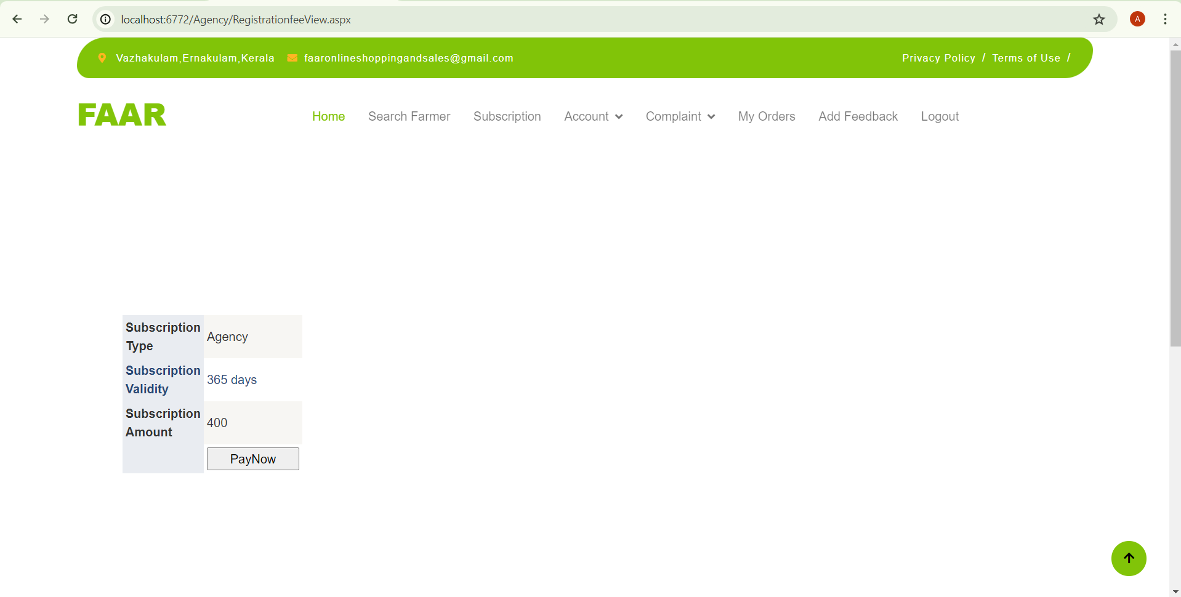

Agency Subscription Details

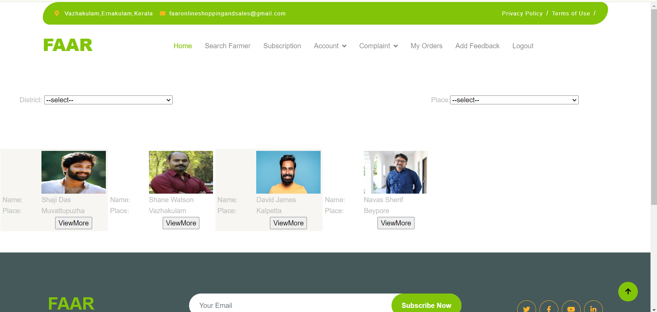

Searching of farmers

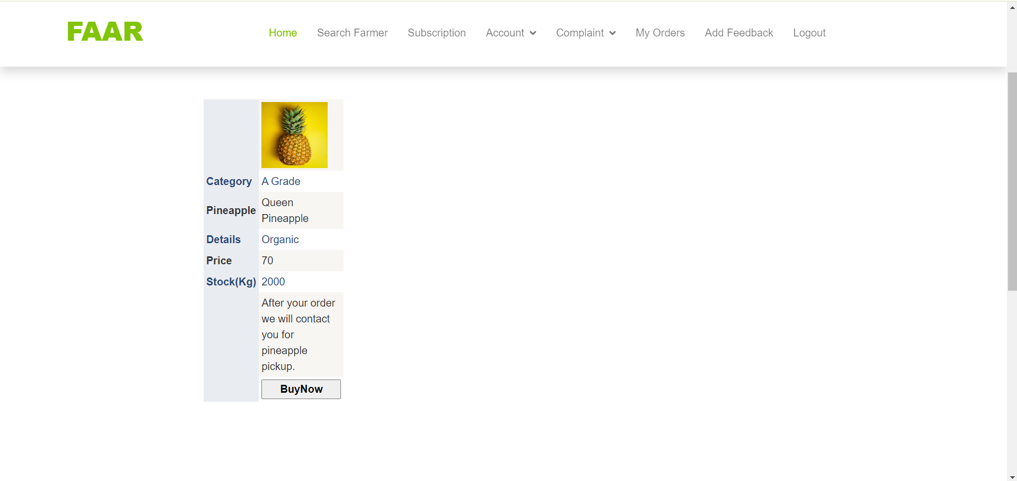

Pineapple Details

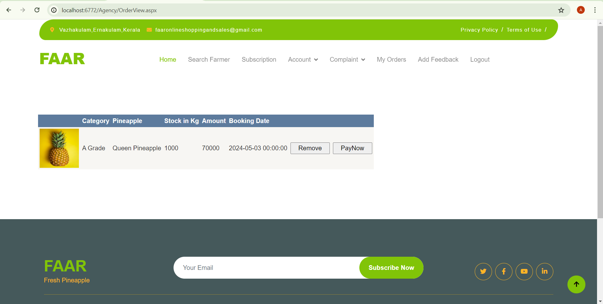

Pineapple Order Details

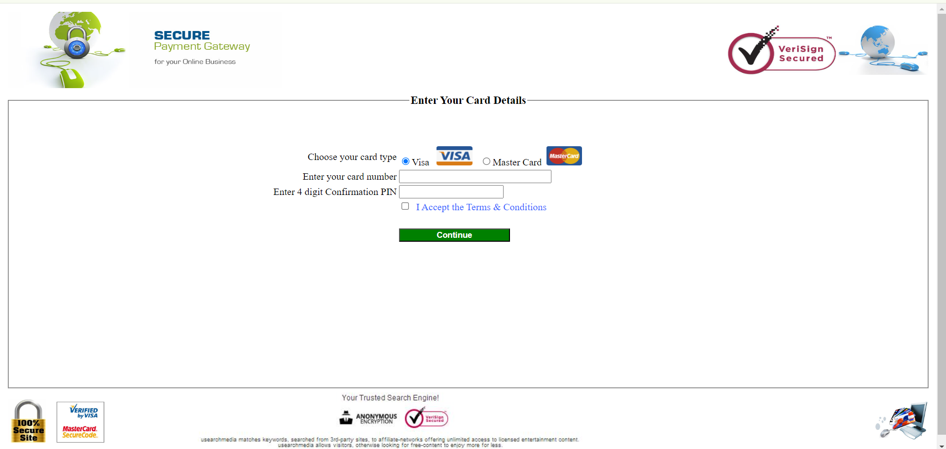

Payment Gateway

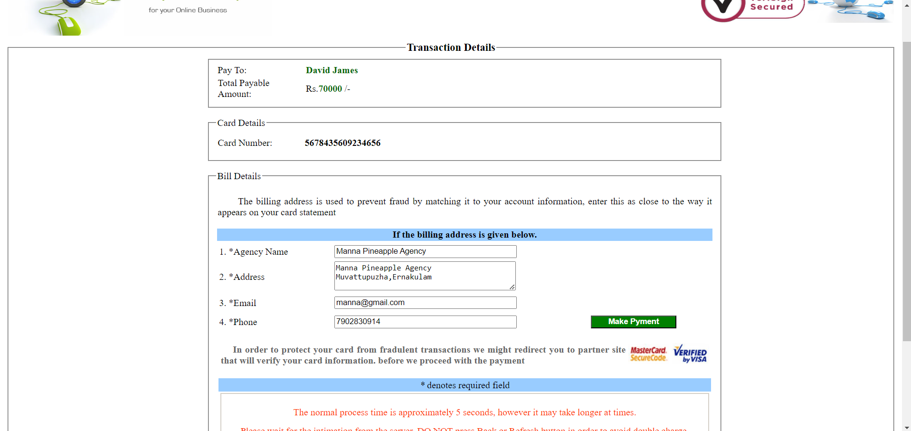

Billing Details

**FARMER**

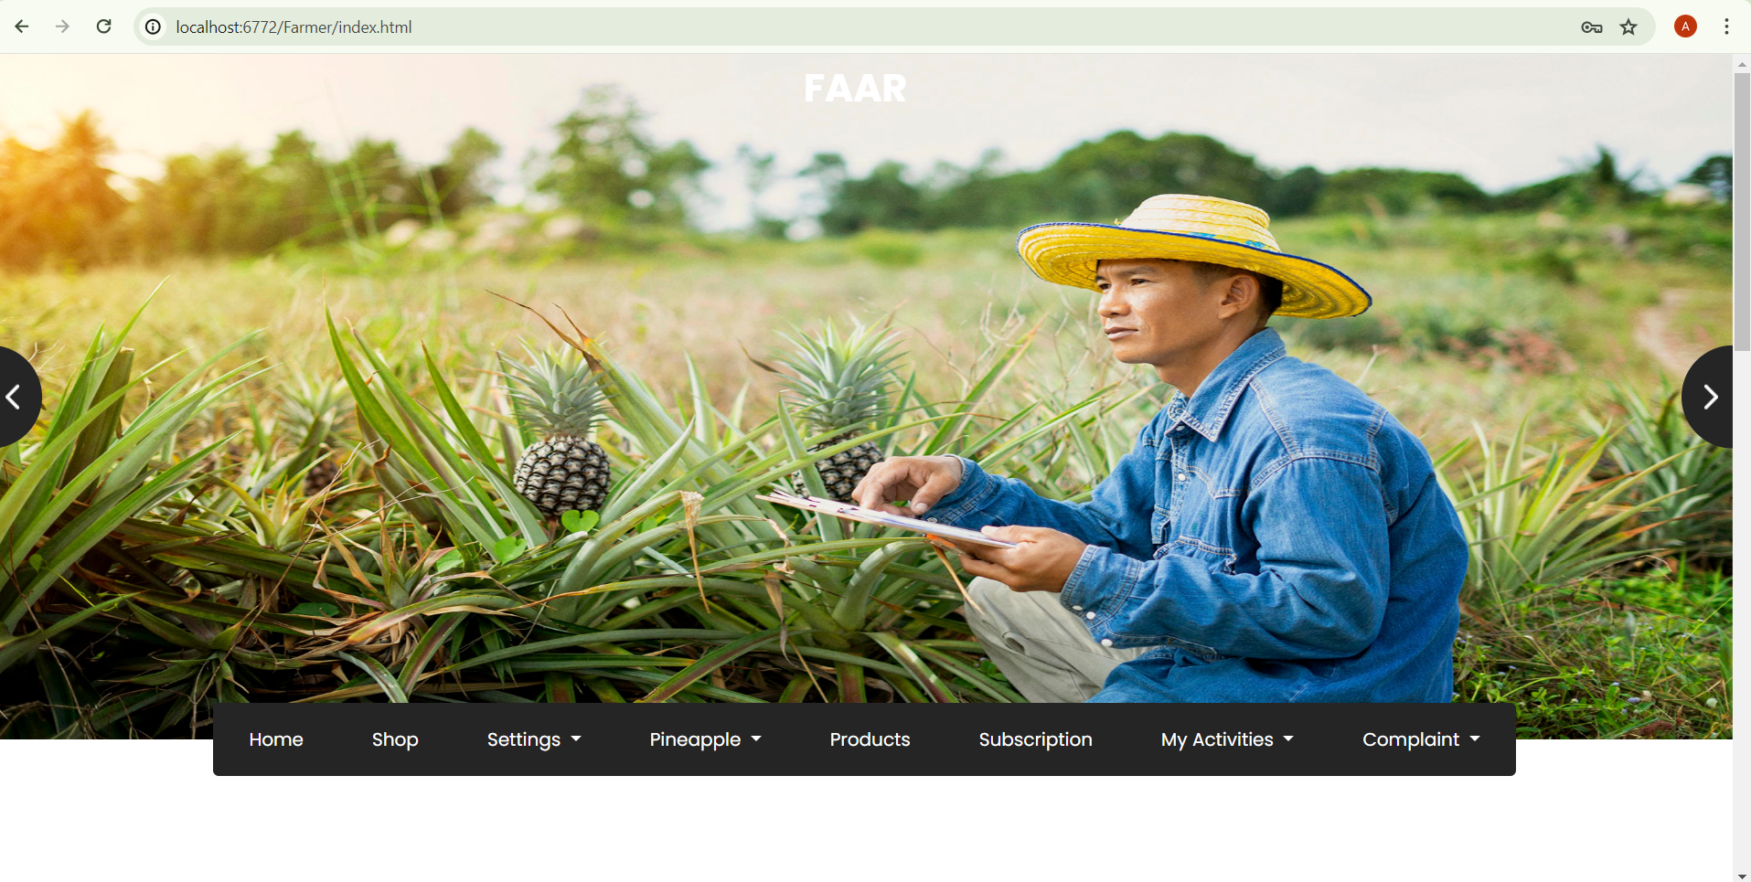

Farmer Homepage

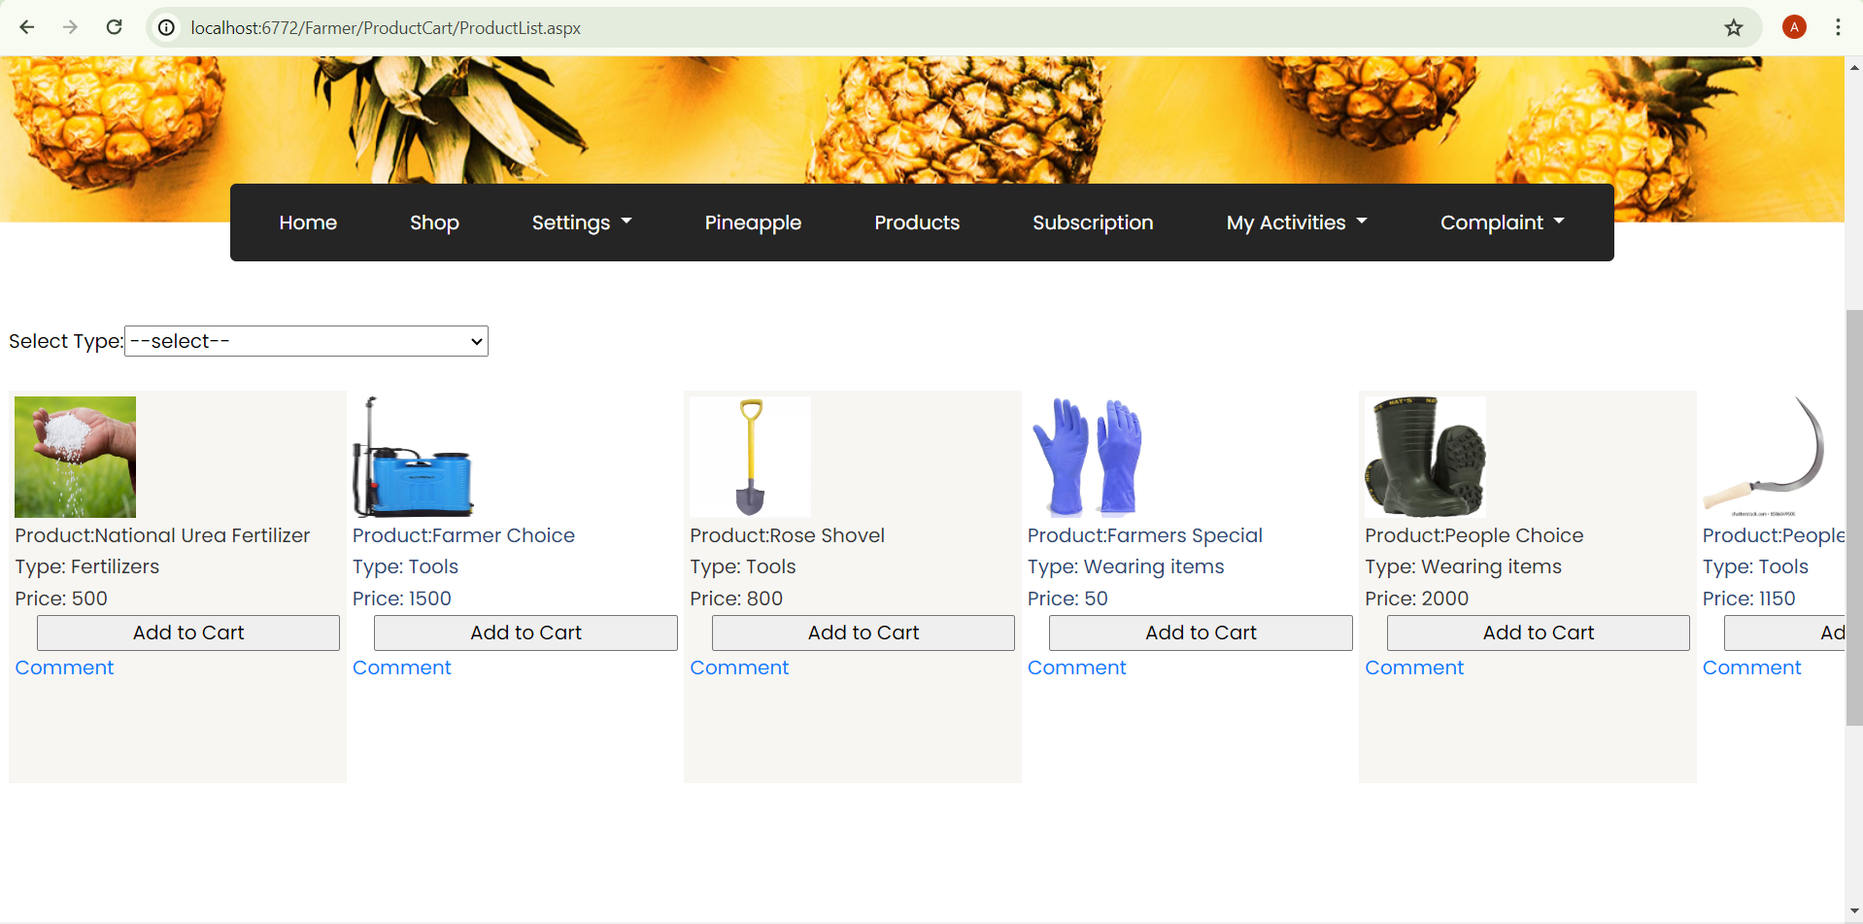

Searching of Products

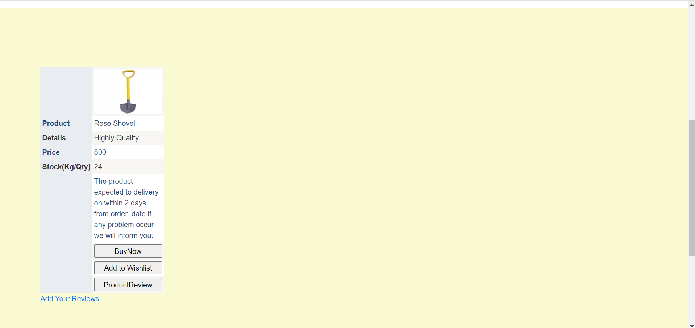

Product Details

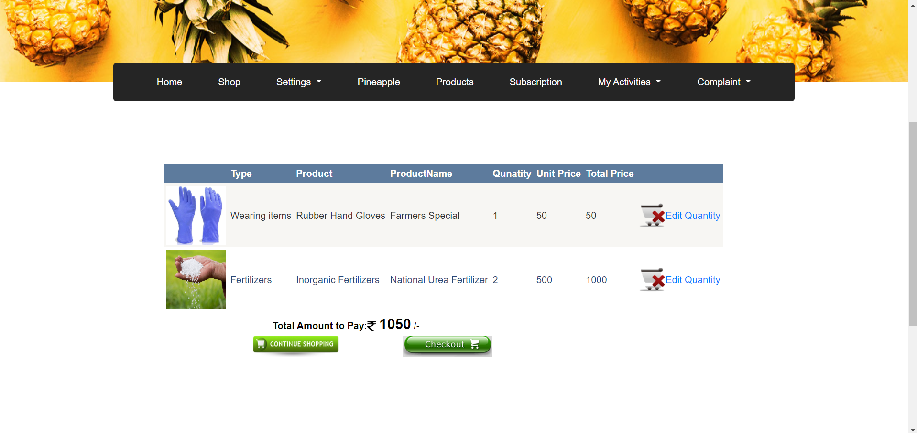

My Cart

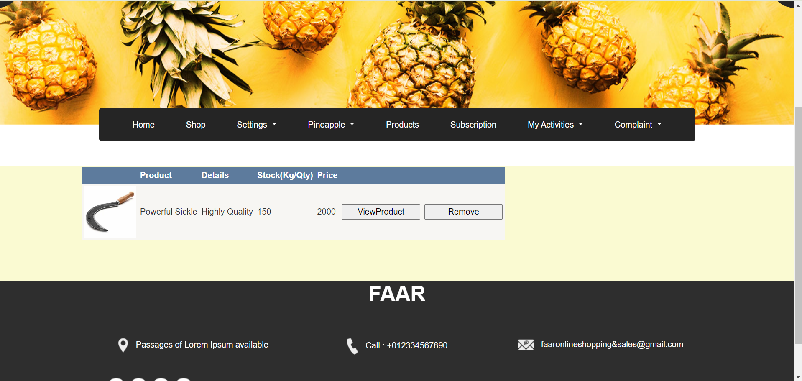

My Wishlist

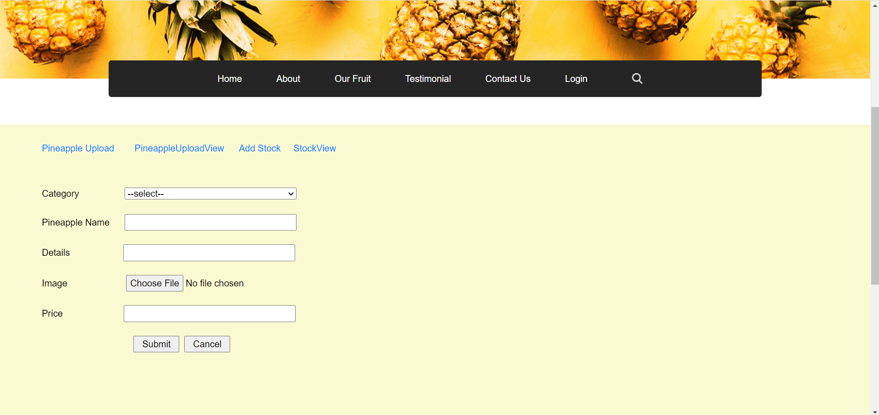

Pineapple Upload

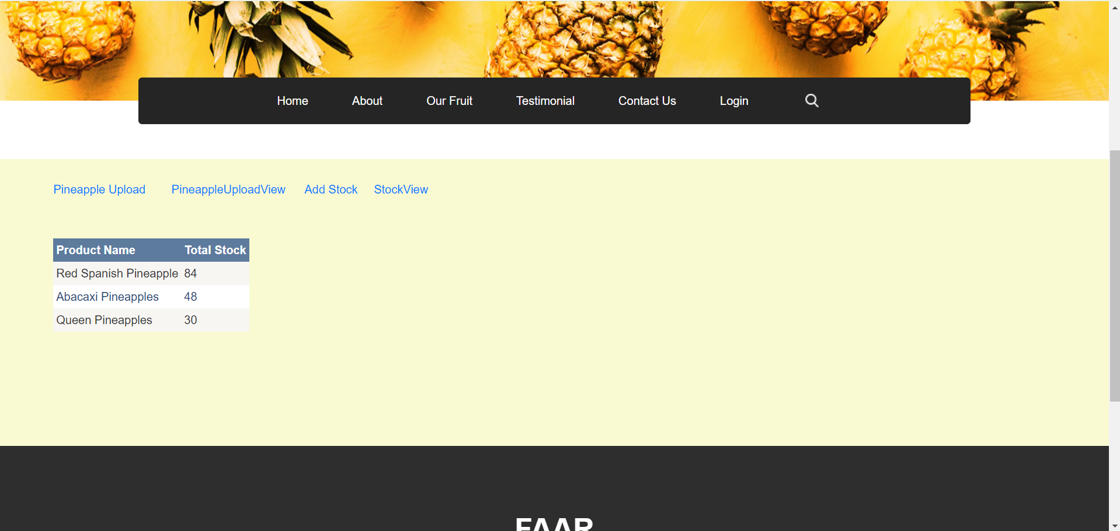

Pineapple Stock View

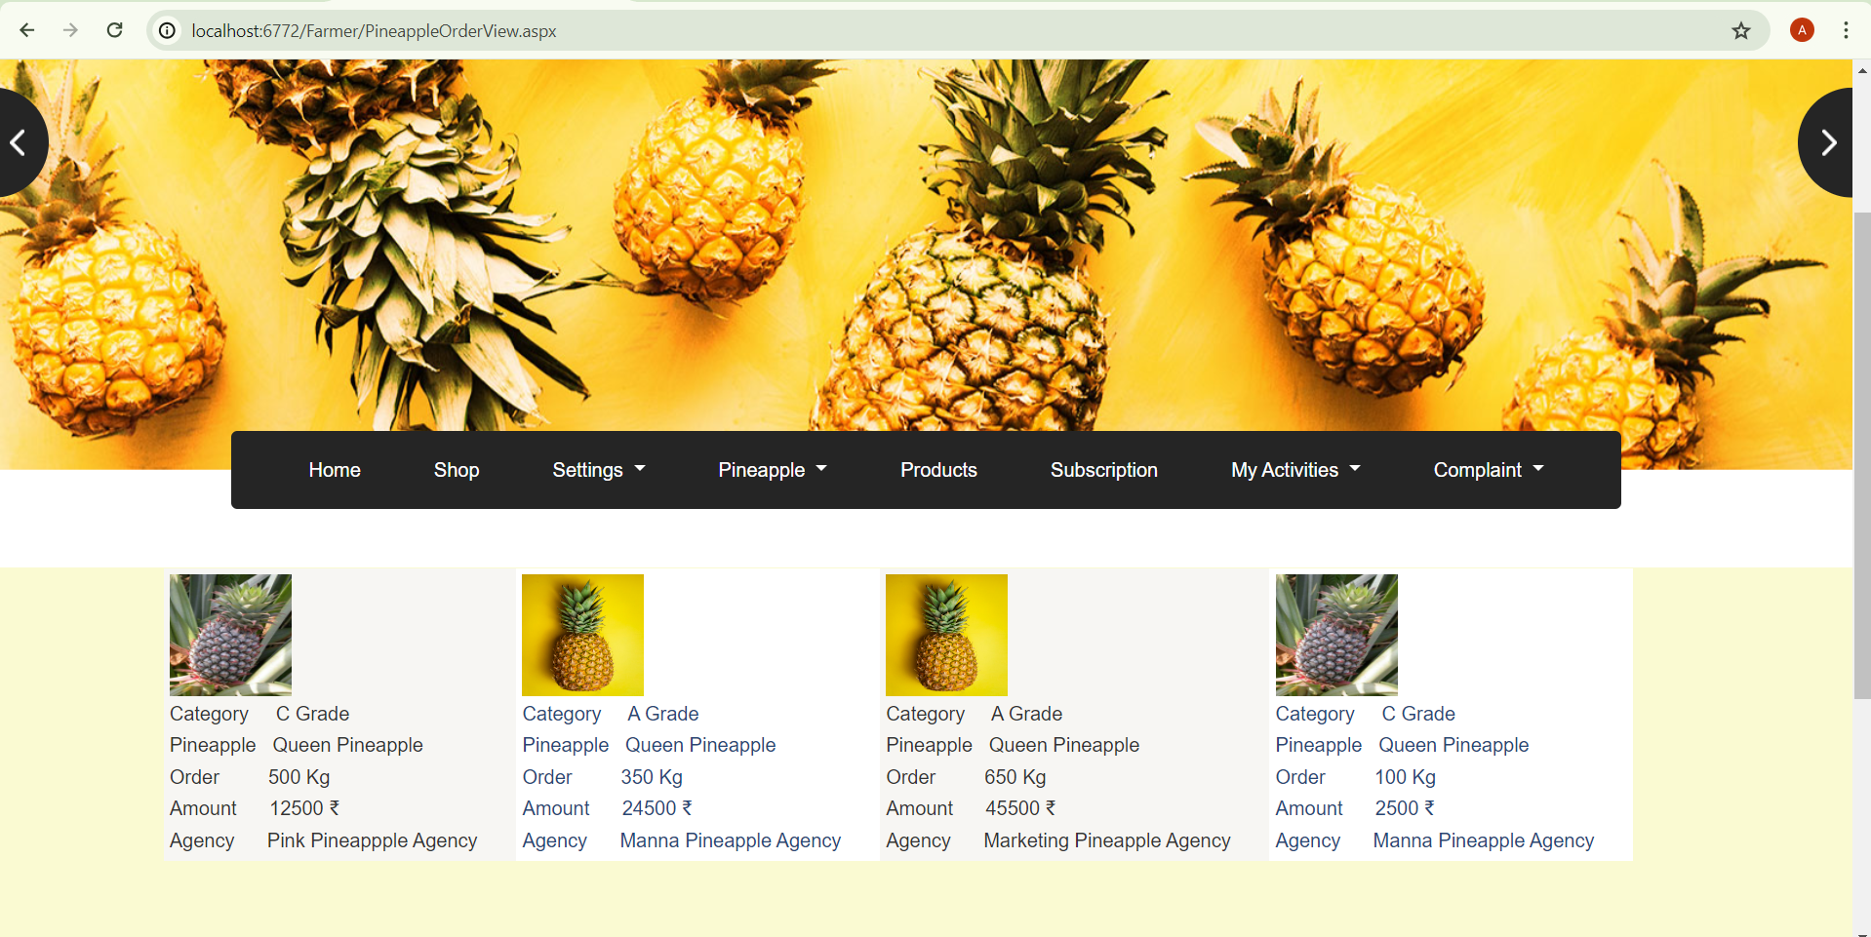

Pineapple orders

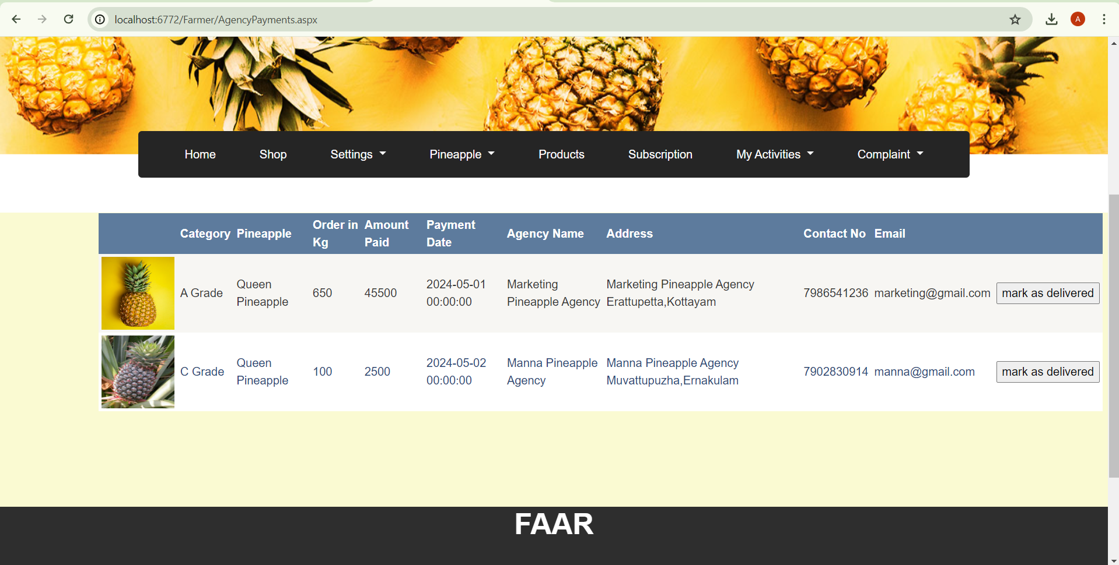

Order & Delivery Details

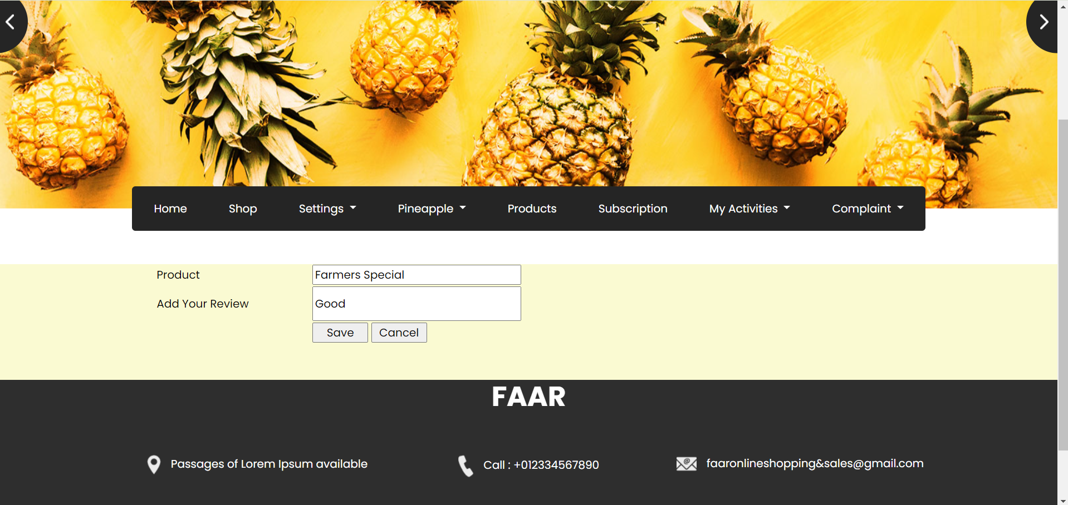

Product Review Form

**SHOP**



Shop Homepage

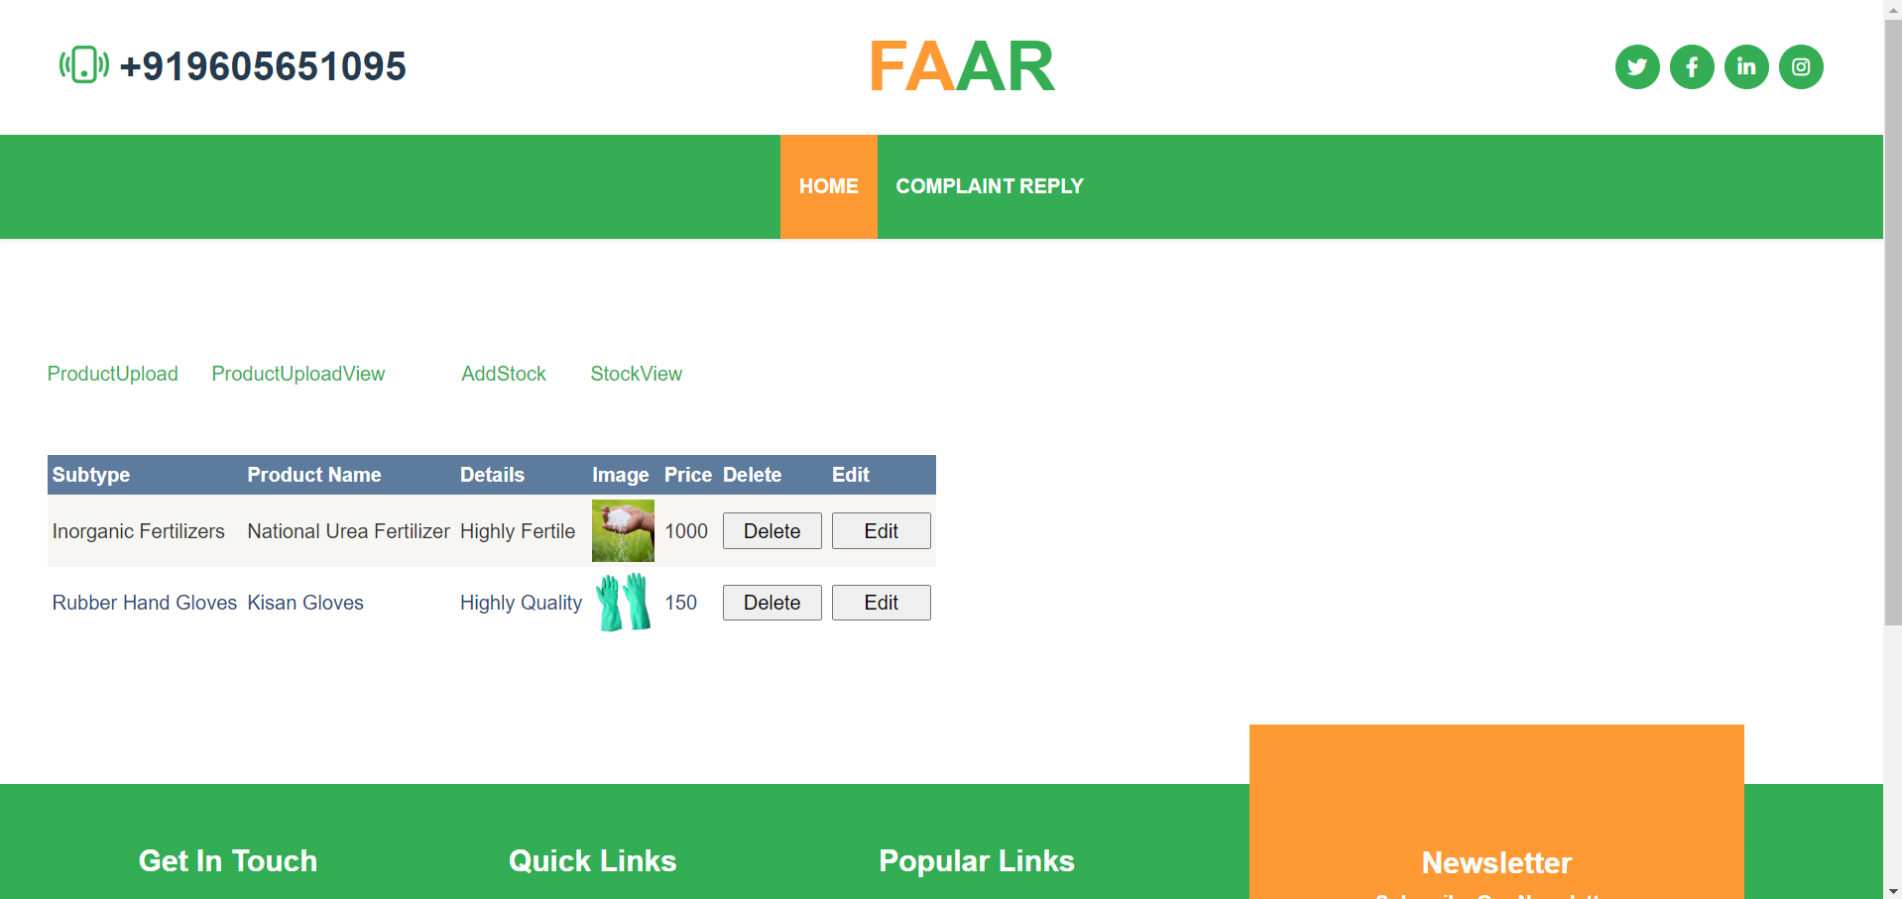

Product Upload View

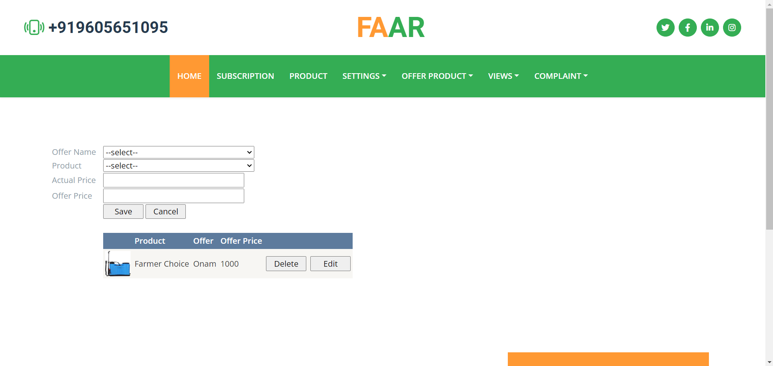

Offer product upload & View

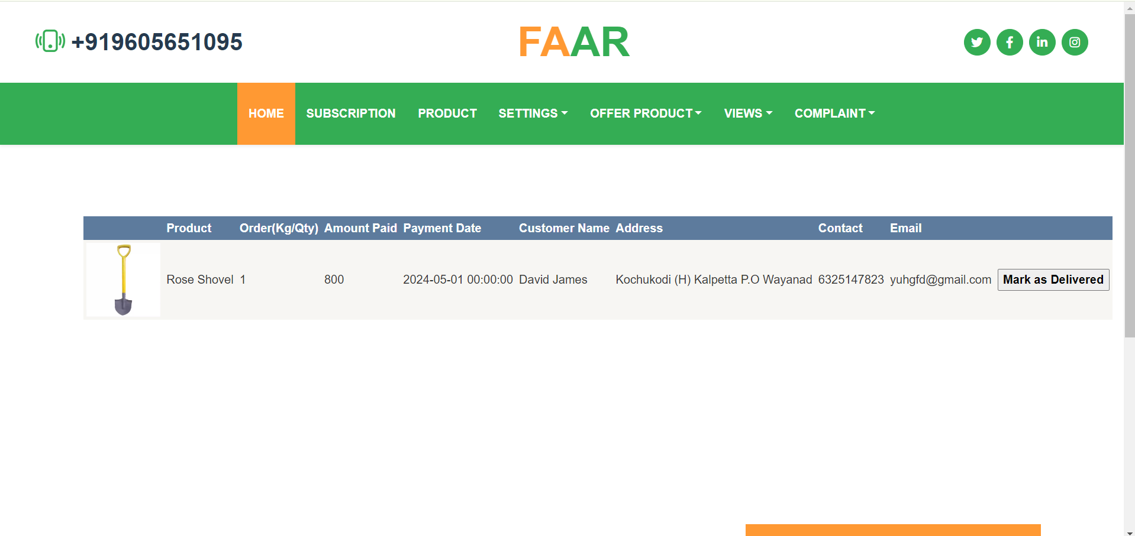

Order & Delivery Details View

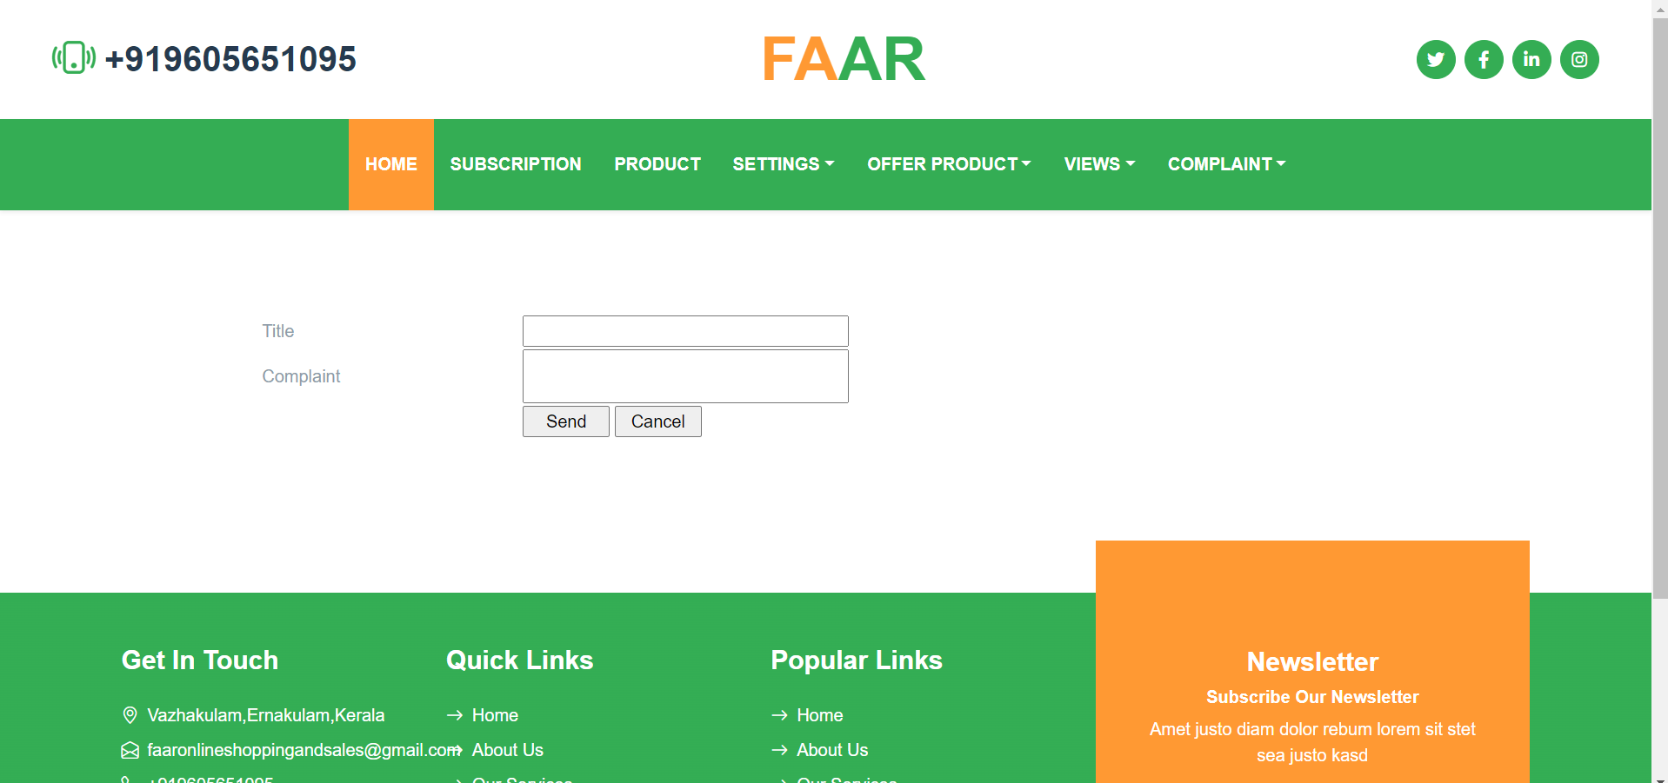

Post Complaint Form

# 

# Account Deletion